INTRODUCTION
Volume V and partly Volume VI of Monograph of Hungarian Stamps describes the stamps issued by the Hungarian Post Office in the last twenty years, that is from 1 May 1945 to 4 April 1965.
This twenty-year period of time is only a short one in the 94-year-long Hungarian postage stamp history; however, considering the number of issues, these last twenty years’ yield by far exceeds the number of the issues of the first 74 years of the postage stamps.
While the period between 1871 and 1944 saw nearly 1000 various Hungarian postage stamps, this number in the nearly twenty years between 1945 and 1965 was 1500.
Today we may almost correctly evaluate the classic issues. Resesheeters and expert writers have dealt with their scientific analysis. The resesheet of these issues has taken place over several decades; the assessment is almost finalized, and the results of the resesheet seem to be obtained.
On the other hand, the Hungarian stamps of the last twenty years may not have been in the focus of as many philatelists, resesheeters and specialists as they would have really deserved. However, the stamps of this period offer numerous special features of great interest for philatelic resesheeters. Moreover, the latter may even be surprised.
While in case of earlier issues it was the printing technique to result in versions, due to the use of the modern printing technology and the introduction of the photomechanical process, such versions became less and less common. In case of recent issues, however, the use of diverse printing techniques, the introduction of multi-color printing, the disorders of uniform quality raw material supplies, the cost saving measures regarding paper consumption, and the occasional deficiencies of control mainly resulted in versions of paper, watermark, and perforation. These versions have not yet been fully revealed. In case of the issues of 1945-1946, relief printing used again resulted a wide range of printing disorders.
While in collections of philatelists collecting Hungarian stamps there are almost always horizontally arranged stamps with Turul (Hungarian mythological bird) of 1914 and watermark versions of vertically arranged Portraits of the Soviet Republic series of 1919, Building I and II series of. 1952-1953 with the vertically arranged watermark are not represented in these collections, not mentioning the watermarks and the watermark positions of the later issues.
Yet they should also be integral parts of well-organized Hungarian collections. The same refers to the perforation versions.
However, it is worth mentioning that rarities in the field of watermarks, the temporarily returned manufacturing watermark numbers, and perforation of greater value than those of the previous issues have already come to light; other such rarities still wait for exploration by hard-working resesheeters.
While earlier issues were published in millions of copies, and they were available for many decades for the phylatelic resesheet, the latest issues have been limited; collectors and resesheeters can obtain relatively small quantities. Without being properly studied, they are sent to the foreign stamp market, and become forever lost for the domestic philately resesheet.
We should not forget that our classic postage stamps were easily available in large numbers at the time, whereas today, because of their rare occurrence and high value, they are unavailable to the overwhelming majority of collectors. Just two decades have passed since May 1, 1945, but the “Liberation" series issued then has become hard to obtain for younger collectors. We must also pay attention to the fact that we have to appreciate our existing, today still easily accessible philatelic values before they become victims of mass collecting, as it happened in the case of the Hungarian inflation-period correspondence of 1945-1946, so precious from the philatelic point of view.
This volume covers a huge area of the stamp issues of the Hungarian Post. The accomplishing of this task in a way resisting any criticism and taking into account all possible details of course surpasses the performance of a single person. For the perfect implementation of such work, a large pool of the Hungarian stamp collectors would need to unite their efforts. Despite the objective difficulties that have arisen, I have tried to systemize my 20 years of resesheet and some of my enthusiastic philatelist friends' data in a way as to provide deeper details for exploratory, scientifically based philatelic resesheet. The continuation of this work is necessary not only for the purpose of processing newer issues but also because the period in question is not yet a finalized area of the philatelic resesheet. If this volume of the Monograph of the Hungarian Stamps reaches this purpose, it will fulfill its mission – at the present stage of describing the history of the Hungarian stamps.
I would like to express my gratitude to all those who helped me with my work as a philatelist and professionally: the Stamp Museum:Postal Traffic Director Imre Hamza, Post Supervisor Jenő Koncz, and Postal Advisor Dr Gyula Kadocsa, who gave me the chance to use the huge stamp collection of the Museum for my resesheet; to the Post Office Directorate for its authorization to communicate the data that had been missing previously; to Post Office Superintendent István Kalovits and Post Office Supervisor Frigyes Koppány for their diligent calculation of the number of copies of the issues of years 1945-1965; at the State Printing House: to Director János Jámbor and Head of Intaglio Plant Dr Béla Tölgyesi; at Banknote Printing House: to chief economist Antal Karsai and graphic artist Zoltán Nagy
for their professional guidance on the production technology of stamps. Finally, I would like to express my gratitude to the technical editor of this book, József Habermann, for his professional advice and practical guidance in the field of illustrations.
I should not leave out those who have helped my work over this short period of time by providing support in specialized areas or checking the correctness of the data and descriptions. These people include Dr Endre Dudich, a professor and a head of department; Dr Rezső Soó, an academic, a university professor (area of botany); Ernő Nagy, an aerospace mechanical engineer; Jenőné Papp, a European rowing champion, member of staff of newspaper “Népsport”, the advisor in the field of sports.
Budapest, June 1966
The Author
POSTAGE STAMPS AND PAYING FOR POSTAGE
IN HUNGARY
(1945—1961)
written by
László Pákozdi
Chapter I
ROAD GUARD MAIL CARRIER SERVICE IN HUNGARY IN 1944-1945
In Nagyszeben (Sibiu), the first troops of the Red Army of the Soviet Union crossed the Hungarian border on 23 September 1944, and the occupying German army started to get expelled from Hungary. A few days later, on September 2, 1944, the first two localities were liberated, Battonya and Makó.
On December 22, 1944, the Temporary National Government was established in Debrecen. In the liberated parts of the country, the difficult but inspirational work of the reconstruction started. Another politically necessary task was the organization of the new public administration. The administrative authorities of the country and the municipal councils developed rapidly. The construction and the setting up of new public administration, the transmission of orders and reports would have been difficult to accomplish without postal connection. In addition, the demand for postal services was generated by the industry and commerce, as well as the demand of the population – the dispersed families needed to communicate in the thunderstorms of war.
The rapid setup of the operations of the Hungarian Post and the launch of the letter post was heavily impeded by the lack of means of transport to the west, primarily the railway rolling stock, and the destruction of the postal equipment during the evacuation. The remaining equipment was damaged by the military events. The existing and functioning rolling stock and tracks were used by the Red Army to complete the war as soon as possible. Therefore, in the first liberated southeastern, eastern and northeastern territories, postal service terminated completely in the absence of means of transport.
The new life on the ruins of the devastating war could not wait for the launch of the official and regular postal services. The innovative first step in this direction in Hungary was taken by Békés County, the county administration and the administrative body of Gyula, the "Békésvárosi Közigazgatási Főnökség".
The idea of creating a courier service is not an unknown concept in the Hungarian Post History. In Gyula, on November 2, 1944, the National Board of Public Administration of Békés County, by Decision 28/1944 decided to set up a courier service to ensure the smooth running of the county administration, in order to replace the suspended postal traffic. The courier service was carried out by the staff of the road guards, organized and directed by the State Building Office of Gyula.
The Ministry of Commerce and Transport was informed about the Békés County Initiative from its report to the Temporary National Government in Debrecen, and instructed the public administration to arrange temporary postal service on the basis of the model of the courier service.
In its Notice no. 9 of January 9, 1945, the Ministry called upon the postal administration in the liberated areas to organize mail services based on the courier service model. The purpose was to involve the post offices and individual settlements of the liberated areas into the postal stream in order to facilitate the delivery of official and private letters.
This instruction was not fully implemented in all counties partly for objective, partly for subjective reasons. At least this is what we can conclude from the report of some postal administrations to the Ministry of Commerce and Transport, on the basis of which the Ministry reiterated its instruction to set up mail couriers in its Circular of 6 Msheet 1945.
Based on the available letter pool, the resesheet carried out so far shows that notwithstanding the initiative, the courier service did not operate in any county as precisely and for as long period as in Békés County. Therefore, we will get the most accurate picture of the practical implementation of the courier service if we look attentively into the Békés County.
According to the instructions given by the Gyula State Sheetitects’ Office, the road guards had to travel 8 km to the nearest guard post and hand over the mail carried by them to another guard or to the recipient. Mail sent to the opposite direction had to be handed over to the State Sheetitects' Office. This walk, amidst harsh weather conditions, required a significant effort.
The registered mail was delivered using either earlier printed return receipts or homemade ones; they had to be returned to the State Sheetitects’ Office after delivery.
The Soviet military commanders provided road guards with ID and white armbands to ensure their free movement. This auxiliary postal service started to be used by the civilian population in January 1945.
For the payment of the postage of letters, the stamps listed below, previously issued and in circulation could be used:
- 1939/41/43 Churches series I, II, III, 30 f, 40 f, 50 f, 70f, 80f;
- 1941/42 Horthy series II, III, 1 P, 2 P, 5 P;
- 1943/44. Military Leaders series, 18 f and 24 f
- 1943/44 Military Leaders series, all other 16 face values;
- 1944. St Margit 30 f;
- 1944. Red Cross III series, 4 face values;
- 1944. Red Cross series, 4 face values;
- 1944. Famous Women series, 6 face values;
It is to be noted that the stamps listed in points 1, 2, 3, 5 and 6 were definitively withdrawn from postal traffic as of 15 August 1945 by Regulation 113566 / A4 published in P.R.T. no. 11 of 1945. Those listed in points 4, 7 and 8 could in principle be used for the payment of postage until 30 June 1946 (PRT 1946/38, Regulation 233 703 / 4). But postage could also be covered in cash.
As shown in Figure 1, the Gyula State Sheetitects’ Office handed over letter mail hand stamped, using a rather non-sophisticated hand stamp prepared for this purpose. It was made of rubber letters of children’s printing game, and consisted of three lines.
State Sheetitects’ Office
-ROAD GUARD MAIL CARRIER-
- GYULA -
Considering the lowercase and the uppercase letters used and the signs, four types of this postmark are known.
Type I was used until the end of January 1945, with red stamp ink.
Type II was used since the end of January 1945, initially with red and then with violet ink.
Type III started to be used in mid-February 1945 with violet ink.
Type IV was used first in the middle of Msheet 1945 with red ink.
On January 14, 1945, the Governor of Békés County, with regard to the general price and the devaluation of the money, although irregularly from the point of view of the postal administration, provided for the increase of postal tariffs. According to this regulation, the postage rate for a local postcard was raised to 20 fillérs, the countryside postcard cost 40 fillérs, local letters 40 fillérs, and letters to the countryside 80 fillérs.
Against this rate increase, which was not an isolated phenomenon and occurred in other parts of the country too, the competent ministry of the Temporary National Government in Debrecen protested to the county governors.
The courier service briefly outlined above slowly coupled with the regular postal service that resumed with the commencement of the train traffic. While the delivery of letters was initially carried out by the road guards themselves, later this work started to be shared with the professional postmen, and finally the letters were handled exclusively by the local postal delivery service.
The letter mail subject to the resesheet also proved that the courier service at the Békés County did not only send mail within the county but to other counties too, or contributed to sending mail past Békés County to other counties. In addition, it was involved in forwarding mail from Romania. For this purpose, especially in Gyula, mail items from Romania were received and forwarded (see Figure lb).
The Ministry of Commerce and Transport, in its Regulation 1846/1945. III. 1, terminated the road guard mail carrier service in Békés County
L r;\ ' c. •"
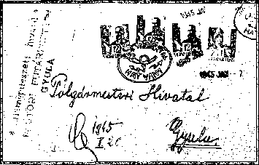
Figure Ia
Figure Ib

as of May 15, 1945, as regular mail delivery became available there. Thus, the six-and-a-half-month auxiliary postal service of the county, the road guard carrier mail service, finished operating.
One of the tasks of the Hungarian philatelic resesheet is to establish in which counties the temporary courier mail service organized on the basis of the model of Békés County operated in this period. Did other state sheetitectors’ offices use distinctive hand stamps similar to the ones in Gyula?. From this point of view, the eastern, southern and northern provinces and counties between the Danube and the Tisza can be considered – though the later liberated counties cannot be ruled out completely, even though the existence of such service there is not probable. It operated until 40 days after the liberation of the entire territory of Hungary.
In order to facilitate this resesheet, we include Table 1, which shows when the larger cities of the country were liberated. Later on, this table will be helpful for Payment of Postage During Inflation section.
- . 1
DATES OF LIBERATION OF MAJOR HUNGARIAN TOWNS – COMPREHENSIVE LIST
23 September 1944 | Red Army crosses the Hungarian border.
25 September 1944 | Liberation of Makó and Battonya
6 October 1944 | Liberation of Békéscsaba
11 October 1944 | . Liberation of Szeged
19 October 1944 | Liberation of Debrecen
21 October 1944 | Liberation of Baja
31 October 1944 | Liberation of Kecskemét and Nyíregyháza
4 November 1944 | Liberation of Szolnok
15 November 1944 | Liberation of Jászberény
23 November 1944 | Liberation of Tokaj
29 November 1944 | Liberation of Mohács and Pécs
30 November 1944 | Liberation of Eger and Szekszárd
2 December 1944 | Liberation of Kaposvár
3 December 1944 | Liberation of Miskolc and Szigetvár
9 December 1944 | Liberation of Vác
25 December 1944 | Liberation of Salgótarján
17 January 1945 | Liberation of Pest
13 February 1945 | Liberation of Buda (Budapest)
21 September 1945 | Liberation of Esztergom
23 Msheet 1945 | Liberation of Veszprém and Székesfehérvár
25 Msheet 1945 | Liberation of Tatabánya
28 Msheet 1945 | Liberation of Győr and Zalaegerszeg
29 Msheet 1945 | Liberation of Szombathely
1 April 1945 | Liberation of Sopron
4 April 1945 | Liberation of Nemesmedves

Chapter II

INFLATION PERIOD POSTAGE STAMP ISSUES 1.V.1945-26.VII.1946
1945: LIBERATION
On December 26, 1944, when the 2nd and 3rd Ukrainian Front troops were united in Esztergom, Budapest got encircled – the ring of the Red Army surrounded several German divisions, the remains of the 3th Hungarian Army, about 180 000 soldiers, and over 1 million of the civilian population.
After 29 December 1944 when the two deputies of the Soviet Army carrying the ultimatum of the Soviet army to surrender were murdered, Budapest turned into a combat zone. The siege of the encircled city began, turning the capital into a battlefield.
On January 17, 1945, the Soviet troops occupied the left part of the Hungarian capital and liberated Pest. Although on January 19, 1945, the Hungarian National Independence Front proclaimed that the Soviet troops liberated the town, on the right bank of the Danube, in Buda, the bitter struggle continued, especially for the Castle Mount turned into a fortress. Further 27 days of hard fighting took place, during which Buda was cleansed from the last remains of still defensive teams.
On February 13, 1945, the liberation of Buda put an end to the nearly 50-day siege of Budapest, which had brought about huge sacrifice of human life and serious destruction of material goods. The unbelievable damage in buildings was still of smaller scale than the material loss that resulted from the manufacturing and factory equipment having been shipped to the West. The workers, starved and impoverished during the siege, heroically did their best, though hungry and cold, so that life could resume as soon as possible. Their tasks included the removal of the debris, the restoration of public utilities, the creation of transport opportunities, the elimination of the danger of epidemics, and distribution of food supplies.
Shortly, the Temporary National Government moved to Budapest and continued the huge work of the rebuilding of the liberated capital and the country as the supreme body of the state power. The invading German troops tried to counterattack, retaining at least the oil fields in Zala for their war machine. However, their attacks, after some interim success, failed, and after fierce fighting for fifty days, the whole of Transdanubia was liberated. The last locality was liberated on April 4, 1945, the border village of Nemesmedves in Vas county.
The Temporary National Government, Ministry of Trade and Transport, in its Regulation 72/1945. IV. K.K.Msz. (1945/19 of M. K.), provided for the issuance of a postage stamp series commemorating 4 April, 1945, the full liberation of the country.

The Hungarian Post introduced this stamp series on 1 May, 1945, due to the objective difficulties mentioned earlier. It was the first series issued after the Liberation – overprinted, 26-piece one, consisting of 13 face values.
At this time, it was still unthinkable to design and execute new stamps, given the existing technical circumstances – the former Hungarian stamps were manufactured in the Castle District. The Printing House was still in ruins, and in Dunántúl the war was still ongoing. This was the reason why those 13 values of the former series Military Leaders 1943/44 were used. There were sufficient stocks of these stamps in the Post Office Stamp Warehouse.
While determining the nominal values of the stamps, The Hungarian Post took into account the provisions of Regulation 79/1945-IV. KKM on the first postal rate increase, which was inevitable because of the inflation.
Period of Use
The values of the series could be used for sending mail from May 1, 1945 until June 30, 1946, according to the relevant regulations. Virtually, however, the face values of the series were not used very widely for postage, as the stocks of the post offices selling the series were bought by stamp collectors and postage stamp traders. Their use was limited to a short period, due to the rapid depreciation of the money; it terminated way before the deadline for the withdrawal from circulation (233.703 / 4 P.R.T. 1946/38).
Number of Copies
Of this stamp issue, 50,000 series were printed with yellow base prints, while 50,000 series with blue base prints. The color of the overprint is red in both series. Although the issuing regulation mentions 100,000 series, of which 50,000 series were printed in yellow and 50,000 series in blue, the stamp collectors consider that the two series together constitute a complete series.
Sales
The stamps were sold only in full series until the stocks had run out, at the following post offices: Budapest 1, 2, 3, 4, 5, 7, 8, 10, 53, 62, 72, 114 and Budafok 1, Csepel 1, Kispest 1, Pestszentlőrinc 1, Pestszenterzsébet 1, Újpest 1, Debrecen 1, Miskolc 1, Pécs 1, Sopron 1, Szeged 1.
Figure 2

10 fillérs | on 1 fillér
20 fillérs | on 3 fillérs
30 fillérs | on 4 fillérs
40 fillérs | on 6 fillérs
50 fillérs | on 8 fillérs
1 kreuzer | on 10 fillérs
150 fillérs | on 12 fillérs
2 kreuzers | on 18 fillérs
3 kreuzers | on 20 fillérs
5 kreuzers | on 24 fillérs
6 kreuzers | on 50 fillér
10 kreuzers | on 80 fillérs
20 kreuzers | on 1 kreuzer

Overprints
The State Printing House was not yet operational at this time. The overprinting was carried out in Pest, at Athenaeum Printing House, as the printing house workers first managed to turn these facilities running, as a result of their huge effort. The basic information on postage stamp production is outlined in the introductory part of "Turul" stamps (mythical Hungarian eagle).
Overprinting was done at Athenaeum Printing House in two rounds:
- Base print, yellow or blue
- Overprint, red
1. Producing Base Impression
The base impression was made using smooth polished zinc plate with relief printing, on Victoria equipment. The earlier statement in the resesheet periodicals that the base impression was performed with a rubber roller was incorrect. With rubber roller, only infinite impression can be produced, which extends over the whole length of sheet. In this case, however, the base impression is rectangular, and does not extend over the entire stamp face. The thumbs of plate fasteners on the galvanized sheet, if not so often, still can be seen on the sheet edges too, as illustrated in Figure 3.
The plates used for the base impression will be discussed in detail when discussing series Auxiliary Stamps I placed in circulation on 1 June, 1945, since the prints of both editions were made of the same two zinc plates. This circumstance can be established without doubt from the prints of the thumbs of plate fasteners at the edges of the sheets (Figure 3).
The yellow and blue colors of the base impression show a scale of varieties. The yellow color extended from light to dark, while the blue color from pale light blue to sky blue, in many variations. The color variations were mainly caused by the lack of raw materials and the lack of paint. Paint of the same composition was not available in sufficient quantity. Therefore, the stock available was used. When mixing paints, the same color shades were rarely produced.
The color variations of the base impressions were not significantly influenced by the color variations of the base stamps, since the latter came from the postage stamp warehouse; they originated from original packages and,.
as shown by dates on the edges, with few exceptions come from the same production period.
The color of the base impression is different often on one and the same sheet. Darker or brighter spots, smaller or bigger base impression deficiencies may occur.
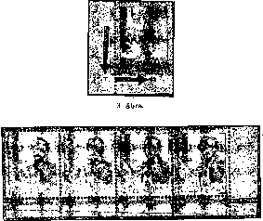
Figure 3a

The origin of the so-called marble design is primarily due to the applied printing process, the unevenly spread paint over the flat base plate, and, last but not the least, the poor quality of the paint used for printing.
It is in this issue that we first encounter an interesting version, the pearls, which is closely related to the overprinting of the already perforated sheets (Figure 3a). The detailed discussion will be provided when discussing Auxiliary Series I.
The sliding in any direction of one of the four sides of the base impression resulted in copies with a white edge. Few-millimeter slides in the side stamp of the sheets are very common, while sliding beyond 5 millimeters is less frequent, due to the careful control of this issue (Figure 4).
The non-overprinted, base impression-only copies were produced in the 1st run, and were illegally placed on the market passing by the control. Their philatelic value is low.
2. Producing Overprints
Overprints were made using relief printing, in the second round, using galvanized plates, on two pieces of cruciate-type Victoria equipment. The preparation of the printing plates (cliché) was reconstructed using the slightly incomplete documentation (in the custody of the Postage Stamp Museum), as well as on the basis of the guidance by Ödön Csathó, who participated in the printing of these stamps.
On the basis of these sources, an overall area of 78.2 x 86 mm was made from letters of different size; this area contained the full text of the overprint. The letters of the work “FELSZABADULÁS" (Liberation) were typed between two inclined steel sheets, which were placed in a gypsum for fixation, since no suitable molds of the proper shape were available. The rest of the overprint was placed horizontally.
For further photomechanical procedures, printing on white chalk paper was produced. The test sample of this 78.2x86 mm assay is shown in Figure 5 in original size. This 78.2x86 mm proof is shown in Figure 5 in the original size.
As the basis for the printing plate, this print was used to make the plate (cliché) by taking photos and reproduction. The first photo was taken from a predetermined distance so that the picture on the postage stamp was 14,9x16,3 mm. Of the negative, 10 diapositive copies were made; these were mounted at the predetermined distance corresponding to the ten stamps of the horizontal row. This strip of ten diapositives is shown in Figure 6, interrupted for technical reasons.
The strip of 10 diapositives was turned in 10 negatives, the required retouches were performed, due to which the separation signs and the film edge shadows were disappeared. Such a 10-piece strip negative is presented in Figure 7.
Next, the 10 strips each containing 10 negative portraits were assembled, retouched, and a diapositive of 100 postage stamps was created. A reduced copy is shown in Figure 8.
From this, a 100-piece negative was produced (Figure 9), and then, after yet another retouch, the cliché.
The 100-piece negative was copied onto a galvanized sheet, developed, and the residual drawing portions were made acid-resistant by special treatment. Subsequently, the zinc plate was placed in nitric acid solution.

or removed. As a result of the described operation, only the text of the overprint was raised from the plate, and the paint covered only these parts upon printing.
After the necessary washing, the plate was completed; as the technique was relief printing, the finished plate was fixed to a few-centimeter-thick wooden underlay.
It should be noted that the printing technique used to produce the overprint differs from the present-day process. However, it should be kept in mind that the Athenaeum Printing House was not yet prepared for pink postage stamps requiring relatively complex preparation.
3.
■I

5.
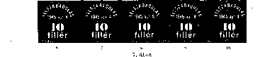

The destruction caused by the war had seriously damaged or destroyed the printing equipment and material stock.
If we compare the letters and numerals on the films used to make the cliché and the finished stamps, we can see that the galvanizing of the sheet was far from perfect. On the diapositive and the negative, the letters and numbers were very beautifully drawn, bordered with sharp lines, so they did not require any retouching. Retouching did not appear either on the overprint, merely with the exception of the black spots of negatives. Knowing this is very important when examining plates, evaluating, defining the overprint features.
The overprinting of the entire hundred-piece sheets was made on two Victorian machines, were not up-to-date.
It explains the many variations created during the pressure.
While at the pressure on the high pressurized high pressure press the roller mold and the paper backpressure roller rotating motion- Scratched with strong, but uniform pressure, in the present case, the plate with the engraved sheet is slammed as a hammer at the same time with a painted plaster (cliché).

Figure 8

The technique resulted in uneven color variations of the base impression and the overprint, as well as the fact that the lines of the borders of the letters and digits were of the color of the overprint, though of darker shades.
These lines resulted from the fact that due to the hitting motion, the paint ran to the edges and dried there;
This first 78.2x86 mm typing was preserved, and when the next "filler" plate was produced, only the value digit was replaced; for pengő denominations, "filler" currency was replaced by "pengo". .
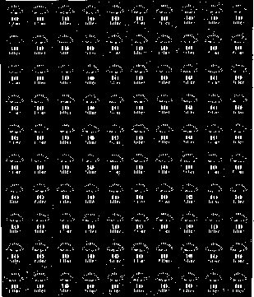
Figure 9

The rest of the inscription remained vertically arranged. This was followed in all cases by the photomechanical procedure already described.
When scrutinizing the dimensions of the 100-postage stamp overprint, we can see smaller deviations in their size. They were caused by the reproduction (photographic) operations and the deformation inaccuracy of the film (contact).
ANALYSIS OF OVERPRINTING PLATES (CLICHÉS)
10-fillér plate
Figure 10

This plate was used for printing 10-filler sheets on 1-filler sheets.
The overall width of the overprint was 208 mm.
The overall height of the overprint was 246.5 mm.
Features
The upper left corner of letter "F" on Stamp 31, in word “FELSZABADULÁS”,. (Figure 11) is often missing. This version is not typical of the 10 fillér plate, as it. also appears on other plates (eg. 50 f / 8 f). Its reason is not related to the plate problem, but to the lack of ink supply, and usually appear on the right-side edge stamps.
20-fillér plate
Figure 12

This plate was used for printing 20-filler sheets on 3-filler sheets.
The overall width of the overprint was 209 mm.
The overall height of the overprint was 247 mm.
No remarkable feature of 20-fillér plate is known so far.
30-fillér plate
Figure 13

On the 15th postage stamp of the sheet, the “0" of the numeral "30" is discontinuous at the bottom. Its reason in case of this and later plates can be explained by the fact that the thin lower or upper parts of some “0s” was due to imperfect chemical procedure during copying; then, in the course of etching, it grew thinner. Upon printing, these thinned sections grew worn more intensively, and when the paint supply was uneven, they did not produce impression (Figure 14).
On the 69th stamp of the sheet, the bottom point of "3" is discontinuous (Figure 15).
40 fillérs plate
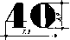
Figure 16
This plate was used for printing 40-filler sheets on 6-filler sheets.
The overall width of the overprint was 208.2 mm.
The overall height of the overprint was 245.5 mm.
Features •
a) On the 99th and 100th stamps of the sheet, letter "á" is written without the accent. The lack of accent was probably due to the copying and etching of the plate. This is a typical plate deficiency of the 40-fillét plate (Figure 17).
On the 40th, 64th, and 100th stamps on the sheet, the horizontal and the slanting lines of the “4” are incomplete, discontinuous at the junction of these lines (Figure 18).
The “0” of the “40” face value is discontinuous at the top. This deficiency is stronger or weaker on stamps 50, 59, 60, 70, and 100 (Figure 19).

50-fillér plate
72
Figure 20
<
This plate was used for printing 50-filler sheets on 8-filler sheets.
The overall width of the overprint was 208 mm.
The overall height of the overprint was 245,5 mm.

Features
- It often happens that the end point of “5” in “50” is not connected to the rest of the numeral, usually on stamps 21, 32, 49, 51, 97 and 99. The reasons include the thinned numeral and the poor paint supply (Figure 21).
- The “0” of the “50” is discontinuous at the top on stamp 21 and at the bottom on stamp 77 (Figure 22).
- On the 50-fillér sheets with the yellow base impression, it was also common that on the 97th stamp, due to the poor paint supply, the plate produced hardly visible, faint impression.

1-kreuzer plate
This plate was used for printing 1-kreuzer sheets on 10-filler sheets. The overall width of the overprint was 207,8 mm.
The overall height of the overprint was 245,8 mm.

Features
- There is a color point at inscription "ápr 4" (4 April), to the right and slightly above letter “r”, on the 48th stamp of the sheet, indicating the retouching deficiency of the 100-piece negative sheet (Figure 24).
- On the 52nd stamp, the lower right corner of the face value “1” is
defective, incomplete (Figure 25).

150-fillér plate
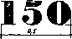
Figure 26
This plate was used for printing 150-filler sheets on 12-filler sheets.
The overall width of the overprint was 207,8 mm.
The overall height of the overprint was 245,8 mm.

Features
- On the 67th postage stamp, the bottom right-sides part of the "5" is damaged, incomplete (Figure 27)
2-kreuzer plate
Figure 28

This plate was used for printing 2-kreuzer sheets on 18-filler sheets. The overall width of the overprint was 207,8 mm.
The overall height of the overprint was 2458 mm.

Features
- The full stop after “2” was unconnected on Postage Stamp 11 (Figure 30)
- On the 74th postage stamp of the sheet, the full stop at the bottom right side of "2” was a little deficient, probably due to etching (Figure 29).

3-kreuzer plate

Figure 31

This plate was used for printing 3-kreuzer sheets on 20-filler sheets. The overall width of the overprint was 207,8 mm.
The overall height of the overprint was 245,8 mm. There were no significant features on this plate.

5-kreuzer plate
Figure 32

This plate was used for printing 5-kreuzer sheets on 24-filler sheets. The overall width of the overprint was 207,8 mm.
The overall height of the overprint was 245,8 mm.

Features
- The top part of “4” in “1945” is deficient on the 10th postage stamp of the sheet (Figure 33).
- In abbreviation “ápr” (April), letter "p" is discontinuous at the top end of the vertical line, on the 86th stamp (Figure 34).

6-kreuzer plate
3,4
Figure 35

This plate was used for printing 6-kreuzer sheets on 50-filler sheets. The overall width of the overprint was 208 mm.
The overall height of the overprint was 246,3 mm.

Features
a) In the case of this plate, it is very common that the thin lines of “6” on the overprinting are missing, resulting from etching, wear, and poor paint supply. So, the bottom of “6” is discontinuous on the following sheets: 10, 21, 31, 41, 60, 61, 90, 91, 95 and 100 (Figure 36).
b) The loop is discontinuous at the top on Postage Stamps 20 and 51 (Figure 37).
c) The loop is discontinuous at the bottom and top on Postage Stamp 11 (Figure 38).
d) Sometimes, the full stop after “6” is not connected; on the 51st postage stamp, it is never connected (Figure 39).
e) On the 73rd postage stamp of the sheet (Figure 40), the bottom of “6”. is defficient at the right side.

'
10-kreuzer plate
I
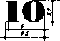
Figure 41

This plate was used for printing 10-kreuzer sheets on 80-filler sheets.
The overall width of the overprint was 208 mm.
The overall height of the overprint was 246,3 mm.

- The “1” of the “10” face value is discontinuous at the top. This deficiency appears on Stamps 12, 21, 22, 31, 32, and 41 (Figure 42).
Features
- The horizontal bottom line of “1” is missing for the same reasons on Stamps 11, 12, 13, 21 and 41 (Figure 43).

20-kreuzer plate
Figure 44

This plate was used for printing 20-kreuzer sheets on 1-kreuzer sheets.
The overall width of the overprint was 208 mm.
The overall height of the overprint was 246,3 mm,

Features
- On the 44th postage stamp of the sheet, the “0" of the numeral "20" is too robust due to jamming (Figure 45).
- On the 11th postage stamp, in the left half of “0”, a white spot appears (Figure 46).
Smaller color shades in the red color of the different overprinted values suggest that overprinting was not performed using paint mixed at a single point of time; however, we have not come across color variations within the same face value. When considering color variations, the fact that the red color from the same mixing renders a different shade to the yellow and yet another to the blue background must not be overlooked.
Since the paint used for overprinting had not been made for postage stamp production – it was not a synthetic paint, the red color of the overprint was not endurable and very sensitive to water, the stamps which have already been in contact with water cannot be used for color comparison.
31

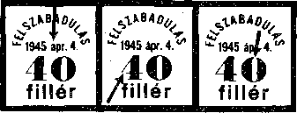
99., 1Û0. 40., 64., 100. ' 50., 59., 00., 70., 100.
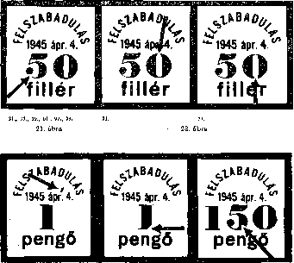
Figure 17 Figure 18 Figure 19 Figure 17 Figure 18 Figure 19
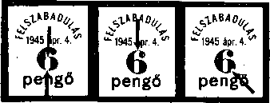

61
73
11
Figure 38
Figure 39
Figure 40

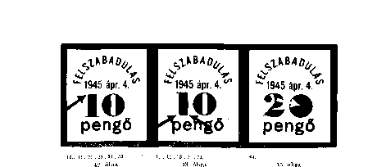
Slid overprints were rare to enter circulation, as the Printing House detected them. While a significant instance of sliding in the vertical direction is hardly known, the horizontally slid overprints are encountered more often (Figure 47).
4 fi. álii H
Figure 47
Erroneous printing also occurred in this edition. The inverted overprint of the 2 P / 18 f denomination with yellow base impression was also commercially available. Out of these erroneous prints, an entire sheet stays in the Stamp Museum; a four-piece block is presented in Figure 48. Recently, an invert of 30 f / 4 f with yellow base impression came to light. Although the overprint was made with the original cliché, the shade of the red color of the overprint is different, so it can be concluded that it was intentional and later implemented printing
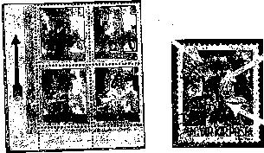
Figure 48 Figure 49

The pseudo double printed version is a variant of this edition, which never occurs over the entire sheet, but only partially, especially around the sheet edges. These pseudo double printing was caused by the fact that the devices of the clishé fixing the sheet did not fulfil their function – the sheet was not properly fixed, and air went in between the sheet and the clishé. The protruding part of the sheet came into contact with the plate (cliché) first, and receiving the first impression. After extracting the air, the sheet returned to its position, and received the final impression. On the postage stamp presented on Figure 49, 3 P/20 f, with the pseudo double impression, the distance between the two impressions is 35 mm.
If the plate (clishé) was not properly cleaned while printing, stains of the color of the overprinting occur on the stamps.
Their watermark and watermark orientation signs are the same as those of the base stamps: X, A/1,2.
Perforation: 15. .
On the day of the letting into circulation, 1 May 1945, the Post Office applied commemorative postmarks. Rarity!
Forgeries
There is no notion of forgeries of this issue.
1944 BAJCSY-ZSILINSZKY
Commemorative issue, with surcharge, to commemorate Endre Bajcsy-Zsilinszky
The postage stamp was designed by Sándor Légrády.
Issued on May 27, 1945, by Regulation 101561 / 1945. KKM (MK 1945/36). Officially, this stamp was withdrawn only on 30 June 1946, by Regulation 233703 / 1946 (PRT 1946/38), but it actually stopped to be used due to the depreciation of the currency.
Number of copies: 300,000 perforated postage stamps
Points of sale: Budpest 2, 3, 4, 5, 7, 8, 10, 53, 57, 62, 72, 114, Budafok 1, Csepel 1, Kispest 1, Pestszentlőrinc 1, Pestszenterzsébet 1, Újpest 1, Debrecen 1, Miskolc 1, Pécs 1, Sopron 1, Szeged 1. One customer could purchase maximum 5 pieces.
Figure 50 1 Kreuzer + 1 Kreuzer, dark violet

Image: in the foreground, there is the statue of Endre Bajcsy-Zsilinszky, while in the background – an eagle with its breast stabbed with an arrow, symbolizing martyrdom. At the top, "MAGYAR POSTA” (Hungarian Post), at the bottom, "BAJCSY-ZSILINSZKY ENDRE" inscriptions appear; at the top right, the face value and the surcharge take place.
The image is of rectangular shape, 33 x 22 mm.
Printed: Temporary Printing House of the State Printing House, with solid grid print. The negative was made with a small amateur camera, as the reproduction camera was damaged. Due the absence of the required paint solvent and toluene, vehicle gasoline was collected at various points of the city and used, due to which the color of the stamp is highly benzine-sensitive.
Due to the lack of necessary equipment, on a number of stamps of the sheet, there are several smaller plate defects. Out of these stamps, it is worth mentioning the 30th stamp of the sheet, on which two printing errors are found (Figure 51). In the lower right corner of the image, 1 mm away from letter "g" of word „Légrády”, there is a 3x1x1 mm dark triangle. Cause of occurrence: when copying pigment paper, after the grid has been transferred, a foreign body fell - probably a fallen off gelatin particle - between the pigment paper and the positive, which, by lifting the paper, made the area of the contaminant blurred (lighter), while the area of the foreign body, since the light had not penetrated it, became darker.
There may be a double reason of the formation of the colored line on the forehead.
1 Retouching the damaged gelatin layer of the positive.
2 Tiny scratch filled with dirt on the copying glass. The latter is more likely, as this phenomenon is seen on many other stamps of the sheet, eg. Stamps 19, 55, and 70.
There are also frequently present separate color spots that are not paint splashed on the stamp paper, but improper contamination (dust particles), due to improper handling of the positive. Such errors can be detected, for example, on Stamps 5, 8, 13, 56, 57, 63, 64, 67 and 80 of the sheet
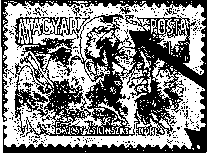
Figure 61

Grouped colored spots appearing in cloud-like manner on Stamps 20, 50 and 70 of the sheet are the consequence of the air bubbles remaining between the pigment paper and the clamping glass during increasing the light sensitivity of the pigment paper.
It was marketed in 100-piece sheets.
Date on sheet edge. On the left side of sheet edge, in the center, "45 V " indicates the date of production. This is the home engraving of the printing house on the printing roller (Figure 50). We will see such stamps only on the stamps issued in 1950.
Made of 01 mm thick white, X-watermarked treasury paper.
Watermark and watermark position: X watermark, standing (A).
Watermark position A / l 2
Gumming: white
Perforation: 12:12’/2, comb. The size of the stamp is 37 x26 mm. Non-perforated pieces (□) were phase impressions placed on the market.

These stamps were barely used for covering postage. The small issue was almost completely purchased for collector purposes.
Proofs: for this issue, a number of color proofs were produced; they are in the custody of the Stamp Museum.
1945 AUXILIARY STAMPS (Overprinting Athenaeum Press)
As a result of the general price increase and the depreciation of the currency,
postage rate increase was provided for of 1 May 1945, as the postal stamps in circulation could not fully fulfill their mission related to postage, covering postage fees. Since there was no possibility of printing a newly produced general series of new postage stamps, there was only a single solution to the producing of new denominations: overprinting the existing postage stamps with a new face value.
Therefore, the Ministry of Commerce and Transport of the Provisional National Government ratified Regulation 100981 / 1945 IV KKM (M K 1945/36) providing for the introducing of the series of 15 new overprinted denominations but containing of 25 pieces as of June 1, 1945. The date of issue was probably influenced by the fact that the armistice agreement with the Allied Powers came into force on June 1, 1945. The ordering of the base color and overprint was justified by the fact that the formerly reconquered uplands, Transylvanian and Southern parts of the country joined the neighboring states again under the armistice agreement and the subsequent peace agreement. In these administrative areas previous Hungarian stamps, partly in their original appearance, partly overprinted with the new face value “kreuzer-fillér" had been in circulation for a long time.
For the production of the newly overprinted series, the following were used as basic stamps: the 18 face values of “Hadvezérek” (Military Leaders) of 1943/44, the “Szent Margit” (Saint Margit) commemorative stamps of 1944, and the 6 face values of “Nagyasszonyok” of 1944. In addition to the inventory of the Hungarian Post Office's Postage Stamp Warehouse, the stamps of the post offices emptied during military operations were overprinted too.

Period of Use
- The face values of the series were published, as per Regulation 109359 / 1945 (PRT 1945, Volume 7), in the order in which they were produced, beginning from 1 June 1945. These stamps were withdrawn by Regulation 233703 / 4. (PRT 1946/38) as of June 30, 1946; however, due to the depreciation of the money; their postal usage was practically gone much earlier. This assumption is supported by Regulation 135277 / A / 4 of 24 October 1945 (PRT 1945/36), which ordered that the the post offices return all "fillér" postage stamps, while the "fillér" stamps already sold could be used by buyers until 30 June 1946.

Sales
The stamps of the series could be purchased (with the exception of face value 10 P / 2 f) at post offices, the postage stamp shops and the postage stamp sales office opened on August 1, 1945. In accordance with Regulation 190476 / A / 4 (PRT. 1945/12), postage stamps of face value 10 P / 2 f "for the time being” did not go on sale.
A large part of the stocks was purchased by people because of the depreciation of money; later, they were put on the market
Figure 52

Face Values Of The Series |  |  | Base Impression  Color | Color of Overprint | Number of Copies
10 fillérs | on 4 fillérs | H2 | blue | red | 8,490,000 pieces
10 fillérs | on 10 fillérs | fi | blue | red | 532,300
10 fillérs | on 12 fillérs | H | yellow | red | 1,093,200 pieces
20 fillérs | on 1 fillér | H | yellow | red | 1,086,000 pieces
20 fillérs | on 18 fillérs | II | yellow | red | 1,773,000 pieces
20 fillérs | on 20 fillérs | X | blue | red | 588,100 pieces
28 fillérs | on 5 fillérs | H | blue | black | 1,156,900 pieces
30 fillérs 30 fillérs | on 30 fillérs | H | blue | black | 2,841,800 pieces
 | on 30 fillérs | M | blue | black | 1,479,500 pieces
30 fillérs | on 30 fillérs | N | blue | black | 1,953,300 pieces
40 fillérs | on 24 fillérs | H | yellow | red | 5,597,600 pieces
40 fillérs | on 24 fillérs | N | yellow | red | 438,400 pieces
42 fillérs | on 20 fillérs | H | yellow | red | 3,038,200 pieces
50 fillérs | on 50 fillérs | H | yellow | red | 3,200,000 pieces
50 fillérs | on 50 fillérs | N | yellow | red | 1,005,400 pieces
60 fillérs | on 8 fillérs | H | yellow | red | . 6,576,400 pieces
80 fillérs | on 80 fillérs | N | yellow | red | 1,560,400 pieces
1 kreuzer | on 70 fillérs | N | blue | black | 591,500 pieces
1 kreuzer | on 80 fillérs | H | blue | red | 1,719,200 pieces
1 kreuzer | on 1 kreuzer H |  | yellow | red | 16,033,100 pieces
150 fillérs | on 6 fillérs | H | yellow | red | 445,200 pieces
2 kreuzers | on 2 kreuzers | H | blue | red | 5,369,200 pieces
3 kreuzers | on 3 fillérs | H | yellow | red | 3,796,000 pieces
5 kreuzers | on 5 kreuzer | H | yellow | red | 1,619,000 pieces
10 kreuzers | on 2 fillérs | H | blue | black | 1,480,400 pieces

In determining the nominal value of stamps, the Hungarian Post Office took into account the tariff increase of 1 May 1945. For this reason, the 150-filler face value was produced, which at this time was the postage of a 500 gram local letter, registered local letter or express letter fee. The stamps with the nominal value of 28 and 42 fillers were for long time used to supplement postcards of 12 and 18 fillérs.
Overprints
The overprinting of the stamps of the series was carried out at Athenaeum Printing House in two rounds.
Base print, yellow or blue.
Overprint, red or black.

Producing base printing
The base printing was made on Viktória machines, of two finely ground 220 x261 mm zinc plates. The plates used for the base printing were the same as those used for the postage stamp series “Liberation 1945". It is necessary to speak in a more detailed way about these printing plates, because, as we will see later, although th State Printing House had produced a different base plate, it still continued using the postage stamp sheets with the base impression already produced in the Athenaeum Printing House.
When examining the dimensions of the base impression, we talk about something from a few tenths of a millimeter to 1 millimeter variations. The explanation of the size changes lies in the fact that the sheets that had already been gummed and perforated did not always fit perfectly on the plate. This circumstance should always be taken into account when concluding on the dimensions of the full text overprint of sheet.
The size of the base impression produced in the Athenaeum Printing House can, however, undoubtedly be separated from those produced in the State Printing House. In addition to the difference in the size of the plates for the printing the base impression, Athenaeum Printing House’s typical feature was the imprints of the nails for fastening the plates at the edges of the stamps, outside the area of the base impression. It was exactly the scrutiny of these nail imprints that led to the finding that Athenaeum Printing House had used two plates to print the base impression.
The plate of Type I is 220 x 261 mm, and as shown in Figure 53, at the upper edge of the plate there are 7, at the bottom edge 9, at the left side 8, and on the right side 4 nail imprints (dotted).
These impressions are of different intensity and always partial. A sheet containing all imprints over the whole postage stamp sheet has not yet come to light. In general, only one or two sides of the sheet were fully or partially imprinted; the least pronounced were the imprints on the right side, where the first and the fourth imprints were the most impressive, while the second and the third were only partially printed.
If the postage stamp sheet was adjusted to the printing plate in a reverse way, which often occurred with the stocks returned from various post offices in the country and stored irregularly, the impression produced was reverse. This occurrence of such imprints can only, of course, be found on full sheets or sheet edges, not on individual postage stamps.
The Type II printing plate is of the same size as the Type I, namely 220 x 261 mm, as shown in Figure 53 with irregular circles.
At the top edge of the plate we can find 4, at the bottom edge 4 full or partial round shapes; on the left side 4 and on the right side 1 thinner or thicker oblique line can be found.
This type of the nail imprint is always partial and usually very small. It is so much so, that these sheets until recently, when Type II has been recognized, were considered base impressions without nail imprints. Reverse base impression sheets of this type also occur.
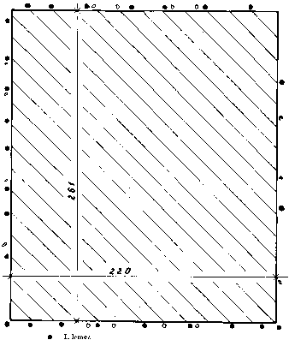
Plate II
Figure 53

For both plates, it may be accepted that the number and strength of the plate nail imprints on the edges of the sheets depends on the strength of the printing plate impact.
If we do not find nail head imprints at the edges of the sheets, the distinction between the base impression of the Athenaeum Printing House and the State Printing House should always be based on the width of the base prints.
The yellow and blue color of the base impression always ranges over a large scale. The wide range of the yellow and the blue is closely related to the different colors and qualities used for printing, the paints found on stock, the various results of the mixing, and other factors described in detail in this volume (pp 333 to 337).
However, in this case, it is also important to consider the fact that the base stamps used (on the basis of the dates on the edges) were printed at different dates. Thus, they also were of different variations. The same overprints, when printed on different color shades of the base stamps, show a significant difference in color both under the umbrella lamp, and even at daylight. We must again point out that soaked postage stamp, those which have already came into contact with water, cannot be used for defining color range. The color of the base impression turned to bleached gray when soaked over long period, especially the blue color.
As opposed to series “Liberation 1945”, the quality deteriorated sharply, due to the overprinting of a large number of pieces; thus, we see a large number of variations of the base impression.
The marble pattern of the base color resulted from the already mentioned paint delivery gaps and the applied crucible technique. Due to the lack of paint supply on the plate, the darker-lighter spots in the base color were produced, and smaller or larger base impression defects.
However, the defect of the base impression in Figure 54 was produced by the folding of the lower left postage stamp, which was caused by torn perforation.
There were also instances when base impression was missing on the whole sheet, when two sheets were joined together upon the base printing, and the lower sheet was left without base impression; this defect was revealed when the two sheets were separated for the base printing to be performed. These postage stamps without base impression but overprinted with a new face value mark were rejected upon supervision, and were taken from the Postage Stamp Warehouse to the Stamp Museum. These denominations were the entire sheets of the following: 10 f/4 f ÏÏ, 28 f/5 f H, 30 f/30 f H, 30 f/30 f M, 40 f/24 f H, 42 f/20 f H, 60 f/8 f H, 1 P/70 f N, 1 P/80 f H, and 5 P/5 P H. Some deficient sheets were illegally smuggled out, and entered collections: 10 f/4 f H, 28 f/5 f H, 40 f/24 f H, and a 60 f/8 f H. Earlier research literature mentioned these face values.
Sometimes the case was that the base impressions turned out deficient and stained, and were overprinted again, which double base impressions. Their recognition is facilitated by the double imprints appearing on the edges of the entire stamp sheets, which extend over the nail impressions. In the case of a separate overprinted postage stamps taken out from the sheet,

the characteristic feature is the extraordinary dark color of the base impression, which is not included in the color range of the commonly used colors. Double base impression is known mainly on blue postage stamps (Figure 55). However, this should not be confused with the so called “edge impression” of the base impression, which can be seen on the 28 f / 5 f H face value denomination.
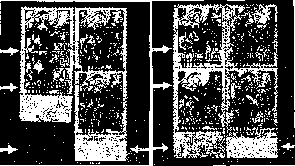
Figure 54

Figure 55

Two base impressions on a stamp can also occur when two sides of a sheet were printed upon. Base impression on the rear side may result from the following reasons: impression on the rear side, paint transfer by equipment, and paint transfer by the sheets (Figure 56).
In some parts of the stamps, next to the teeth, usually parallel to them, at the distance of some millimeters, there are tiny lines of the same color as the overprinting but of a darker shade, the so-called pearls. The reason for their occurrence is the lack of frequent cleaning of the applied equipment and of the galvanized sheet for producing the base impression. As was often the case, the galvanized sheet was not cleaned at intervals, and therefore the paint on the parts of the plate (zinc plate) that fell between the teeth of the postage stamp perforation remained there. If the stamps were repeatedly and permanently placed in the same place on the plate, the remaining paint accumulated and dried there. In cases where one of the sheets, in the course of continuous printing, was fixed a little shifted as compared to the position of the previous sheet, the paint spots accumulated on the printing sheet did not match the areas between the teeth of the perforation but produced bead-like, dark, colored impression, functioning as if it were relief printing. This variant is called colored beads (Figure 57).
Figure 57

But we can also see the negative of the pearls on sheets and postage stamps, in the form of white, tiny, round spots. They were generated when the above-mentioned paint spots attached to the plate, getting in contact with the postage stamps placed on the plate to be overprinted, took back the printed imprint, leaving tiny, round white spots on the sheet with the base impression. This variant is called white beads; they are presented in Figure 649 "Auxiliary I” containing due delivery postage stamps.
In this edition, it is very common that the base impression shifted towards one side of the stamp. The shift of the base impression ranges from a few millimeters to the size of the entire postage stamp image Thus were generated pieces with white borders at the edges of the sheets (Figure 58). Connected postage stamps from the upper or lower edges of the sheets where on some the base impression is missing, while on others is present are very precious, due to the large shift of the base impression.
Non-overprinted pieces with only base impression, which turn up even as full sheets, were produced in the 1st round of overprinting, overlooked by the quality supervision, and entered trade and postage stamp collections.
Sheets or postage stamps that have base impression only on the rear side are rejects, which entered trade illegally.
Figure 58

Producing Overprints
The overprints of different values with the year, the face value, and the currency were made using galvanized plates in the second round, on the above mentioned Viktória equipment, using relief printing technique.
The producing of the plates (clichés) is reconstructed on the basis of the remaining maculature, proofs and other available data.
From the typing material, full-size 10-piece overprint was produced; it then was printed onto white chalk paper using further photomechanical procedures. In Figure 59, the proof of the original ten-piece typing is seen, with the sole modification that the value number is covered because the material used comes from a different number of prints, and this may be confusing.
This tiny chalk print was photographed. From the negatives, 10 rows of 10 positives with overprinting were produced; then, they were glued one under the other, with the spaces in between. A new original-size photo was produced – the negative film of the photo already contained 100 pieces of overprints, sufficient for overprinting the entire sheet. After that, retouching took place.
The retouching was followed by transferring of the 100-piece sheet to the light-sensitive galvanized sheet, called copying and then treating with the nitric acid.
1945 | 1945 | 1945 | 1945 | 1945 | 1945 | 1945 | 1945 | 1945 | 1945
fillérs | fillérs | fillérs | fillérs | fillérs | fillérs | fillérs | fillérs | fillérs | fillérs
« . . |  |  |  | Figure 59

1945 | 1945 | 1945 | 1945 | 1945 | 1945 | 1945 | 1945 | 1945 | 1945
fillérs | fillérs | fillérs | fillérs | fillérs | fillérs | fillérs | fillérs | fillérs | fillérs

Figure 60

First of all, it must be noted that when producing series "1945 I/A Auxiliary”, the retouching played a very important role. While in commemorative series "1945 / Liberation" memorial series, retouching was limited to covering the parts of the negative film left white, not seen in the overprint, in this case, retouching was used to for correcting the overprint and making it nicer.
The retouching was followed by transferring of the 100-piece sheet to the light-sensitive galvanized sheet, called copying and then treating with the nitric acid. After rinsing, the finished printing plate was put at a wooden faucet, placed in the machine, and the printing process started.
In order to make it easier to examine the plates to be described later, let us take a close look at Figure 60, which is a proof of an original printing plate, and compare the forms of the letters and numbers in Figure 59, which is the proof of the original 10-piece types.
The decisive difference between the two prints is that while the letters and numerals of the print of the typing are well-drawn with sharp lines, the edges of the numerals and the letters of the printing plate (clisé) are most often bordered irregularly. We can also observe the typical feature of all printing plates that appears both on the typing, and even more firmly on the plate – the first and seventh year "1945”, “9” is of closed or almost closed shape. This phenomenon appearing on the plate is the consequence of the rather poor etching and the lack of retouching, and is also a clear illustration of the difference between printing of the same image using typing technique and cliché. This difference is important when recognizing counterfeits, which is to be discussed later
Overprinting is the same as in case of series "1945 Liberation", perhaps with the only difference that, in this case, the overprinting of nearly 1 million sheets of postage stamps (postage due stamps included) was no longer performed with the same care as series "1945 Liberation". But to do this more thoroughly, sufficient number of machines and time was not available at that time.
When producing different plates, the point of departure was in each case the original 10 types, only the value number changed when different face value denominations were produced. Later, “kreuzer" denomination was changed to “fillér".
The same plate was used for the printing of the common denominations of postage due stamps.
When examining the dimensions of the entire plates, which included the overprints for 100 stamps, we can see smaller dimension variations The maximum distances measured on the total overprint sheets vary between 2035 - 207.5 x 246 - 248.5 mm. This is explained by the fact that the Athenaeum Printing House did not have the "additive" device that was essential for modern postage stamp production. The applied photomechanical procedure, various photographic distances resulted in differences in dimensions.

DESCRIPTION OF OVERPRINTING PLATES (CLICHÉS)

10-filler plate was used for the printing on 4-filler postage stamps. This plate has not yet turned up in overprints of other 10-fillér postage stamps.
The overall width of the overprint was 20 4—205 mm.
The overall height5 of the overprint was 246 mm.

Features
- Closed numerals “9” were detected on Stamps 11, 21, 41, 51, 61, 81 and 91, as well as on stamps 7, 17, 27, 37, 47, 57, 67, 77, 87, and 97 (Figure 62).
- On the other hand, numeral “9” is retouched, not closed, on stamps 1, 31, and 71 (Figure 63).
- The typical feature of the 10-fillér platens of type I, overprint 93: in “1945”, the top part of “9” was a bit discontinuous, probably due to etching (Figure 64).
- When determining the two types of plates, recognizing if the value “10” are 9.2 mm wide in the first and the fourth vertical rows, while this number varies between 8.7-8.8 mm in other vertical rows is important. The height of value numeral is uniformly 5 mm (Figure 61).
- It is very common either the top or the bottom of “10” is discontinuous. The thin joining lines of the numerals “0” were thinned or completely discontinuous, due to etching. During the printing process, the thinned parts grew more worn, and in the case of particularly uneven or insufficient ink supply, no impression was produced.
On 6th, 16th, 56th, 86th, 73rd and 75th stamps of this sheet, this discontinuity of “0” below or above is very common, but but it is always there at the bottom of “0” on 56th stamp (Figure 65).
For overprinting 209 562 sheets, a sole plate of 10 fillérs did not prove sufficient, and producing of another 10-fillér plate became necessary.

10 fillérs, Plate I
4 For the measuring the full width of the sheet, the maximum distance between letter "f" on the first stamp of the sheet and letter “r" of the “fillér" on the tenth stamp was measured.
6 For the measuring the full height of the sheet, the maximum distance between the top of “1” in "1945" on the first stamp of the sheet and the bottom of letter “f” in "filler" on the ninety-first stamp was measured.

ffwwvvw ywtfiru'a
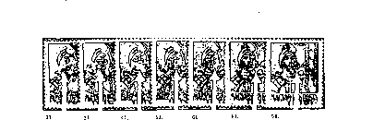
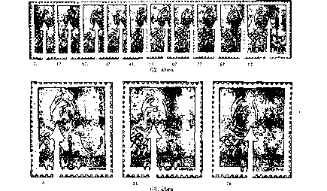

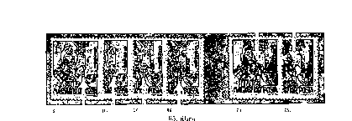
10-fillér Plate II
It was used, unlike plate I, for printing all 10 filling denominations, ie 10 f / 4 f H, 10 f / 10 f H, 10 f / 12 f H, and 10 f / 2 f and postage due 10 f / 3 f denominations. This large amount of 10-fillér denominations was not fully exploited due to rapid inflation, but after the return of the fillér denomination postage stamps, 95,000 sheets of the 10 f / 4 f H were overprinted with "TI-2"; they were then put back to mail stream for the postage of long distance letters, in series. ,,II. tarifa” (2nd tariff).
The overall width of the overprint was 203.5 mm.
The total height of the overprint was 246 mm.
Figure 64
Such errors can be detected, for example, on Stamps 11, 21, 81, 41, 57, 61, 71, 81 and 91 of the sheet.
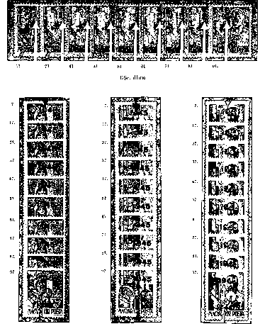

Characteristic Features

- Closed “9s” appeared in “1945”, on Stamps 11, 21, 31, 41, 57, 63, 64, 67 and 80 of the vertical row of the sheet, with the exception of the first postage stamp (Figures 66a-c) and on each postage stamp of the seventh vertical row (Figure 67).
- Well-drawn, retouched “9” in the first vertical row of the sheet, unlike sheet, is found only on a single piece, on the first postage stamp of the sheet.
- While number 10 in the first and fourth vertical rows of the platen X is 9.2 mm wide, on the second plate the. size of 9.2 mm appears only in the first vertical row of the postage stamps. Number 10 of the fourth vertical row is, however, remarkably narrow, with the size of 8.3-8.4 mm.
- On the 10th postage stamp, the bottom part of “5” of "1945” was retouched to straight, and letter "r" of "filler". was retouched to render it diagonal. This is a typical feature of in the II. (Figure 69). This is a typical feature of in plate II (Figure 69).
- On the postage stamps 94 and 95, the upper right corner of “3” is not square but rounded. This variant also occurs on other postage stamps of the sheet, but not as a typical feature (Figure 70a, b).
- A frequent deviation was when either at the top or at the bottom numeral “0” was discontinuous, due to poor ink supply. Typical thinning or discontinuity of the line in “0” turns up at the bottom on stamps 16, 56 and at the top on stamp 96 (Figure 71).
- Another interesting feature of the plate appeared on the 11th and 21st postage stamps: the left-hand horizontal section of the line of letter "f" of word "filler" was retouched out (Figure 66a-c).
- The best-known and the most characteristic feature of Type II of 10-fillers is short. letters "r” of word "fillér", which are only 2 mm high instead of the usual 2.4 mm, on 5th and 6th postage stamp of the sheet (Figures 72a-c). This variation is probably also due to retouching, since the zinc plates made sturdier by galvanizing are not likely to break.
This version was already described by earlier specialized literature.’¹
Figure 68
⁶ Filateliai szemle 1955 2 as per Hugó Solt

Figure 69

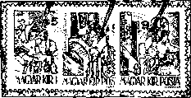
04
94
04

Figure 70a
Figure 70b

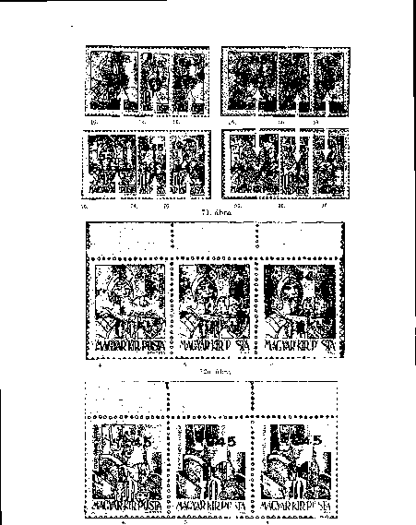

•î 5.
Figure 172c

20-fillér Plate
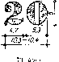

This plate was used for the printing of a 20 f/1 f H, 20 f/18 f H, 20 f/20 f N postage and 20 f/4 f, 20 f/6 f, 20 f/8 f postage due sheets.
The overall width of the overprint was 203.5-204 mm.
The overall height of the overprint was 240-246.5 mm.
Features
- On each stamp of the first and seventh vertical rows of the sheet, we find the typically “locked” 9s (Figure 74), but in addition, the locked 9s can be detected on the 40th and 50th stamps.
- As a general feature of the printing plate of 20 fillers, the hook of “9” in the year "1945" runs as high as the upper part, so the numeral can be mistaken for “8”, on the postage stamps other than those listed above.
For this reason, it is worth noting the postage stamps of the sheet on which “9” is well-drawn. These are the following: 3., 4.,.6., 8., 12., 15.,45.,
- 53., 58., 60., 64., 68., 69., 70. 73., 74., 80., 83., 86., 94. Some of them are presented on Figure 75.
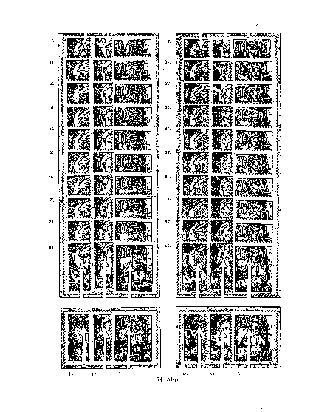

- The head of "9" in year “1945” is dented at the bottom left on the 34th postage stamp (Figure 76).
- “0s” - discontinuous or thinned at the bottom - also occur in "20", on stamps 31, 72, 74 and 97 of the sheet, while on stamp 25, “0" is discontinuous at the top. On stamp 74, “0" is frequently discontinuous also at the top (77. figure).

Figure 75

- The lower part of letter "f" in the currency denomination “fillér" is frequently deficient left-to-right, in diagonal direction, on the 52th postage stamp of the sheet (Figure 78).
- While the above-described deviations derived. from etching errors or erroneously covered graphic parts during retouch, on Stamp 98, a small plate error resulted from the retouching of 100-piece negative, to the left “2” in “20”, below – two small colored spots appeared there (Figure 79). Such occurrence is typical.
- Similarly typical and a more familiar error of the 20- filler plate occurred on the 70th stamp. It derived from the retouching deficiency described in the previous point. A hook (crescent) of the same color as the overprinting, of 1.3 mm, took place in almost horizontal position under letter “r" in word "filler" (Figure 80).

Figure 79
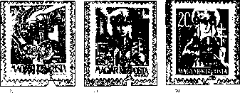
Figure 80

28-fillér Plate
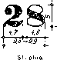

This plate was used for printing 28-filler sheets H on 5-filler sheets.
The overall width of the overprint was 203.5 mm.
The overall height of the overprint was 246.5 mm.
Features '
- “9s” with their lower ending reaching up to their upper part can be found in year “1945”, in the first vertical row, postage stamps 1, 31, 41, 71, and 91 of the sheet and on each postage stamp of the seventh vertical row, except for postage stamp 47 ( Figure 82).
- It appears that copying and etching of the 28-fillér plate was not the most successful because, apart from the aforementioned, in all “9s” of all the postage stamps of the sheet, the lower ending reached up to the upper part, except for eight stamps. These eight pieces are nicely edged, the lower ending well visibly does not reach up to the upper part. This numeral “9” is of a characteristic shape, and is located on the sheets on Stamps 10, 11, 21, 47, 51, 61, 70, and 81 (Figure 83). The evidence of the retouching is the fact that among them there are those postage stamps of the first and seventh vertical rows that are not in (a).
1. 01. . 41. • 71. 01.

17. 2'. 07. 57. 67. 77. 87. 07. .
Figure 82

Figure 83

- Stamp 81, “2” of the face value numeral. 28, on the right, is dented (Figure 84).

- On the 88th postage stamp of the sheet, the “8" of the numeral "28" is too robust (Figure 85).
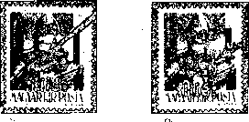
Figure 84
Figure 85

30-fillér Plate
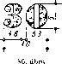

This plate was used for printing sheets 30 f/30 f H, 30 f/30 f M, 30 f/30 N.
The overall width of the overprint was 203.5 mm.
The overall height of the overprint was 246.5 mm.
Features
- “Locked” “9s” in “1945” can be detected on Stamps 1, 11, 41, 61, 71, 81, 91, as well as
17., 27., 47., 57., 77., 87., 97.,45., 75. and 78. (Figure 87a—c). . . .
- On the 18th stamp of the sheet, the upper left corner of “1” and “9” of “1945” are incomplete (Figure 88).
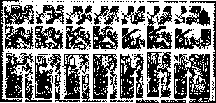
41. 01. 71. SÍ. 91.
87a. ábra
l.
11.

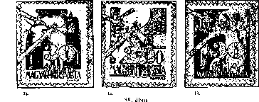
17. 27. 47. 57. 77. 87. 07.
S7b. ábra
45. 75. 7$.
Figure 87

- Stamp 71: “1945”, the shorter part of “1” is rather long, 1mm, and of special shape. This shape is unique among 1700 pieces of “1s” in 17 plates of Athenaeum Printing House. There is some little similarity between the “1” of the forged overprinting produced by movable type (Figure 89).
- There is also a special plate feature on postage stamps 31 and 88 of the sheet - a typical shape of “1”. Instead of the retouched upper part of “1”,. there is only a small pointed tip (Figure 90a, b).
- On the 7th, 15th and 37th postage stamps of the sheet, the bottom part of “9” in “1945” retouched straight (Figure 91).
f) On the 9th and 07th postage stamps of the sheet, the lower lip of the “9” was retouched in a typical way (Figure 92a, b).
g) On the 32th stamp of the sheet, the upper right line of “3” in “30” was discontinuous; the same occurred in the upper point of 24th postage stamp, at the left side (Figure 93).
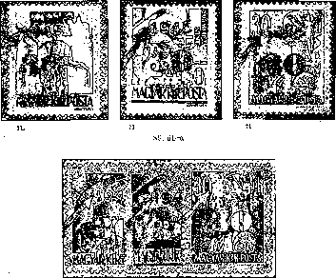
31. 31. - 31.
Figure 90a

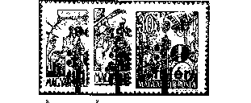
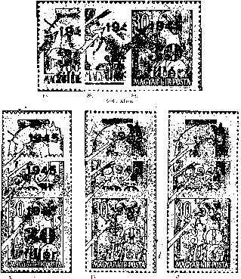
Figure 91
Figure 91a
9

- On the 91st stamp of the sheet, the lower point of “3” in “30” is disconnected; “0” is discontinuous at the top (Figure 94).
- The upper point of “3” is disconnected on postage stamps 92 and 97 (Figure 94).
*
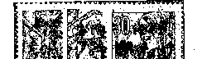

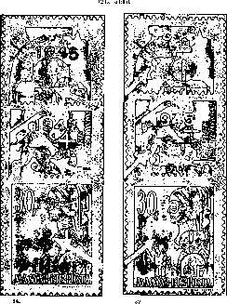
Figure 93

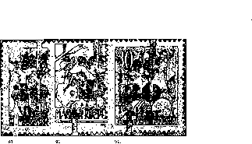

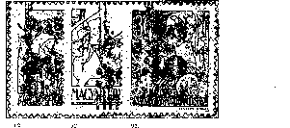

Figure 94

j) On the 37th postage stamp of the sheet, the “0" is discontinuous at the bottom (Figure 95).
k) Finally, the outer curve of the right side of “0” and the point of “r” are retouched straight on sheet 100 (Figure 95).
Figure 95
40-fillér Plate
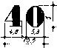
Figure 96

For printing, postage stamp sheets 40 f/24 f H, 40'f/24 f N and postage due postage stamps 40 f/12 f, 40 f/16 f és 46 f/18 f were used.
. The overall width of the overprint was 203.5—204.5 mm.
The overall height of the overprint was 246—247 mm.
Features
- The typical feature of the 40-fillér printing plate is the well-drawn, not blurry “9” of “1945”.
The locked “9s”, which may be called typical for the first and the seventh vertical rows, do not appear here. Moreover, each “9” of the first row may be called typical: thinning vertical line, not locked “9s”.
Similarly, the seventh vertical line is strongly discontinuous.
- This is best seen on the 47th postage stamp (Figure 97).
From these phenomena, we may conclude that the 100-piece negatives, but the initial 10-piece negatives in the first place, of 40-fillér plates were strongly retouched. It is unlikely that second type was produced.
- Relatively slightly locked “9” in 1945 appeared only in postage stamp 99 of the sheet (Figure 98).
Figure 98

- One of the interesting features of 40-fillér plate is the damage of the 7th postage stamp of the sheet. The “4” of the seventh "40" of the plate must have been hit when the platen was fixed with nails, and the digit was flattened, slightly tilted to the right and deformed. Its dimensions have been enlarged. The vertical line of “4” instead of the usual 2 mm
- was 2.4 mm, its height being 5.3-5.4 mm instead of the standard 5 mm, and the total width of numeral "40" was 5 mm instead of 4.8 mm. The dimensions of “0” remained unchanged (Figure 99).
- Another distinctive feature of the plate, which was known also earlier, can be seen on the 44th stamp of the sheet. The vertical, thick line of “4” of numeral "40" was discontinuous in the top right corner. Considering the roundness of the lines, it may be concluded that retouching took place. Since this phenomenon occurs on all sheets, it was probably not the result of later plate damage (Figure 100a).
- On the 78th stamp of the sheet, the horizontal line of “4” no longer touched the vertical thick line (Figure 100b) in subsequent prints.
- Finally, on the 37th, 47th, and 77th postage stamps of the sheet, the “0s” of "40" are discontinuous at the top (Figure 101), and on the 77th postage stamp, the inclined line 4 is incomplete.
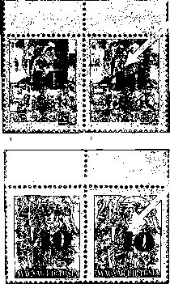
6. 7.
Figure 99

44. 44.
Figure 100а

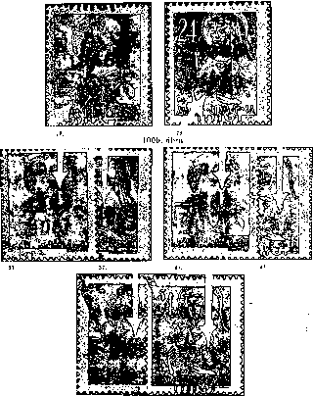
77. 77.7
Figure 101

42-fillér Plate
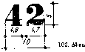

This plate was used for printing 42-filler sheets on 20-filler sheets. The overall width of the overprint was 204.5-205.
The overall height of the overprint was 246 mm.
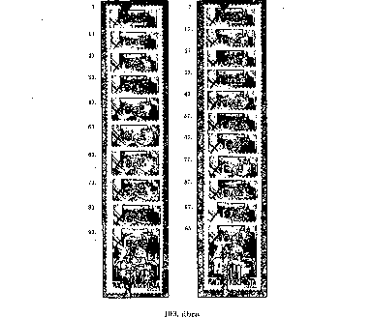

Characteristic Features
- On each stamp of the first and seventh vertical rows of the sheet, we find the typically locked “9s” in “1945”; in addition, the locked 9s can be detected on the 65th postage stamp. The “9s” in the seventh row are less pronouncedly locked. Otherwise, the typical feature of the plate is the nicely implemented digits “9”.
- The number “2” of the value number "42" is often disconnected, mainly on pages 49, 59, 80 and on postage stamp 100 (Figure 104).
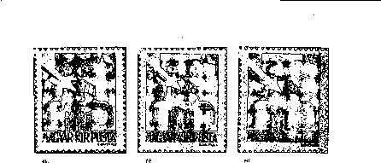
100.
Figure 104

- There is a typical loss of continuity on three stamps of the sheet (10, 79, and 82) on the lower thinning line of “2”, which similarly to the defect mentioned above in b) appeared already on the proof plate (Figure 105).
Ì • ■
50 filléres lemez ,
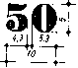
Figure 106

Used for sheets 50 f/50 f H és 50 f/50 f N.
Entire width of the overprint: 203.5—204.5 mm.
Entire hight of the overprint: 247 mm. •
Features
- Locked “9s” appear on each stamp of the first and the seventh vertical row of the sheet, and in many other places of the postage stamps of the sheet. “9” was especially locked on Postage Stamp 73 (Figure 107).
- “5s” of the value numeral "50" are often characterized by continuity shortages, mainly due to insufficient ink supply, so these occurrences can not be considered as typical features. The breakage of the area under the horizontal line of “5” on the 78th stamp is a characteristic feature of the 50-filler plate (Figure 108).
- Very common for this plate is the discontinuity of “0s” in the value numeral, due to the retouching. We can find discontinuity at the bottom of “0s” on postage stamps 26, 36, 46, 56, 66, 72, 75, 82, 83, 85, 92, 93 and 94 of the sheet (Figure 109).

- We can find discontinuity at the top of “0s” on postage stamps 15, 55, and 96. In addition, on postage stamp 55, “0” is somewhat incomplete at the upper left side (Figure 110a-c).
- We can find discontinuity at the bottom and top of “0s” on postage stamps 16 and 86 of the sheet (Figure 111a).
- On the plate of 50 fillér an interesting fault is found on the 22nd stamp. At the bottom of the letter "i" of word "filler", at the bottom, approx. 1 mm long, colored, oblique line departs, as this small error. has not been retouched on the negative (Figure 111b).
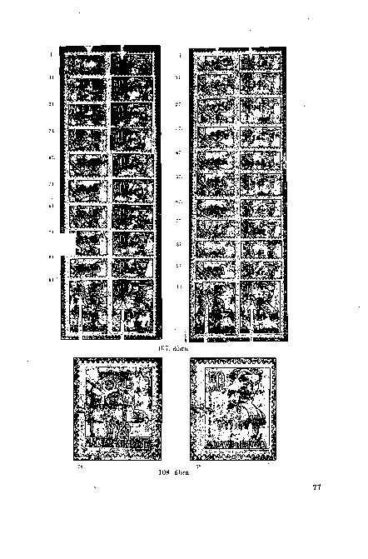

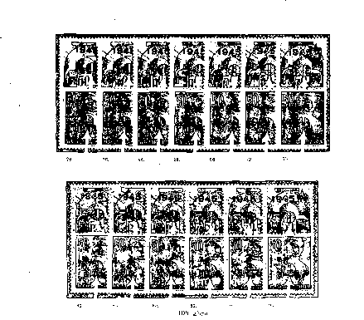
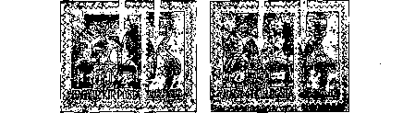
15
90
15
Figure 110a

бэ.
Figure 111a
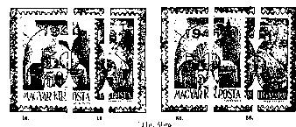
22. ti.
Figure 111b
60-fillér Plate

-t-
Figure 112

This plate was used for printing 60-filler sheets on 8-filler sheets for regular, and for printing 60-filler sheets on 24-filler sheets for postage due postage stamps.
The overall width of the overprint was 203.5-206 mm.
The overall height of the overprint was 246.5-247 mm.
Features
- Locked “9s” in "1945" appear in all values of the vertical row of the sheet, except for postage stamp 41, which was retouched, and on each postage stamp of the seventh vertical row, and on many other postage stamps, but the latter were mainly due to clogging in the course of large-scale prining (Figure 113).
- The thin, connecting lines of the face value "60" very commonly were incompletei due to low-quality ink and insufficient ink supply on the platen. But the wear of the platen is also a major factor here because of the heavy use, as there were over 86,000 sheets printed on the plate. However, there are some postage stamps of the sheet on which discontinuous numerals reappear. We can find “0” discontinuous at the bottom on postage stamps 31,
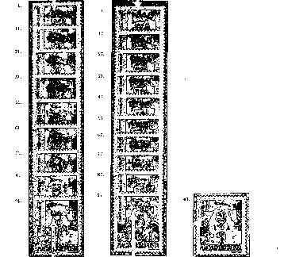
41, 51, 71, 75, 91 and 94 (Figure 114).
- "0" is open at the top on Stamps 95 and 99. bélyegen. On the latter, the dot of the "6" is separate too (Figure 115).

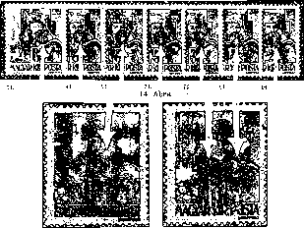
95. 99.
. • Figure 115

80-fillér Plate'
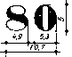
Figure 116

Used for postage due sheets of 80 fillérs, 80-fillér N, and overprints of postage due 80 fillérs on 30-fillér sheets. -
Entire width of the overprint: 204.5-205.5 mm.
Entire hight of the overprint: 246-247 mm.
- "Locked" "9s" in ,,1945” on all stamps of the first and the seventh vertical columns of sheets (Figure 117). .
- On Stamps 15, 20, 25, 31, 57, 63, 64, 67 and 80 of the sheet, the upper circle in “8” is discontinuous at the right side - it does not connect with the thicker part (Figure 118).
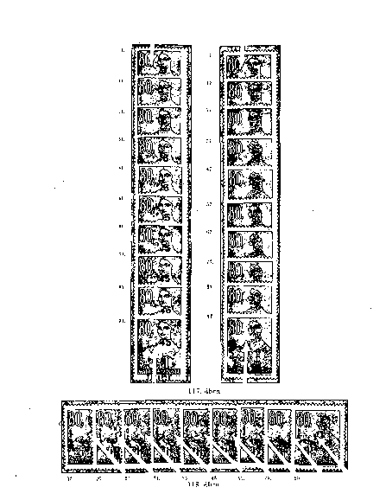

- We can find “0” discontinuous at the top on postage stamps 84 and 85, and often on the 95 (Figure 119).
- We can find “0” discontinuous at the bottom on postage stamps. 16, 75, and 91 (Figure 119).

. In addition to the aforementioned, there are often discontinuous “8s” and “0s” on the sheet, but their occurrence is not related to the errors of the platen, but to the shortages of the ink supply. The interesting thing about the platen is the round points of the letters "i" in word "filler".
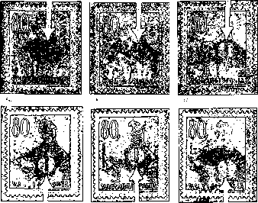

1-kreuzer Plate
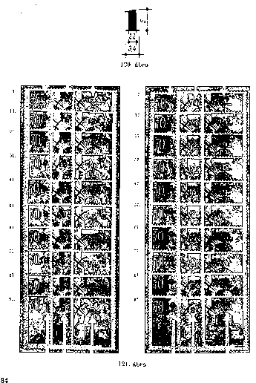

These plates were used to press 1 P / 70 f N, 1 P / 80 f H and 1 P / l P H regular, as well as 1 P / 10 f and 1 P / 40 f postage due postage stamps.
The overall width of the overprint was-206.8-207.3 mm.
The overall height of the overprint was 247-248 mm.
Characteristic Features
- Locked “9s” appear on each stamp of the first and the seventh vertical row of the sheet in “1945”. The “9s” in the seventh row are less pronouncedly locked (Figure 121).
- When producing the 1-kreuzer printing plate, the value number "1" was often retouched, and the etching of the plate was far from perfect either.
The thin lines of the digit, the upper hook and the base line are often missing, so there is no visible impression either. It mostly visible on the 16th, 75th, 76th and 86th postage stamps of the sheet (Figure 122). On top of this, the extremely high number of prints, approximately. 221,000 overprints were produced with this plate, due to which we can encounter this error in many cases, for example, on postage stamps 22, 37, 45, 47, 82 and 93.
- The hook of value number "1" is usually absent due to the abovementioned reasons, on the postage stamps 90, 91, 92, 96, and 100 (Figure 123).
16. 75. ' 76. 86.
Figure 122

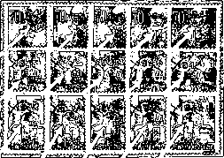
00. 91. 92. 96. ÎOJ.

Figure 123150-fillér Plate
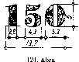

This plate was used for printing 150-filler sheets on 6-filler regular postage stamp sheets.
The overall width of the overprint was 206.5 mm.
The overall height of the overprint was 246.5 mm.
Characteristic Features•
a.) Locked “9s” in “1945” appear in all postage stamps in the first and the seventh vertical rows, the “locked” nature of the “9s” in the seventh row being less pronounced (Figure 125).
h) Typical fault on postage stamp 51. Under “1” of "1945", barely visible for about 1mm horizontal, downward sloping, slender, colored lines may be seen, due to failure to retouch this negative error (Figure 126). . •
Figure 125
- A typical error resulting from etching is the sharp thinning of the vertical line of “1”, from about the middle of this line, in. "1945” of 150-fillér plate, on postage stamp 29 of the sheet (Figure 126).

- Damage of the same origin can be seen on the 48th postage stamp of the sheet, in year "1945". There is also a shortfall at the bottom of figure “9” and in the lower line of digit “5” (Figure 126).
- Likewise, we can detect a double fault due to etching in "1945", also on the 99th stamp of the sheet.
Figure “9” on the inside part of the top and at the left side of digit “4” is slightly deficient (Figure 126).
Figure 126

- In the denomination "150”, in digit “5”, there are two etching faults. Digit “5” at the right side is a little deficient on postage stamp 6, just as the point of “5” on postage stamp 18 (Figure 127).
Figure 128
- Flaws of the thin lines of digit “5” are common on the 31st and 41st postage stamps of the sheet, which results in the point of “5” standing unconnected (Figure 128).
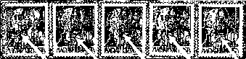
21. 75. . 85. • 90. 95.
Figure 129

- On postage stamps 21, 75, 85, 90 and 95 , however, there is no impression of the thin line starting from the vertical line in digit “5” (Figure 129).
- Of course, this plate does not lack discontinuous “0s” in face value "150". We can find “0” discontinuous at the bottom on postage stamps 6, 81, 84, and 85 (Figure 130).
- We can find discontinuity at the top of “0s” on postage stamp 95, and both at the top and at the bottom on postage stamps 86 and 96 of the sheet (Figure 131).
Figure 131 . "
85
Figure 130.
WWW
Figure 131
2-kreuzer Plate

This plate was used for printing sheets 2 P/2 P H and postage due ones 2 P/20 f, 2 P/50 f, 2 P/60 f.
The overall width of the overprint was 206.5—207.5 mm.
The overall height of the overprint was 248—248.5mm.

Characteristic Features
- Strongly locked “9s” appear on each stamp of the first and the seventh vertical row of the sheet in “1945”. In the seventh row, “9s” are less pronouncedly locked here too (Figure 133).
- On the 92th stamp of the sheet, “9” and “9” of “1945” is poorly etched, and therefore incomplete (Figure 134). .
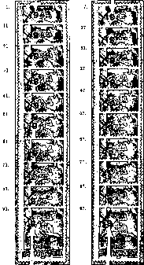

- We often find an interesting version of face value numeral "2" on the 4th and 94st postage stamps of the sheet. The thin line starting from digit “2” normally follows the curve of the circle, in a slightly curving manner. On the two abovementioned stamps, the thin line starting from this point rises almost perpendicularly, then suddenly bending to the right and becoming angular. This difference is likely to result from damage to the platen (Figure 134).
Figure 134

- Incomplete impression of the thin lines of digit “2” is also a common phenomenon here, especially in case of the thin line after the point on postage stamps 1, G, 34, and 83 of the sheet, resulting in the point of the digit standing unconnected (Figure 135 a, b).
- Even more frequently, the lower thin line of the digit is missing, especially on postage stamps 18, 19, 41, 46, 58, 68, 79, 87, 97 and 1Ò0 of the sheet, which is the consequence of poor ink supply to this part of the plate (Figure 136).

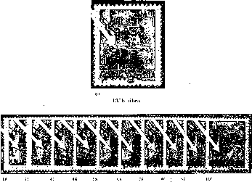
Figure 136

3 -kreuzer Plate
Figure 137

This plate was used for printing 3-kreuzer sheets on 3-filler sheets.
The overall width of the overprint was 200—206.5 mm.
The overall height of the overprint was 246.5—247.5 mm.
Characteristic Features
- Locked “9s” appear on each stamp of the first and the seventh vertical row of the sheet in “1945”, as well as on other postage stamps (Figure 138).
- On the 34h stamp of the sheet, “9” of “1945” is heavily retouched, its end thickened (Figure 139a). .
c)The top of the value number "3" is non-connected on postage stamp 78 and sometimes on 85 of the sheet (Figure 139a).
- The top of the value number "3" is faulty at the right side of the thick line, due to poor etching, on postage stamp 76 (Figure 139b).
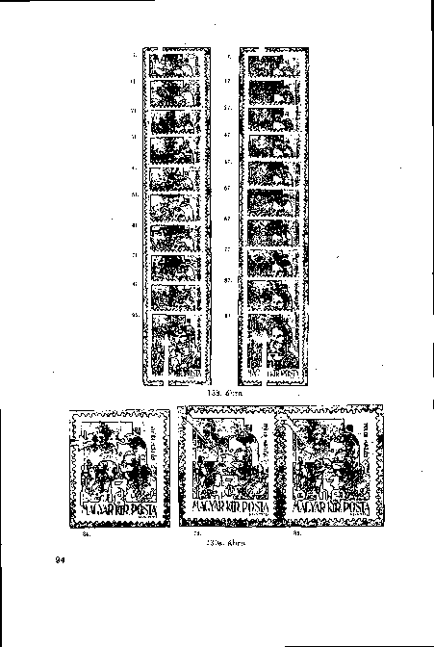

Figure 139b
5-Kreuzer Plate
Figure 140

This plate was used for printing 5-kreuzer sheets on 5-kreuzer H sheets.
The overall width of the overprint was 205—206 mm.
The overall height of the overprint was 246.8—247.2 mm.
Characteristic Features
- Locked “9s” in year “1945” appeared in postage stamps 1, 11, 21,.31, 4L, 61, 81, and 91, and on each postage stamp of the seventh vertical row. It should be noted that the “9s” were slightly locked in the sixth vertical row, while on the postage stamps 51 and 71, “9s” were improved by retouching and thus clearly drawn (Figure 141).
- The vertical line of “1” in year “1945” was. retouched short in the diagonal direction, 2.4-2.5 mm instead of 2.7 mm, on postage stamps 10, 20, 30, and 40 (Figure 142a).

This retouching error probably took place on the negative of the row of ten pieces, because the traces of this error appeared on the other stamps of the tenth vertical row, although not so heavily, but still can be found. On postage stamps 60, 70, 80, 90 and 100, this error was improved to a certain extent on the 100-piece negative, but it still remained shorter at the top.
A small mistake of the same origin can be seen on every postage stamp of the fourth vertical row, where on the first 10-piece strip, the bottom of “9” was retouched to straight in “1945” (Figure 142b).
- The upper left corner of the horizontal line of "5" is missing on the 80, 85, 90 and 95 stamps of the arc (Figure 143).
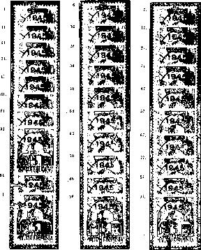
Figure 141
²⁰- ³⁰' . 40. 60. 70. 80. ВО. 100

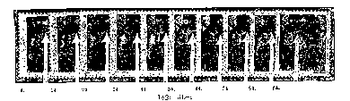

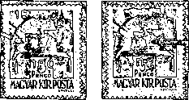
6. 100.
Figure 144

d) There is a slight etching fault in the left-side point of postage stamp 5 of the sheet; on postage stamp 100, the slight etching error appears at the right side of the numeral (Figure 144).
10-Kreuzer Plate
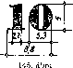

Figure 145
This plate was used for printing 10-kreuzer sheets on 2-filler sheets.
The overall width of the overprint was 205 mm.
The overall height of the overprint was 248-248.5 mm.
It should be noted that the dimensions of value numeral "10" are the same as in Type II of 10-filler plate.

Characteristic Features

- Locked “9s” appear on each stamp of the first and the seventh vertical row of the sheet in “1945” (Figure 146).
- On postage stamp 31, the lower part of vertical line of “1”, diagonally, in "1945" is deficient (less pronouncedly, also on postage stamps 20, 30 and 40); on postage stamp 67, it is deficient in two places on the right side due to poor etching (Figure 147).
- The “1” of face value “10” is discontinuous at the top. This deficiency appears on Stamps 8, 18, 28, 38, 48, and 80 (Figure 148).
- On each stamp of the second line vertical line, the thin left foot line of value "1" is missing (Figure 148).
All deficiencies mentioned in c) and d) are already found in the proof of the strip of 10 pieces. The photos produced from the chalk printing of the 10-piece strip transferred this initial fault to all stamps of the eighth and the second vertical row of the 100-piece sheet. But while on the 100-piece negative this fault was not repaired by retouching in the second vertical row, this deficiency was abolished on the 68th, 78th, 88th, and 98th postage stamps of the eighth vertical line.
Since these two variants are typical of the 10-kreuzer plate, the separation of these from the regular value numeral “1” seems necessary, even more so in order to make easier the detection of counterfeits.
Accordingly, the 10-kreuzer plate (Type II, “10”) has two subtypes:
- TypeRegular shape “1”, with hook, bottom with full foot line
Subtype IIa: Digit “1” without a hook above
Subtype IIb: Digit “1” without the bottom line (Figure 149).
- A fault resulting from etching in face numeral "10" can be found on postage stamp 15, where the upper left outer side of “0” is discontinuous (Figure 150).
- Finally, we find the discontinuous “0” in the value numeral on postage stamps 77, 78, and 81 of the sheet (Figure 150).

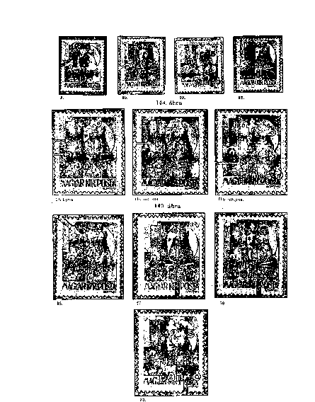
VERSIONS OF OVERPRINTING
COLOR VERSIONS OF OVERPRINTING
Postage stamps overprinted with black color do not deserve particular attention when examining color variations of overprinting. The black ink used for overprinting is relatively homogeneous. The stamps, when held askew towards a light source, are slightly glossy. We can come across deep black, non-glossy pieces as well, but do not have them mistaken for the overprinted black prints soaked in water.
The red color of the overprinting presents a very wide color range in case of some face values and denominations, those whose number of printed copies reached millions. Color variations are due to the use of different quality of ink and solvents, the frequent mixing of the ink without any manufacturing prescription, the fluctuation of temperature and the humidity in the machine room, the speed of the drying of the ink, the color tones under varying illumination at different times of day, and ultimately the decisive factor was also the variety of base colors blue and yellow. Yet another factor was the color variations of the base stamps printed at different times.
The proper color scale of the postage stamps with red overprinting was a frequentyl discussed topic of the earlier philatelic resesheet. Generally speaking, resesheeters mainly stood for the distinction between three main colors, namely the carmine, lilac carp and cinnamon. Due to two decades of analytical work and the rather neglected by the earlier opinions two important factors, namely the consideration of the base stamps and the base color variations, have resulted in the red overprinting being divided into two main color groups.
The carmine color ranges from reddish violet through dark carmine to brownish carmine. With this color, all postage stamps of the series, namely 19 ones, were overprinted.
Cinnamon, which can range up to dark orange. It should not be confused with the brick red color that Athenaeum did not use.
Stamps with cinch red overprinting are known to be 10 f / 4 f H, 40 f / 24 f H, 42 f / 20 f H, 50 f / 50 H, 60 f / 8 f H, 1 P / 80 f H, 1 P / PH, 150 & lt; / RTI & gt; f / 6 fH, 2P / 2PH and 3P / 3fH
If we examine the occurrences of the red color variants within the individual values in relation to the number of copies, we can see that our assumption that individual denominations were not printed at the same time, but only in a certain amounts corresponding to the instantaneous need is justified. The remaining sheets were later overprinted in other shades, and were issued continuously, ready for sale upon demand. Therefore, it is possible that the number of color variations is greater in face values and denominations printed in large numbers, while the face values and denominations printed in small numbers do not have color variations or have just few of them, as for example 150 f / 6 fH.
Shifted Overprints
If ta postage stamp to be overprinted was incorrectly placed and fixed on the platen, and slipped in one of the directions (which occurred frequently during rapid work), the overprinting appeared on the postage stamp in an irregular manner, somewhat sloping in one direction.
In this edition, the shifting to the upper or lower edges of the sheet, sliding to the right or to the left, shifting diagonally, i.e., obliquely printed overprinting are common.
These instances of shifted overprinting may be partial or complete, depending on whether a part of the overprint is missing or replaced on the stamp, or the slippage is so large that entire postage stamps on the sheet remained without overprinting.
Of the partial overprint shifts, those are of philatelic interest where at least one out of the. three lines of the overprint appear on the sheet, and consequently, on the postage stamps.
Figure 161

The text of the overprint was slid one line up. In the first nine horizontal lines, each postage stamp (1 to 90) reads "1945 - 10 - fill" instead of "10 - filler - 1945 ", while the letters of the last horizontal line are “10 - filler" (Figure 151).
When a letter slides down one line, the text of the stamps is changed as follows. The postage stamps of the upper horizontal row (1 to 10) read "1945-10", while all other postage stamps (11 to 100) of the sheet read "filler - 1945 - 10" (Figure 152). Such slippage is known for all stamps of the series.
In the case of a minor slip, the stamps have four lines, but the words in the lower and the upper lines are incomplete (Figure 153).
On the sheets of 1 P / 80 f, there should be two overprinted lines. Their shift downwards must have occurred on other denominations with similar overprinting too. But out of these versions, only the postage stamps containing the lower (in case of shifting upwards) and the upper (in case of shifting downwards) text lines are interesting for philatelists, since the rest of the postage stamps of the sheet are identical to the overprints with faulty text described above (Figure 154).
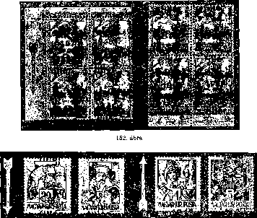
Figure 154

Smaller or larger shifts to the left or to the right may occur on the overprinted postage stamps, but for philatelists, only those with at least 50 percent shifted overprinting are of interest, because instances of smaller shifting are very common (Figure 155).
The sheets fixed in inclined position received oblique overprinting. The deviations from the horizontal of 15 degrees are very common, and do not deserve much interest.
The greater the deviation is, the more of our attention will it deserve.
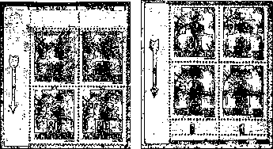
Figure 154

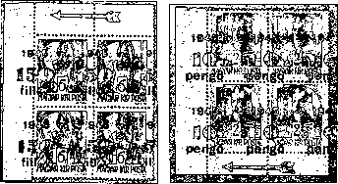
Figure 155

Flaws of Overprinting
While partial overprint slippage is very common in this edition, the rarer and the more serious the slippage is, the larger its philatelic value. Such are the overprint shifts due which the overprinting is missing from the whole postage stamp image, naturally in pairs or blocks with normally overprinted stamps.
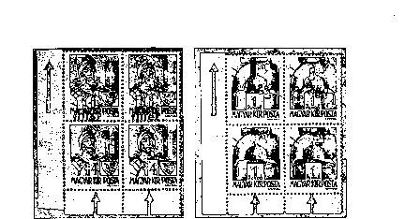
Due to the slippage of the overprint upwards, the last horizontal line (91-100) of the overprinted sheet was not overprinted on sheets of 10 f / 4 f H and 1 P / l P H as shown in Figure 156. Similar incidence is not excluded for any other denomination.
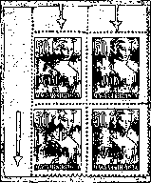
Figure 156
Due to the slippage of the overprint downwards, the first horizontal line (1 - 10) of the overprinted sheet was not overprinted on sheets of 5 f / 50 f H as shown in Figure 156. Similar occurrence is mentioned by dr. Buzássy in 3 P / 3 P H denomination.
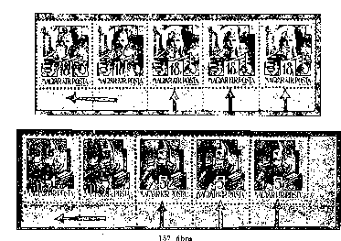

There is a shortage of three overprinting imprints in Figure 157 on postage stamps 20 f / 18 f H and 28 f / 5 H of the sheet, which was the result of a great slippage to the left, so the postage stamps of the vertical rows 8, 9, and 10 were overprinted. The stamps shown in Figure 157 are owned by the Stamp Museum. They entered the collection as printing rejects.
There is also a lack of overprinting on the left, as mentioned also by dr. Buzássy in connection to the postage stamp 10 f / 4 f H, which is the result of the entire overprinting being shifted to the right.
The inclined overprints of up to 15-40 degrees created a wide scale of the instances of lacking overprints either partially or fully, as. discussed above. As can be seen in Figure 158, due to the inclined overprinting, on top of the instances of missing overprinting, other "special features” may be separated, with the help of the sheet portions which were not overprinted. Providing details on these seems unnecessary.
We would like to note that such defective “reject" sheets could only be marketed exceptionally, as they were rejected in the course of the quality check of the Printing House and the Post Office. The Stamps Museum kept 12 different denominations for study purposes. Slanting overprints are usually left-to-right and downward.
The full or partial lack of the overprint discussed so far arose from the sheets being adjusted to the printing platen in faulty manner.
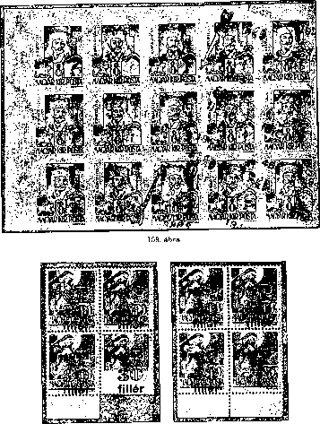
Figure 169
ЮТ

Other instances of partial or total lack of the overprinting are also remarkable and bear significant philatelic value. But before discussing them in detail, let us recall a piece of information mentioned at the beginning of the discussion of this edition: in addition to the stock of the Postage Stamp Warehouse, the postage stamp stocks of emptied post offices returned were also overprinted. Although overprinting in this case took place only over entire sheets, it is not difficult to imagine what the condition of the quickly packed sheets returned from post offices to the Postage Stamp Warehouse were. Part of the postage stamps torn along perforation, while the sheet edges were damaged too. During printing, when placing the sheets on the printing plate, these errors could not be always noticed, and, when the plate was pressed upon, some torn off or folded sheet parts resulted in pressure errors. Some of these sheets, after printing, picked up their original form, and thus were overseen by the control. This could be the reason why the 30 f / 30 f M denomination shown in Figure 159 could also be marketed. Here, the folded over the edge covered the postage stamp face, so it was this edge upon which value. "30" of the word "fillér" was printed upon, while the stamp was only labelled with the year "1945".
On the sheet of the denomination 30 f / 30 H, on the postage stamps 6, 7, 8, overprinting is partially missing as the upper edge of the sheet covered these three postage stamps (Figure 160).
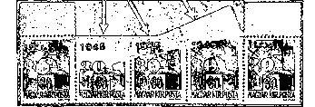

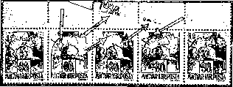
Figure 160

A very interesting feature is shown in Figure 161, which was generated during overprinting of one of the 1 P / 80 f H denominations. The perforation of the stamp tore at the top, between postage stamps on 7 and 16 and 17.
As a consequence, the 5th, 6th and 16th completely folded over and covered stamps 3, 4, and 13, 14. So the latter four postage stamps did not get overprinted.
The overprinting was printed upon the rear side of postage stamps 5, 6 and 16.
Similar irregular printing appeared on sheets 60 f / 8 f H, 2 P / 2 P H, which for the same reason were overprinted partially or not at all, or got overprinted at the rear side.

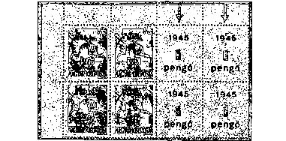

Figure 156

The missing overprint shown in Figure 161a was generated by the creasing of the sheet.
There is also known such 30 f / 30 f M postage stamp sheet where one of the horizontal lines was partially overprinted because of the sheet edge fallen on it, one its vertical row remaining without overprinting, or partially overprinted.
®Va‘ . •
In addition to the cases presented and listed, similar occurrences can be found in other denominations.
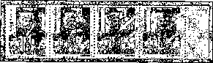
Figure 162

A partial or entire lack of the overprint was rarely due to incomplete ink supply, when some of the postage stamps were only slightly overprinted because the rubber roller transferring the ink on the postage stamp completely missed its turn. This is presented in Figure 162.
As a warning, “faulty imprint” at the Stamp Museum should be presented. It is a full sheet of 50 f / 50 f N, with each even vertical row overprinted, while odd vertical rows covered with paper strips were not overprinted.
Due to the vigilance of the postal inspection, this apparent "specialty" did not enter the postage stamp market, and thus could not start its philatelic career.
The biggest interest for the erroneous prints in this edition was paid to the inverted imprints (Figure 163). As it is known, reverse overprints are generated when the postage stamp sheet is adjusted to the printing plate in the inverted position.
It is a controversial, and yet not completely closed problem deciding of which denomination “true" inverted overprints were produced. The results of our several-direction resesheet is summarized below.
So far, there are some real inverted overprinted postage stamp sheets: 10f/4f H, 10f/12f H, 20 f/1/ H, 20 f/ 18 f H, 28 f/5 f H, 30 f/ 30 f N, 40 f/24 f H, 40f/24f N 42/20 f H, 50 f/50 f H, 60fl/8f H, lP/80f H, lP/lPH, 2P/2P H, 3P/3f H, 5 P/5P H, and 10 P/2 f H.
The listed 2 P / 2 P H and 5 P / 5 P H inverted overprints of entire sheets are those in the possession of the Stamp Museum, which have not been known so far.
There occurred doubtful reverse overprints of 20 f / 20 f N, 30 f / 30 f H and 30 f / 30 f M stamps.
So far unknown denominations with inverted overprinting: 10 f / 10 f H, 50 f / 50 f N, 80 f / 80 f N, 1 P / 70 f N 150 f / G f H, although their existence cannot be excluded.
It must be noted that producing inverted overprint stamps did not always take place by accident. Among them, there are a number of deliberately created inverted overprints that were diverted to collectors’ circulation. Since these sheets were also made with an original clichés and in a relatively small number, their distinction from the real inverted overprints cannot be made, so they are still considered as rarities in demand of this edition.
For postal sales, denominations 10 f / 4 f H and 30 f / 30 f N were destined. However, philatelists did not overlook them - some of them were collected by collectors after they had been used for postal clearance.
Repeated Overprints
If a stamp sheet or a part of it received faint overprint due to the insufficient ink supply or the weakness and drying of the ink, the overprinting of the sheet was repeated. If the prints did not coincide, double and seldom triple overprints were created. However, duplicate or multiple prints may have arisen due to technical faults or due to the operator's inattention. These defective prints have been rejected by the quality control team. Nevertheless, these postage stamps were sometimes placed on the market.
Most well-known duplicate overprints are those of 20 f / 1 f H, 30 f / 30 f 1ST, 50 f / 501 f H, 60 f / 8 f H, 80 f / 80 f N and 1 P / 70 f N denominations. Some of these are shown in Figure 164, just as the triple overprint of 42 f / 20 fH, which did not enter the market.
This group also includes double prints, which were already introduced in the section devoted to series “1945. Liberation” (Figure 165).
«jq? '£9i
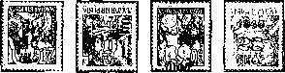

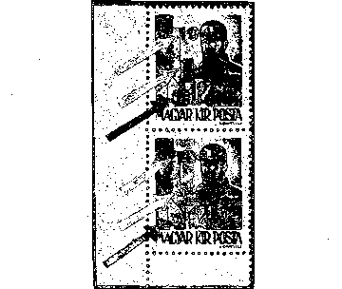
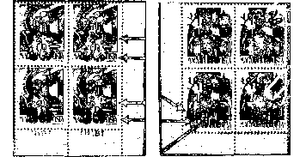
1G4-. ábra
Monograph of Hungarian Stamps V
101

On the rear side, the image of the weaker or stronger prints is rarely directly derived from the cliché. Since the overprint, however, independently from how it derived - for some reason - appears on the rear side of the stamp, these occurrences have to be summarized here.
1. We have already dealt with the overprint gaps when discussing the gaps of the overprinting, of which the former is an integral part. We could see that authentically only those postage stamps could be overprinted on their rear side which covered other postage stamps upon overprinting, positioned in irregular way (Figure 161).
There is no notion of any sheets overprinted only at their rear side or on both sides. Most probably, such sheets were not produced.
While the postage stamps of this group the image appears on the rear side in regular position, on the variants listed below it appears on the rear side as reverse reflection of the overprint.
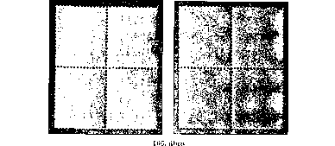

Strong Impressions Heavily protruding impressions on the rear side of the postage stamps turn up in all denominations. These protruding prints are colorless (Figure 166, on the left). They are explained by the intaglio printing of the printing press. The size of the protrusion can reach the height of 0.2 mm.
Especially in the case of strong pressure, weak partial or full discoloration of the color of the overprint may be found on the rear side. This phenomenon can be found in all editions, and it is a variant of the present edition too, appearing in all denominations, although it is much less common for black overprint stamps (Figure 166, right-side image). Its origins are discussed in detail in our first volume. (pagers 316-320).
Partial or full color transfers by sheets (pulling down) is also frequent, especially in red overprints (Figure 167).
The most favored rear-side print of the collectors is the strong impression of the color transfer by the machine (Figure 168).
Volume I also deals in detail with how the color transfers by equipment originated and their grouping (Pages 316—317).
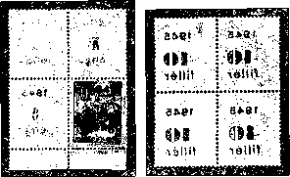
Figure 167 Figure 168

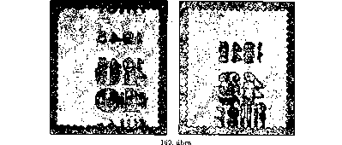

The color transfers by equipment are very common in red overprints, in all values. By contrast, the color transfers by equipment of black overprints are rarer and must not be confused with color transfers by sheets.
The variants listed under points 1 to 5 are in the form of occur as both full and partial prints. In addition, combinations of variants are also known. This is illustrated in Figure 169, as double rear-side overprints.
Other irregularities of the overprinting
and many other features are also known of the overprints produced in the Athenaeum Printing House. The first of these is the texts composed of thinner and thicker numbers, which originated from the uneven ink supply, the phenomenon often found within one the same sheet. In Figure 170, the letters of word "fillér" of the left side of the postage stamp sheet are of normal thickness whereas those of the right side are considerably thinner, due to the above-described reasons. Knowing this is important so as not to make a false finding that there were several printing plates with thicker or thinner letters.
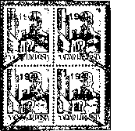
Figure 170

A rarely occurring specialty is shown in Figure 171 on the left side, on denomination 50f / 50f H, which, due to its character, can only occur on overprinted postage stamps. When the finished gummed sheets are stored, and then stick together because of some moisture, they sometimes were violently separated, prior to overprinting. In such cases, a portion of the image sticking to the back of the sheet over it was torn off too. . If such a damaged sheet was not rejected, the overprint became visible also on the empty area from which the image had been torn off. Such postage stamp, partially without the image but overprinted, postmarked and used, is presented here, as two postage stamps of a four-piece block.
Due to poorly diluted ink or insufficient ink supply, color overprints may display smaller or larger deficiencies, white spots, or strips, such as, for example, in value number "20" of the right stamp in Figure 171. Since these variants do not come from the characteristics of the platen, they are not typical occurrences – thus, we did not mention them when discussing the printing plate.
If the cliché was not washed at proper intervals, and, consequently, it was not cleaned from the excess of the ink or other dirt, this ink or dirt was deposited in the deeper parts of the plate, stacked and transferred to the sheet in the form of colorful, irregular patches. These non-required impressions may have been occasional occurrences, such as the patches shown in Figure 172 in the upper left image, but in the event of drying on the plate, they may have also appeared as permanent impressions, as. in the lower two blocks (30 f / 30 f M).
Figure 171

In this group, the blurred overprinting on the 10th postage stamps of the sheets deserve to be specially mentioned. The operators lifted the still wet sheets gripping them on the top right corner, pulling them off, and placing them on top of each other. The traces of this appear on the postage stamp shown in Figure 172, in the upper right corner.
Among stamps which were soaked off, we often find very light, opaque, red overprinted pieces. Again, we must emphasize that we use only the unused or uncoated postage stamps for the comparison and processing of the colors of the prints. The overprint color of the edition is very sensitive to water, especially the red color.
Watermark The postage stamps had watermark “X”, so the watermark positions matched the watermarks of the base postage stamps, namely they were A / 1, 2. Determining the watermark position is very difficult due to the base coloration and the overprint. It is not advisable to soak the postage stamps in petrol for long periods.
Perforation The perforation of the postage stamps, of course, is the same as that of the basic stamps, with their 15 teeth, comb perforation. However, we should mention the often recurring 42 f / 10 fH, which lacked perforation. However, the pieces presented so far did not originate from a sheet without perforation at the bottom, but were only such pieces which were the perforation equipment slipped, as in case of the piece shown in Figure 173, the bottom teeth of which were often removed.
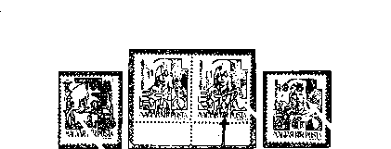

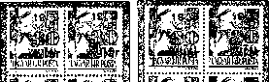

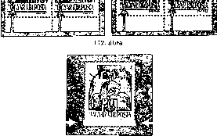
Figure 173

Covering of Postage
The covering of postage by the postage stamps of this series will be discussed comprehensively at the end of the discussing of the inflation editions/issues. It must be noted, however, that the 10 P / 2 f was not sold by the post, so it could hardly be used by the collectors or the public to pay for postage. Real run mail with this postage stamp is not known. Postmarked copies in collectors’ circulation were retrospectively postmarked as a favor.
Proofs In this edition, 12 sheets were overprinted as proofs with 2 and 10 pengő value.
The color of overprinting was violet on 2 P / 2 f H, 2 P / 5 f Л, 2 Є / 30, 2 P / 30 f M, 2 P / 30 f N, 2 P / 70 f N denominations, and black on 10 P / 2 f H, 10 P / 5 H, 10 P / 30 f H Î 0 P / 30 f M, 10 P / 30 f N, 10 P / 70 f N denominations. These proofs are in the custody of the Stamp Museum. In Figure 174, the proofs of 10 are presented, namely the 81st stamp of the complete sheets, with "0" discontinuous at the bottom.
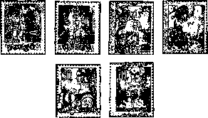
Figure 174

Forgeries
The 10 P / 2 f H denomination and its reverse overprint values of "1945 Kisegítő" (Ancillary) postage stamp series which were not sold, especially the 20 fillers, tempted forgers to accommodate to collectors’ demands.
Recognizing forgeries, as we will see, is not a difficult task for those who have come to know and master the printing techniques and the variants of the present edition.
The forgeries of this edition can be divided into two main groups.
1 The first group consists of forgeries produced with dies from rubber, whose base printing and overprinting are so primitive that their distinction is not difficult for collectors with the average knowledge. (Figure 175).
2 Another feature of these forgeries is that the postage stamps were overprinted one by one. Their base impression was also falsified, and their color can be clearly distinguished from the real one by only looking at them. Their base color is uneven, spotted. In the first group of counterfeits, mainly the 10 P / 2 and H regular and reverse position prints are known.
Identifying counterfeits of the second group is a difficult task since they were printed in a printing house. Their identification, however, does not cause any difficulty after comparing them to the original, on the basis of the following considerations.
- The base coloration of the second group of counterfeits is real. However, according to our findings, the sheets colored in the Athenaeum Printing House and in the State Printing House were overprinted. There was no particular obstacle to this, because on the postage stamp market there were a lot of stamps that had been stolen from both printing houses. with only base print.

The distinction between the two color prints produced in different printing houses is often a difficult task, especially in case of individual postage stamps and without a quilt lamp.
- It is a much more helpful tool to detect counterfeits by thoroughly examining the overprint.
The most important thing is to recognize the difference that while true prints were made with plates (clichés) as described in the description of how printing plates were produced, the false prints were printed from type.
The difference between the two prints is shown in Figures 59 and 60, and the important differences in the prints have already been formulated. But in addition, there are still many features that are essential and need to be described.
Look up Figures 179, 180, and 181, which show the numerals and letters magnified tenfold for study purposes and presented together to facilitate comparison - this is the reason why they were not presented in their relevant sections.
Their distinctive analysis is performed in four parts.
- The difference between the digits of the year "1945"
- 7 Difference between the digits of the value numbers
- Difference between the letters of the denomination
- Color differences among overprints
A. Examination of the numerals of the year "1945"
1 Looking at the top and bottom inscriptions of the year "1945" in Figure 179, we can first see the difference in the overall width. The year "1945” of the Athenaeum Printing House is 9.4-9.5 mm, while counterfeits are 9.8 mm wide.
2 The most distinctive and thus the most explicit difference between the two is numeral “1” in. “1945”. The Athenaeum Printing House's “1” has a characteristic slanting part, slightly bullet-shaped and up to 0.4 mm, as appeared from the study of the various plates, while on the forgery it is 0.6 mm, stretching out longer, and being of a different shape. As can be seen in Figure 176, two types of forged numerals “1” have so far been known.
In Type I, the shorter part ends with a vertical straight line, while the Type II the end of the hook is perpendicular to its two sides.
Figure 176
The left side of the horizontal line of “4” is rounded at the Athenaeum type (3) while the counterfeit (2) is square.
3 The same is true, though to a lesser degree, for the tips (4) of Athenaeum Printing House and (3) of the counterfeit.
4 The horizontal line of “5” in the Athenaeum type (6) is tapered towards the end while the counterfeit (4) is nearly flat, 0.6mm wide or slightly widening towards the end.
In general, the counterfeit digits are uniform, the digits are well bordered and the width everywhere is 0.6 mm. By contrast, the Athenaeum Printing House digits are slightly darker on the edges, bordered by irregular lines, so their width varies between 0.6 and 0.7 mm.
Since the year "1945" is there in the overprint of each denomination, its profound knowledge is very important!
В. As for evaluating value numbers, only numbers “1” and “2” will be analyzed, as these two value numbers are most commonly found on counterfeits. Most counterfeits have come up in non-sold regular 10 P / 2 f H and postage due postage stamps of 20 f / 6 f. The most frequent of them are the counterfeits of the inverse overprint of 20 fillérs, both regular and postage due 20 f / 8 f.

Characteristic Features of “1”
1. Please check Figure 180. The first difference in the value number “1” is again in the width of the overprint. The vertical line of the “1” of the Athenaeum Printing House 2.2 mm, while on the forgeries it is smaller, only 2 mm.
2 The second difference is in foot line of “1”. While the footprints of the “1” of the Athenaeum press are tapering towards the end (1) or are very thin, poorly printed, and often even absent, the counterparts of the counterfeiters (1) are strongly and decisively visible in both types (1) - they are 0.3 mm thick.
3 The hook of the Athenaeum type (2) is also indefinite, irregular and is often missing. In the case of counterfeits, the short line is always there, its tip pointed as in Type I or blunt as in Type II. The two types may turn up also within a sheet, because exactly identical numbers were not available for the counterfeit.
4 The above mentioned information applies, mutatis mutandis, to the upper corners of digit “1” too (3). In the digit of the Athenaeum Printing House (3) the corners are rounded, while in Type I of the counterfeits they are pointed (3) or in Type II slightly blunt (3).

Characteristic Features of “2”
1 In Figure 183, the slimness of the forged “2”, due to the size difference, is the most striking. This is also verified by measurements. Its overall width is 4.3 mm, instead of 4.7, and its upper line width is 1.7 mm instead of 2-2.2 mm.
2 The most characteristic and distinct differences can be found at the lower end of the vertical line. The lower end (2) of the “2” of the Athenaeum Printing House (1) is widened, while that of the counterfeit (1) is thinned.
3 It is easy to see even with the naked eye. that the line of the “2” of the Athenaeum Printing House (2) starts from the point steeper and rises in a more curving arc, while in the counterfeits it is flatter and slightly inclined to the right (2).
4 The “0s” of the two-digit value numbers of counterfeits are smaller. Their width is 5 mm, compared to the size of the 5.3 mm used by Athenaeum Printing House. This applies to the other two-digit numbers ending with “0”.
C) The fonts provide even greater help in revealing counterfeits. This finding applies in particular to the "filler" values (Figure 181).
1 The size difference in the overall width of the "filler" is very small, only a few tenths of millimeters. However, when examining with a naked eye, the slimness of the letters of forgeries is striking. The difference is only 0,1 mm (0,0 mm instead of 0,7 mm) but at the same time the distance between the letter "i" and "1" is 0,1 mm, i.e. 0.8 mm instead of 0.7 mm.
2 The typical feature is the horizontal line of “f” of the forged overprints, even though its full length is equal to or just 0.1 mm smaller than the letter of the Athenaeum Printing House. (2) Its shape is 0.5 mm high, a regular rectangle, unlike the one of the Athenaeum Printing House, which is of an irregular, bushy shape with a height of 0.7 mm. The most striking is the difference between the right side of the horizontal line, which is a rectangle stretching out 0.5 mm at the height of the letter “i”.
3 On the forgeries, the dot over the letter "i" (2) is always a regular rectangle, while on the prints of the Athenaeum Printing House it is either circular or irregular, but is always rounded (4).

4 The accent of letter "é" is a triangle on the counterfeit (3), while it is irregular rectangular, trapezoidal on the real overprint (5).
In fact, the letters of the Athenaeum Printing House are bordered by irregular lines and are darker on the edges. The letters of the forgeries are bordered with straight and well-drawn curve lines.
The characteristic features of pengő denominations are the same as those of the fillér ones, with the addition that the accents of letters “ő" are distant irregular rectangles touching the circle of the letters on the counterfeits, while on the real ones, the two accents are often irregular in shape and sometimes in the form of "o".
D) Finally, a few words about the color of fake overprints. The red color of the forged overprints is reddish violet, but under the umbrella lamp, the reddish violet of the Athenaeum Printing House prints can be well distinguished as the composition of the two inks is different.
The black color of the overprint can not serve as a basis for distinction because this color is insensitive to the quartz lamp. But in this case it is not necessary. Black overprints are more pronounced and provide a great opportunity to distinguish numerals and letters.
Figure 177
We would not have provided full description of the counterfeits if we did not mention some of the good 10 P / 2 f H denominations, some of which were so successful as to mislead the public opinion and pass for real, and which today are highly appreciated by collectors.
In Figure 177, in the middle, there is a real reverse, at the left side - a vertically arranged and on the right - a forgery with reverse overprint.
The falsified overprints of the "1945 I. Kisegítő" (auxiliary) postage stamp series was mainly marketed in the 1945-48s as counterfeits to the postage stamp collectors. The use of these counterfeits for payment of the mail or other falsification to the detriment of the post is not known until this time.
1945 AUXILIARY POSTAGE STAMPS I/B
(Overprint by the State Printing House)
Since there was serial abuse in Athenaeum Printing House, which had a strong echo among philatelists, the semi-finished (just with the base color) and unprinted postal stamps were transferred to the State Printing House for further overprinting.
Here, preparations had already been made for the overprinting of the denominations required for the next tariff increase on 2/7/1945. Since the new denominations included the 80-fillér and 1-kreuzer values, the 70 f N and 80 f N postage stamps, which were already the base impression, were first used for work and were issued and delivered for mailing with the same color overprinting.
Stamp collectors soon discovered the difference in digits and fonts of the overprints as compared to the former ones. Nonetheless, and since the Post Office did not regard these postage stamps as separate issues, subsequent resesheet and catalogues failed to make their definite separation. Therefore, most of the stamp collectors, not knowing these stamps, did not include them in their collections.
We now want to fill this gap with a detailed description of the difference between the two prints.

Number of Copies
Face Values of the Series
Figure 178
Color of Base Impression
Data on copies of the State Printing House data is not available because these denominations were handled together with Athenaeum Printing House overprinted stamps. Thus, the number of copies is included in the number of 80 f / 80 f N, which was 1 560 400 and. of 1 P / 70, which was 1 595 500 pieces. Experience has shown so far that. in the State Printing House less of 80 f / 80 f N denominations, and more of 1 P / 70 fN denominations were produced than in Athenaeum Printing House.
80-filler sheets on 80-filler N sheets: yellow, red
1-kreuzer sheets on 70-filler sheets: blue, black

Producing Overprints
The overprint of the two values was also carried out in the State Printing House in two rounds.
1 Base printing was yellow or blue.
2 Overprint: red or black
1 The base print was made on a high-speed fast press. Two different plates were used for the base pressure. Type I produced prints of 218 - 218.5X261 mm, while Type II 221x261 mm, which was determined as an average of many measurements. Most of the base prints were made with Type I plate, ie 218 - 218.5x261 mm, and this was also the case in case of this edition.
On top of the dimensions, the further characteristics of the printing presses of the State Printing House was the regular lines bordering the impression; the fixing nail impressions, so typical for the Athenaeum Printing House prints are missing on these prints. Hence, reverse printouts can not be identified.
Due to the pressure on the high-speed equipment, the base impressions are evenly colored. The marble-like lines disappeared from the base impression, just as the partial lack of impression. Exceptional printing is also noticeable at base impressions. The colors are strong, and the color variations of the base impressions are very rare and hardly noticeable.
Compared to a large number of versions of the Athenaeum Printing House, here only slight shifts on the base impression can be noticable. Since sheets with base impression produced at Athenaeum Printing House were also overprinted, there may be sheets and postage stamps with base impression produced at the Athenaeum Printing House but overprinted in the State Printing House.
Instances with only base impression but without overprinting were made in the 1st round, and entered collections illegally.
2 The overprint was made in the second round from 100-piece type at a high-speed fast press. State Printing House had a large amount of high quality fonts and could therefore undertake printing using type in the second run. The letters and digits are beautiful, almost free of defects. Smaller typographical errors still exist, mainly due to depression and subsequent pressure.

Examination of The Digits And Letters of State Printing House
The denominations of 80 f / 80 f N and 1 P / 70 f N of “1945. I/B Kisegítő” (Auxiliary) produced in the State Printing House may be distinguished from those produced in Athenaeum Printing House Series. on the basis of the digits and fonts used for printing, apart from the applied printing techniques. The most convenient way to do this is to make a detailed comparison of the two subtypes. That is why we have put together the same inscriptions on Figure.

Characteristic feature of the digits of the year "1945"
- I / Athenacmn Press overprints
- The shorter part of “1” is robust, with irregular lines, and has a very varied design. Its average width is 0.4 mm.
- The lower, curved part of “9” is rounded.
- The endings of “4” are irregularly rounded.
- The curve tip of “5” is rounded.
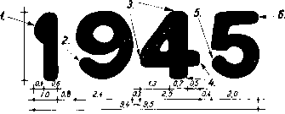
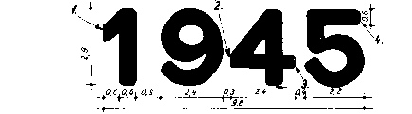
2,8~2,$
Athenaeum Printing House
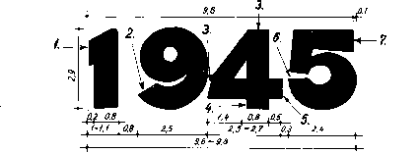
State Printing House
Forgery
Figure 179

- The horizontal part of “5” is thinning towards the end, and finishes in a curve.
In general, the digits are thin (0.6 to 0.7 mm), bordered by irregular lines, and as we have seen in the description of the platens, there is a wide range of numeral types. The overall width of the overprint was 9.5 mm, while its height 2.8 - 2.9 mm.
Figure 179

Overprint Of The State Printing House I/B
1 The shorter part of “1” ends in a vertical straight line. The upper left corner is properly rounded. The overall width of “1” varies between 1 and 1.1 mm.
The curve of “9” ends in a straight line.
3, 4, 5 “4” is constructed from geometric planes bounded by lines, and the lower end. of its vertical line (4) and its horizontal line (5) are regular rectangles. The overall width of the overprint was 2.5-2.7. mm.
6 The curve of “5” ends in a horizontal line, and is at the height of the upper edge of the horizontal line of “4”.
7 The horizontal line of “5” ends in a widening vertical line, quadrangle with straight irregular lines.
Usually, the numbers are geometric planar shapes constructed from straight lines and regular curves with sharp, definite delimiting lines. The overall width is 9.6 - 9.8 mm; the height is 2.9 mm (Figure 179).

Characteristic Feature of “1”
Overprint produced at Athenaeum Printing House I/B
1 The foot line of digit “1” is irregular and thinning, often partially or completely missing.
2 The short line of “1” is a thin and irregular plane, which is often missing.
3 The upper right corner of “1” is rounded.
The contours of the digit are usually irregular, wavy, discontinuous lines. Width: 2.2 mm, height: 5 mm (Figure180).

Athenaeum Printing House Overprint I/B
1 "1" is of the Type I of Athenaeum Printing House.
Bottom of the digit: rectangle, 3.6 x 0.3 mm.
2 Its short line is also a horizontal rectangle, with the size of 0,6x0,4 mm.
3 The upper right corner of “1” is cut, with a 0.5 mm horizontal line.
Usually, it is a digit contoured with straight lines and a curve above; the shapes are implemented using sharp lines.
Its vertical line is 2.4 mm wide. Its maximum width is 3.6 mm, its height is 5.2 mm (Figure 180).

Characteristic Features of “fillér”

1 The overprint was produced at Athenaeum Printing House I / A.
2 The letters are irregular and the corners are rounded.
3 The horizontal line of "f" is drawn irregularly and is of the shape of an egg.
4 The upper ends of the first four letters are also irregularly rounded, and seldom at the same height.
5 The point of the letter "i" is usually circular, sometimes irregular, but never a regular square, and falls beneath the imaginary line connecting the upper end of "f" and "1".
Forgery Type I Forgery Type II
Figure 180

6 The accent over "é" is an irregular rectangular plane figure.

Overprint Of The State Printing House I/B
1. The letters on the soles are straight and square.
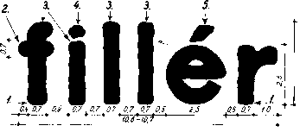

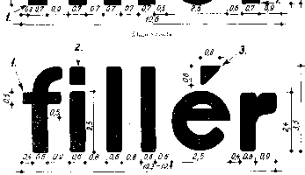
Figure 181

2 The horizontal line of letter "f" is a regular, horizontally arranged rectangle, and its upper edge corresponds to the height of the upper edge of the letter "i".
3 The top edges of the first four letters are aligned.
4 The dot of letter "i" is a regular square, and it somehow continues in letter “f”.
5 The accent of “é” is an irregular rectangle, trapezoid.

In general, the letters are formed by regular straight and curved lines and regular geometric shapes. Their boundary lines are sharp and firm. Overall width is 10.6 mm, height 3.5 mm (Figure 181).

Variants of overprinting:
Of the color variants of the overprint, three versions of the red lilac of 80 f / 80 f N are known: brick red, brownish red, and cherry red.
The brick red is the most common and it should be noted that in 1945 - 46 overprints were only of brick red color.
Brownish color is less common, especially among copies used for paying for the postage.
The cherry-like red overprinting is quite common, and it is mostly seen on the copies used for payment of postage in large quantities.

The most interesting peculiarity of this issue is the reverse overprint of the 80 f / 80 f N denomination, the occurrence of which has so far clarified the lack of this denomination in the “I/А Kisegítő” (auxiliary) series. It has not been discovered so far if this reverse overprint denomination was made in the invert or in the State Printing House (the third stamp of Figure 178/a).
Watermark and Watermark Positions X, A/1,2.
Perforation: 15 teeth, comb
Forgeries of this issue have not turned up.

1944: AUXILIARY POSTAGE STAMPS II
As provided for Regulation 105. 037 / A. 4 on 2 July 1945, due to the postal fee increase, new postal stamps had to be produced and placed on the market. Therefore, the Ministry of Trade and Transport, by Regulation 111. 352/A. 4. (P.R:T. 1945/9), ordered a series of overprinted postage stamps of 14 different denominations, issued as of 18 July 1945.

Again, the existing postage stamp set was used to create the series. 10 new denominations were printed over series “Hadvezérek” (Military Leaders), and 4 over “Nagyasszonyok” (Famous Women).
As per Regulation 111,325 / A. 4 issuing the order for the issue of these postage stamps, they were placed on the market continuously, as they were produced.

Issuing of denominations:
On July 18, 1945, the 3 P / 50 f N and 8 P / 20 f N,
On July 20, 1945, the 2 P / 4 f H,
On July 23, 1945, the 40 f / 10 f H, 80 f / 24 f N, 1 P / 20 f H, 1.60 P / 12 f H, 9 P / lf H, 10 P / 80 f H, 20 P / 30 f N,
On July 26, 1945, 4 P / 30 f H, 5 P / 8 f H, 6 P / 50 f H, 7 P / l PH
These postage stamps were withdrawn by Regulation 233.703 / 4. (P.R.T. 1946/38) issued on June 30, 1946, but practically, due to inflation, the utilization terminated much earlier. Regulation 135, 277/4 of 24 October 1945 (P.R.T. 1945/36) provided that the post offices return the full sheets of "fillér” denominations.

Sales
The values of the series were sold by post offices, postage stamp vendors, and post office postage stamp offices. A large part of the stock was purchased by the public and the stamp collectors because of the depreciation of the money.
Figure 182

Face Values Of The Series |  | Base impression  Color | Color of Base Impression | Number of Copies*
This plate was used for printing 40-filler sheets on 10-filler regular postage stamp sheets. |  | blue | black | 347,600 pieces
Printing 80-filler sheets on 24-filler sheets N |  | yellow | black | 2,876,400 pieces
Printing 1-kreuzer sheets on 20-filler sheets |  | yellow | black | 6,512,000 pieces
Printing 1.60-kreuzer sheets on 12-filler regular postage stamp sheets |  | yellow | black | 2,538,000 pieces
Printing 2-kreuzer sheets on 4-filler regular postage stamp sheets |  | blue | black | 5,348,000 pieces
Printing 3-kreuzer sheets on 60-filler sheets |  | yellow | black | 6,937,900 pieces
Printing 4-kreuzer sheets on 30-filler regular postage stamp sheets |  | blue | black | 4,326,000 pieces
Printing 5-kreuzer sheets on 8-filler regular postage stamp sheets |  | yellow | black | 3,313,000 pieces
Printing 6-kreuzer sheets on 50-filler sheets |  | yellow | black | 2,818,000 pieces
Printing 7-kreuzer sheets on 1-kreuzer sheets H |  | yellow | black | 5,300,400 pieces
8-kreuzer sheets on 20-filler sheets, N |  | blue | black | 7,714,300 pieces
Printing 6-kreuzer sheets on 1-filler sheets, H |  | yellow | black | 1,723,000 pieces
Printing 10-kreuzer sheets on 80-filler, H (regular postage stamp sheets) |  | blue | black | 8, 084,200 pieces
Printing 20-kreuzer sheets on 30-filler, H |  | blue | black | 6,425,000 pieces
*Amount Produced
There are no reassuring data regarding destruction.

The issuing bodies took into account new tariffs when setting new face values for the postage stamps. Thus, the 40-fillér denomination was used for payment of the postage of 20 gr, the 1.60-kreuzer denomination was used for payment of the postage of 100 gr and the 7-kreuzer denomination was used for payment of the postage of 1,500 gr.

Producing Overprints
Overprinting was carried out by the State Printing House. The semi-finished sheets with base impression were transferred from the Athenaeum Printing House, as well as its postage stamp stock not yet unpacked, in original printing house bulks, intact.
The two kinds of printing plates for base color impression and for overprinting used at the State Printing House were described When describing series “I/B Kisegítő” (auxiliary). Therefore, repeating is unnecessary.
1 However, it is important to note that in this series there were already two plates for base impression. In order to carry out the base coloring, plate of type I (218 - 218.5 x 261 mm) was used; however, for some of the denominations plate of type II was used (221 x261 mm) - N - mainly for denominations 80 f / 24 f N, 1 Í / 24 f H, 4 P / 30 f H and 8 P / 20 f N. With this base impression, further denominations are likely to occur.
In the Athenaeum Printing House, the sheets already fitted with the base impression were overprinted (1.60 P / 12f, 4 P / 30 f, 8 P / 20 f, 10 P / 80 f, 20 P / 30 P.). However, occurrences of these are quite rare, with the exception of 20 P / 30 fN. It is noteworthy that the base impression shifts in this edition were mainly produced in the Athenaeum Printing House.
As a curiosity, it must be noted that we are aware of two instances when sheets with only base impressions were sent out to post offices. Both were overprints of 50 fillérs “Nagy asszonyok” (Famous Ladies) to be overprinted to 3 kreuzers, which were returned to the Post Office Postage Stamp Warehouse by the post office in Kiskörös. and Csongrád Post Office 2 on January 30, 1946. Many of the sheets with only base impression were illegally marketed, especially the denominations of 1, 50, 80 fillers and 1 kreuzers of series “Hadvezérek” (military leaders).
2 The overprint was printed in the second pass using type of 100 piece and a high-pressure fast press. As we have seen in the detailed description of the letter and digit types of series "I / B Kisegítő” (auxiliary), the forms of the digits and numbers of the State Printing House, irrespective of the printing process, differ greatly from those of the Athenaeum Printing House, thus further detailed discussion of them is unnecessary. This finding applies primarily to the year "1945" and "fillér" and "pengő". Nevertheless, there is a problem here that we cannot go by without mentioning.
Regarding the font and digit types of series “1945 I / B Kisegítő” (auxiliary), we have mentioned the deviation of a few tenths of millimeters in the size of the "1945". Examining the overprint of this edition, the deviation is also apparent as regards the size of the digits of the year "1945" and of the letters of the denomination.
With many measurements done, the conclusion may be drawn that the year “1945” occurs in multiple sizes (9.6 to 9.8 mm); but we also find differences in the size of individual digits. Thus, the size of “1” digit is 1 -1.1 mm, that of “4” is between 2.5 and 2.7 mm.
A similar deviation can be observed also in the value numerals, especially in the case of “pengő". Here, the difference primarily shows in “f". We find such letters “ő" on which the two accents are in contact with each other on their upper tips, while in the other instances the two accents are far apart. The categorizing of these may seem unnecessary, but it is still important to know these to facilitate the recognition of some very misleading fakes.
Yet another important conclusion is that in the State Printing House the overprinting of one and the same denomination was occasionally carried out using different types. This can also be established by comparing the maximum distances between the prints on the entire postage stamp sheets.
In the following, only the values present both in I and II “Kisegítő” series, will be examined for the sake of completeness and, not least, for the distinction between counterfeits.

Number Types In The Value Numerals

Overprint of 40 Fillérs
Numeral "40" (10.4x5 mm) does not show any significant difference in size compared to the type of the Athenaeum Printing House; only the thin lines of the digit are strong and free of damage.

Overprint of 80 Fillérs
Numeral "80" of 80 f / 24 fN is the same as the overprint of 80 f / 80 f N in series “I/B Kisegítő”

Overprint of 1 Kreuzer
Numeral "1" is the same as in 1 / 70f of series “I/B Kisegítő” (auxiliary), Type 1 of the State Printing House. Figure 180

Overprint of 1.60 Kreuzer
In this denomination again the “1” of the State Printing House Type 1 was used in the value of 1.60.

Overprint of 2 Kreuzers
The value of "2" is very similar to that of the Athenaeum Printing House. There is, however, a discernment, on top of the difference in size that cannot be determined by an unaided eye, and which differentiates it in all cases. This is the lower part of the vertical line marked (1) in our figure. While the “2” of the Athenaeum Printing House ends in a wider tip, here its width is 0.4 mm (Figure 183).
The other characteristic difference between the two “2s” is the difference between the upper part of the vertical line and the height of the digit, i.e. 2.5 mm instead of 2.2 mm and 5.3 mm instead of 5 mm.

Overprint of 3 Kreuzers
The height of numeral "3" is only 5.3 mm, which is different from corresponding numeral of the Athenaeum Printing House. Otherwise, its thin lines are stronger.

Overprint of 5 Kreuzers
Numeral "5" is also different only in size. Its overall width is 4.7 mm, instead of 4.4. Its height is the general digit height of the State Printing House, namely 5.3 mm.

Overprint of 10 Kreuzers
It is in the denomination 10 P / 80 f H that we first meet the State Printing House Type II of “1” (Figure 180). The difference between the two types, as shown in the figure, is that the upper right corner (3) of the type ll of “1” ends in a pointed tip.
Otherwise, the total width of the "10" value is 9.1 mm and the height is 5.2 mm.

Overprint of 20 Kreuzers
“2” of the "20" is exactly the same as that of the State Printing House (Figure 183). The overall width is 10.4 mm, the height of the digits is 5.3 mm. '

Varieties of Overprinting
The overprinting of the State Printing House is an excellent print job. Typical errors, injuries, clogs caused by pressure are rarely occurring except in some cases.
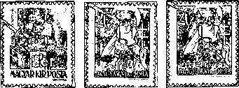
.
Figure 184

- Among them, however, we should mention the errors in the overprint resulting from injuries that occur in later issues, as the three denominations of the series were further overprinted. And here we must first point out that there is an incorrect and widespread finding among collectors when talking about breaking the fonts or the digits used in relief printing.

. 4. • 20.
Figure 184

There were seldom damages that could lead to the breakage of the alloyed lead letters. However, the indentations of letters are more common and more general, which resulted in a decrease in the height of some part of the letters and digits, which, in turn, resulted in no impressions when printing. These impressions were usually limited by straight lines.
1 During printing the denomination 40 f / 10 fH, on postage stamp 58, the slender sloping line of “4” in "40" was recessed when reaching the thick vertical line at the length of 0.6 mm, and later produced discontinuous prints (Figure 184).

2 When the denomination 8 P / 20 f N was printed, “4” in year "1945" was damaged in two places on the type of 100 pieces. As a consequence, on the 4th stamp of the sheet, figure “4” is oblique and diagonally discontinuous. On the 20th stamp, the same line is even more defective due to the indentation (Figure 184).
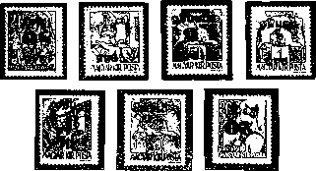
Figure 185

b) The most peculiar feature of this issue is the occurrence of inverted overprint, which was not always accidental in the present case.
Opinions are still different regarding the existence of reverse overprints of some denominations. Hungarian Postal Stamps Data Pool Volume II lists reverse overprint for all denominations.
The reverse overprints known so far of the series are as follows: 80 fj24 N, 2 Pj4 f ff, 6 PjőO f ff, 7 P'jl P ff, 9 Pjl f ff, 10 P[80 f ff, 20 Р[30 fNf
In addition to the aforementioned, it is possible to come across different reverse denominations, though it is unlikely they exist. The existence of these must be considered with caution, as there are forged counterfeit overprints come up too.
с) Prints on the reverse side, with regard to the black color of overprint, are rarely found.
Figure 186 shows a partial ink transfer by equipment of the denomination 7 P / l P H, which was generated by folding of the sheet edge.
Figure 186

d) The ink transfer by sheets is significantly more frequent, which can be either full or partial.
e) The strong impression and the transparent impression are the most common.
Watermarks and watermark positions are the same as on the basic stamps: X, A/l., 2.
The perforation is the same as the one of the base stamps, that is 15 teeth, comb. As a perforation specialty, we should mention the occurrence of the non-perforated denomination of 3 P / 50 f X.
Postage payment is at the end of the inflation issues, in the Summary.

Forgeries
Counterfeits from this edition are mainly inverted overprint for collectors. However, considering these counterfeits and Figures 179, 180, 184 and 181, it should be noted that counterfeiters were not well aware of the numbers and fonts of the two printing houses and the differences between the two types.
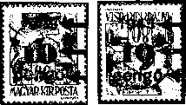
Figure 187

They made the grave mistake of using the State Printing House font and digit types instead of the Athenaeum Printing House type, as shown in Figure 187 on the right stamp 10 P / 80 'f H. Beside, on the left, the original overprint stamp is presented for comparison.
In year "1945”, "1" has a “hook” part, and the digits are thin; value number “1” is narrow, 2 mm instead of 2.3 mm. Its height is 5 mm instead of 5.3 mm, and the slim letters of "pengő" on the counterfeits are also striking.
By following the detailed comparison procedure, it is not difficult to detect counterfeits (that may be of other value than the 10 P / 80 f H denomination shown), even if the counterfeiters used for their prints the same or similar fonts and digit types as the State Printing House.
From this edition, fakes for postage payments are known too. It was also the denomination of 10 P / 80 f H, which is shown in Figure 180.
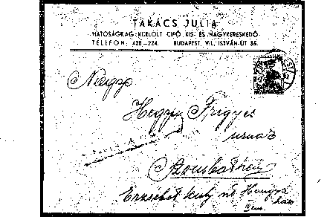
Figure 188
The red overprints of the auxiliary series “1945 Kisegítő”, denominations 1 P / 80 f H were painted black with touch; a “0” was added to “1”, by which the face value was increased tenfold. We know about the existence of several copies of such counterfeits, and all were issued and postmarked on September 17, 1945 at Budapest Post Office 72.

1945: BÉKE I (Peace)
By Regulation 353 / A. 4 K.KMsz. (P.R.T. 1945/9), postage stamps with surcharge for the sake of a new peace-time institution, the “people’s colleges” were issued. It was a series of 4 denominations overprinted with 300% surcharge.
The overprint was designed by Istvan Mácsai.
These postage stamps were issued on July 23, 1945. Officially, they were withdrawn from the market by Regulation 233. 703/1946. No. 4 (P.R.T. 1946/38) as of June 30, 1946, but virtually they fell out from postal usage long before that, due to inflation.
Number of copies: 250,000 full series were produced .
They were sold in Budapest at post offices 4, 7, 114, and in the countryside in the post offices belonging to the Treasury, until July 30, 1945. Only one series was sold to a single customer.
Figure 189
Base Impression
Denominations of Series |  | Color of Base Impression | Color of Overprint
3P+9P | on 20 fillér | yellow | red
4P+12P | on 4 fillér | blue | green
8P+24P | on 50 fillér | yellow | red
10P+30P | on 30 fillér | blue | green

Four denominations of “1944. Kossuth (I)” were overprinted by “BÉKE A NÉPFŐISKOLÁKÉRT” (PEACE FOR THE PEOPLE’S COLLEGES”, and a new face value was added.
Overprinting
Overprinting the stamps of the series took place in two passes.
The first pass was the base impression. Overprinting was originally intended to be implemented at the Athenaeum Printing House, but for the reasons already explained, these semi-finished sheets were transferred to the State Printing House for further overprinting. Therefore, in the Athenaeum Printing House, only the 370 X 265 mm standard overprinting was produced, but the base impression of the 200 sheets of the 3 P + 9 P / 20 f denomination was also done by State Printing House.
The base color is yellow and blue, which, and due to the relatively small amount, does not show any significant color difference.
Smaller or larger base impression slips (white-bordered postage stamps) were common.
Postage stamps with only base impression are prints of the 1st run – they were placed in the collector's circulation illegally.
Instances with no base impression but with overprinting are rejects that were passed to collectors in the same way.
Figure 190

The second pass was the overprint. The postage stamps of the series were overprinted in the State Printing House from 100-piece type on fast intaglio press. The overprint color was brick and carmine or dark green. The latter, when examined at electrical light, often appears to be black. This should not be confused with the black color of the proofs.
Flawed overprints were carefully rejected by the Printing House and the Post Office. Therefore, we rarely encounter such postage stamps postmarked. On the 10 P + 30 P / 30 f shown in Figure 190, the overprint
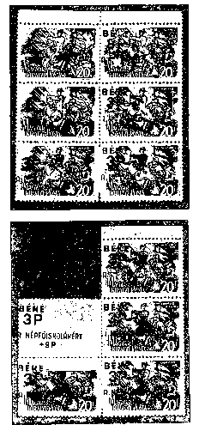

slid to the left. The double overprint on the postage stamp on the right-hand side of the same denomination is black, that is, it is. printing scrap that was generated during the color tests, and which was taken to collectors’ circulation.
Machine color transfers of overprints, though rarely, but occur.
In Figure 190a, a very nice missing overprint and a partially missing overprint is seen (BÉKE) spreading out over two postage stamps, as well as a rear side overprint due to the bending of the same part of the sheet (Figure 190a). Similar occurrences are also known in case of the 8 P 4-24 P / 50 f denomination.
An interesting erroneous print of 4 P + 12 P / 4 f was issued. Instead of letter "N" of the word “NÉP” (people), letter "И” (Cyrillic) was produced (Figure 191). This “printing error" was not so noticeable, as it was repeated the the green, red, and black proofs (13 July, 1945) submitted for approval. The approval was obtained. The mistake was probably discovered later in the printing house because on July 17, the corrected, green overprint copy received the “printable" comment, which was approval.

It is almost inexplicable that, despite all this, how could a considerable amount of these erroneous overprints get into circulation. It is likely that after the approval of 13 July, by mistake, the printing. started, and after its disclosure, the flawed overprint stamps were not completely destroyed.
Another interesting feature of the erroneous prints is that most of them, also by mistake, were exported to Vienna.
The watermarks and the perforation of the postage stamps were the same as those of the base postage stamps, part, i.e. the watermarks and the perforation were the following: X, A/l, 2: 34-9 P/20 f, 10 + 30 P/30 f; X, B/l, 2: 4 + 12 P/4f, 8 + 24 P/50f.
Perforation 12 ½:12-teeth comb perforation
Payment for postage: most of this small issue was bought by collectors and vendors for collecting purposes, so they were not used for payment for mail. Used, and therefor hand stamped copies in collector circulation are largely favored. Mail items for which payment was done using these postage stamps are rare.
Proofs: of three denominations of the series, proofs of different color overprints were produced, some of which were obtained by collectors.
Color proofs:
P + 12 P / .4 f with black and red overprint,
8 P + 24 P / 50 f with black and green overprint,
P + 30 P / 30 f with black overprint.

1945 SZAKSZERVEZET (I.) (UNION)
Commemorative series of stamps of 8 denominations This series was issued by the Post Office to commemorate the trade unions World Congress in Paris, which began on 20 September.

The images were designed by György Konecsni.
These stamps were introduced by Regulation 126.532 / A 4 (P.R.T. 1945/19) on 11 September.
These stamps were withdrawn from circulation by Regulation 233.703 / 4 (P.R.T., 1945/38) as of June 20, 1946; however, their postal usage was practically gone much earlier.
Number of copies: 50,000 of entire perforated series.
Points of sale: Budapest 3, 4, 7, 62, 72, 112 and 114 Debrecen 1, Miskolc 1, Pécs 1, Sopron 1, Szeged 1. Post offices sold these stamps only in a full set, one series to a single customer until September 20, 1945.
Post offices sold 2000 series in the above manner. 25,000 series were awarded to the National Trade Union Council, 5,000 series were received by the Postman Trade Union. 9,000 series were provided to the collectors who were members of the Hungarian Federation of Hungarian Collectors' Associations, while the Hungarian Stamp Vendors’ Association was provided 1800 series.
Figure 192a

Figure 192b

Face Values Of The Series
40 fillérs |  | grey
1.60 | kreuzers | brownish olive green
2 | kreuzers | green
3 | kreuzers | violet
5 | kreuzers | brownish red
8 | kreuzers | dark brown
10 | kreuzers | wine red
20 | kreuzers | greyish blue

Postage Stamp Images
There is a common rectangular. frame, with a lightly darkened oval field in it. In the four corners the are indications of the value of darker shade. The colored text "CONFÉRENCE SYNDICALE MONDIALE PARIS 1945” takes place on the edge of the oval; inscription ”MAGYAR POSTA” in the box and the individual trade union symbols are white.
40 fillérs: Miner, mining, two miner hammer crossed at the top, burning miner lampions.
1,60 Kreuzer: Steel worker, fist grabbing the hammer on an anvil, with a gear in front of it.
2 Kreuzers: Railway worker, a wheel with wings racing on a rail, with a bird flying in front of it.
3 Kreuzers: Construction worker, trowel hung for wall building, plumb line suspended in the front of him.
5 Kreuzers: Peasant, plow in the furrow, sun with rays above.
8 Kreuzers: Postman with porcelain insulating telegraph lines, stylized mail pigeon carrying a letter in its beak.
10 Kreuzer: Engineer, blueprint roll, open calipers in a right hand, four-pointed star.
20 Kreuzer: Private clerk, open business book with a fountain pen.
The 8-kreuzer denomination was declared the most beautiful stamp of the year by MBÉOSZ, and the designer was rewarded.
The postage stamp images are horizontally arranged their size being 33 x 22 mm.
These postage stamp were printed in temporarily restored State Printing House, with single color grid, intaglio technique.
It was marketed in 100-piece sheets.
These postage stamps were produced on 0.08 mm thick, white, "A" quality, X-watermarked treasury printing paper.
Watermark orientation Aj 1., 2.
Gumming: white
Perforation: 12:12 ½, comb perforation The size of the stamp is 37 x26 mm. Non-perforated pieces (□) were phase impressions placed on the market.

Payment for postage: the stamp series purchased for collector purposes was used for postage only occasionally. Stamps of the series used for postage on letters are very rare.

1945: INTERNATIONAL AID (VETERANS)
The Ministry of Trade and Transport issued charity series of 8 denominations to commemorate the "Mourning ceremony" on the day of national mourning held in Budapest on October 18, 1945, in memory of the anti-fascist martyrs. The series supported the "National Aid" and the Ministry of Welfare program aimed at the protection of children. The surcharge was 100%.
The postage stamps were designed: 2P + 2P Sándor Bortnyik, 3 P 4- 3 P Zoltán Tamássi, 4 P -f 4 P Antal Diósy, 6 P 4-6 P and 20 P. 4- 20 P György Konecsni, 10 P 4-10 P Károly Rohony Roheim, 15 P + 15 P Köpcczi István Bócz, 40 P 4 - 40 P Pál Szűcs.
These stamps were introduced by Regulation 132.000/A. 4 (P.R.T. 1945/27) on 6 October, 1945. They were withdrawn from circulation by Regulation 233.703 / 4. (P.R.T. 1946/38) as of 30 June 1946. In practice, because of the depreciation of the money, they went out of use much earlier.
Number of copies is 100,000 full toothed series.
They were only sold in a full series, a single series to a buyer; they were marketed in Budapest, at post offices number 1 in those towns where there were several post offices, as well as in the municipal offices of Berettyóújfalu, Mátészalka and Szikszó until October 20, 1945. Unsold stocks were returned to the Postage Stamp Warehouse after October 20, 1945.
Face Values Of The Series
2P+2P | yellowish brown
3 P+ 3 P | brownish red
4 P+4 P | blackish violet
6P+6P | green
10 P+10 P | Purple carmine
15P+15P | blackish green
20 P+20 P | dark brown
40 P+40 P | dark blue
Figures on stamps, depicted persons

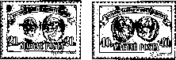
The common figure is a horizontally arranged rectangular dark background. In the middle, there are oval-shaped, medullary half-moon trains, two ones opposite other two ones. There are varying face inscriptions on them, with names in the frame. On the white ribbon, colored inscription “NEMZETI SEGÉLY A VÉRTANÚKÉRT” (NATIONAL ASSISTANCE FOR THE MARTYRS) appears. At the bottom white inscription “MAGYAR POSTA” (HUNGARIAN POST), with the price and the surcharge on the right and on the left.
Figure 193
Persons depicted: 2 P + 2 P Imre Sallai and Sándor Fürst, 3 P + 3 P Lajos and Mónus Illés bats, 4 P + 4 P Ferenc Rózsa and Zoltán Schönherz, 6 Pf 6 P Poet Anna and Knurr Pálné, 10 P -f 10 P György Sárközi and Imre Nagy, 15 P-15 P Vilmos Tartsay and Jenő Nagy, 20 P + 20 P János Kiss and Bajcsy Zsilinszky Endre, 40 P + 40 P Endre Ságvári Dr and Ottó Hoffmann.
The postage stamp images are horizontally arranged, their size being 33 x 22 mm.
These postage stamp were printed in State Printing House, with single color grid, intaglio technique.
They were marketed in 100-piece sheets.
These postage stamps were produced on 0.1 mm thick, white, "A" quality, X-watermarked treasury printing paper.
Watermark position A /1, 2
Gumming: white
Perforation: 12 12-tooth comb perforation. The size of the stamps is 37 x 26 mm. Non-perforated pieces (□) were phase impressions placed on the market.

Payment for postage: this stamp series purchased for collector purposes was used for postage only occasionally. Stamps of the series used for postage on letters are very rare.
To be recorded Regulation 135.031/A.4 K.K.M issued on 25 October 1945 changed the name ,,A posta bélyegértékesítő irodája (Bp. 7)” (Office for selling postage stamps of the Post Office) to ,,A magyar posta bélyegirodája” (Hungarian Post Office Postage Stamp Office). The task of the office was selling of postage stamps domestically and abroad (P.R.T. 1945/47).

1945: III AUXILIARY POSTAGE STAMPS III
As a result of the fourth postal fee increase of November 1, 1945, the creation and issue of new, higher denomination postage stamps was unavoidable. Therefore, Regulation 136.800 / A. 4 K.K.M. (P.R.T. 1945/37) introduced 4 ordinary, new denomination overprinted postage stamps as of November 7, 1945.
To make the series, the Post Office still used 3 denominations of „Hadvezérek” series. and commemoration stamp “Szt. Margit”.
Period of use: the Regulation set the date of the issue of the series as November 7, 1945, but the stamps were only sold after they were produced and in the order of their being produced. Thus the denominations 60 P / 18 f H, 100 P / 12 f H and 300 P / 30 f M were actually placed on the market on November 8, 1945, while 40 P/8 f H on November 9, 1945.
Officially, these stamps were also withdrawn from the market on June 30, 1946, by Regulation 233.703 / 4r (P.R.T. Ï94G / 38), however, in fact, due to the rapid inflation, they were out of postal usage much earlier, in the first months of 1946.
These postage stamps were sold at post offices, postage stamp vendors, and the postage stamp office of the Hungarian Post. A large part of the stock was purchased by the public and the stamp collectors because of the depreciation of the money.
Figure 194

Face values of the series |  | Base impression color | Overprint  color | Number of copies
40 kreuzers | on 8 fillérs | yellow | black | 4,000,000 pieces
60 kreuzers | on 18 fillérs | yellow | black | 6,408,000 pieces
100 kreuzers | on 12 fillérs | yellow | black | 6,270,000 pieces
300 kreuzers | on 30 fillérs | blue | black | 2,326,400 pieces

Overprint
Overprinting was done in State Printing House in two rounds:
1 Base printing was yellow or blue.
2 Overprint: black
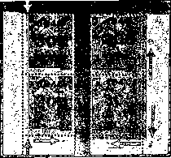
Figure 195

1 The basic coloring was the same as in the previous prints of the State Printing House. It is to be noted, however, that for this edition the sheets with base printing transferred from. Athenaeum Printing House were also used, as shown in the 2nd image of Figure 195. Sheets with such impression also occur from in denomination 60 P / 18 f , apart from the common one of 300 P / 30 f.
The sheets the base impression of which was produced in the State Printing House are darker in colour, while their base impression is even. There are little differences or rarities in base impression. By contrast, the base prints of the Athenaeum Printing House are brighter and have marbled drawings due to the unequal ink supply. Among these, there is often a slight depression, as shown the 1st image of Figure 195.
Number of copies: There is no reassuring data regarding destruction.
Postage stamps with only base impression are prints of the 1st run – they were placed in the collector's circulation illegally.
2 The overprint was printed in the second pass using type of 100 piece and a high-pressure fast press.
The type of the digits used for the overprinting of this edition is significantly different from that of the State Printing House. Although the "1945" year and "pengő" are still identical, as regards the numerals and letters used, to the previous issues, instead of the bold digit types used so far grotesque numerals was used.
Note the dimensions of the numerals used:
The overall width of “40” is 9 mm, “4” is 4.3 mm, “0” is 4.2mm.
“4” is 4.5 mm, “0” is 4.8 mm high.
The overall width of “60” is 8.8 mm, “6” is 4.1 mm, “0” is 4.2 mm.
They are 4.8 mm high.
Face value of 100: full width 12.1 mm; “1” is 2 mm (vertical part is 1.3 mm), “0” is 4.2 mm wide. While “1” is 4.6 mm high, the zeros are 4.8 mm high here.
The overall width of “300” is 13.5 mm, “3” is 4 mm, “0s’ are ...
They are 4,7 -4,8 mm high.
Figure 196

Out of the variants of the overprints, the reverse prints are also the most popular here.
The denominations of 60 P / 18 f H, 100 P / I2 f H and 300 P / 30 f M shown in Figure 196 are real reverse overprints.
The reverse copy of 40 P / 8 f label has already been mentioned in the resesheet, but its existence has not been proved.
Other printing specialties are the same as in the series of „1945. II. Kisegítő” (Auxiliary 1945. II).
Watermarks and watermark positions are the same as on the basic stamps: X, A/1, 2:
The perforation is the same as the one of the base stamps, that is 15 teeth, comb.
Postage payment is at the end of the inflation editions, in the Summary.
Forgeries: in case of this edition, forgeries produced for collectors are known. These are the most dangerous the forgeries mentioned so far. However, careful analysis makes it easy to recognize them.
Overprints of denomination 100 P/12 f H demonstrated in Figure 197:
- Real inverted overprints
- Forged inverted overprints
- Forged inverted overprints
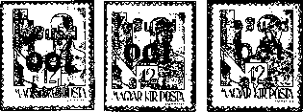
1, 2
Figure 197

Characteristic Features of Forgeries
- The overall width of “1945” is 9.4-9.5 mm instead of regular 9.5-9.8 mm. The height of the numerals is 2.5-2.6 instead of the regular 2.9 mm. This is especially striking in case of “1”.
The width of “5” is 2.2 mm instead of the 2.5 mm measured on the real copies; the distance between “4” and “5” is 0.3 mm instead of the standard 0.5 mm.
In general, year "1945" is visibly slimmer than the real overprint, and the edges of the digits are blurry.
- The difference in “100” in both presented counterfeits is 4.6 mm of height instead of the regular 4.8 mm.
The width of “10” is 7.3 mm instead of the 7.5 mm measured on the real copies; the distance between the two “0s” is 0.6 mm instead of the standard 0.4 mm. That is why the full width corresponds to the width of the real overprint.
For the second forgery, slimmer vertical line of “1” is a typical feature (1 mm instead of 1.4 mm); its long special shape smaller line is also easy to distinguish from the real one. The width of the “0s” is 3.8 mm. instead of 4 mm; and distance between “0s” is 0.7 mm instead of 0.4 mm.
The numerals, but especially the “0s”, are blurred-edged.
- The kreuzer denominations also differ from the true overprint in its dimensions. The total width of the inscription is 13.2 mm instead of the authentic 13.4 mm. The letters are 3.3 and 2.5 mm in height instead of 3.5 and 2.7 mm. The edges of the letters are blurred.
Forgeries for postal use are not known in this edition.

1945: RECONSTRUCTION
The General Directorate issued a tender for the design of a general-purpose series of “Reconstruction". However, despite a number of deadline extensions, the tender was not successful, and due to new postal charges, a series of postcards with a total of 15 denominations, which were intended to be temporary, were placed on the market on November 7, 1945; they were introduced by Regulation 137. 000/A. 4 (P.R.T. 1945/38). on November 5, 1945.
The image was designed by György Konecsni.
Contrary to the issuing regulation, they were placed into circulation in the order of being produced and in accordance with the postal fee increases in the meantime.
They were withdrawn from circulation by Regulation 233.703 / 4. (P.R.T. 1946/38) as of 30 June 1946, but before their expiration, their actual use terminated due to their depreciation.
The issue of the denominations of 12, 24 and 140 kreuzers due on January 10, 1946 became useless, due to the new increase of the postal fees on 16 November, 1945 and 14 January, 1946, but since their issue was already announced to the UPU, they were issued as a limited edition .
Figure 198

Face Values Of The Series |  | Number of Copies | Introduced into Circulation
12 kreuzers | greenish oil | 510,000 pieces | 10 January 1946
20 kreuzers | green | 1,814,800 pieces | 9 November 1945
24 kreuzers | yellowish brown | 500,000 pieces | 10 January 1945
30 kreuzers | blueish gray | 2,300,000 pieces | 10 November 1945
40 kreuzers | yellowish green | 1,411,000 pieces | 11 December 1945
60 kreuzers | brownish orange | 1,320,000 pieces | 22 December 1945
100 kreuzers | yellow | 1,522,000 pieces | 1 December 1945
120 kreuzers | ultra marine | 4,972,000 pieces | 12 December 1945
140 kreuzers | red | 490,000 | 10 January 1946
200 kreuzers | brown | 1,503,000 pieces | 30 November 1945
240 kreuzers | blue | 992,000 pieces | 7 January 1940
300 kreuzers | carmine red | 1 943 000 pieces | 5 December 1945
500 kreuzers | bluish green | 2,200,000 pieces | 22 November 1945
1000 kreuzers | red violet | 2,014,000 pieces | 30 November 1945
3000 kreuzers | red | 2,989,000 pieces | 5 February 1940

These postage stamps were on sale at post offices, with the exception of the denominations of 12, 24, and 140 kreuzers. The separation of the "reverse pairs" located in the center of the 100-piece postage stamp sheets (except the denomination of 3000 kreuzers) was prohibited by the issuing regulation. They were allowed to be sold only in the proper order, maximum in lines of 10 pieces, in order to prevent abusive trade. Out of the denominations of 12, 24, and 140 kreuzers, member associations of MBEOSZ received 80,500 series.
Postage Stamp Image
On each denomination, the image was the same - the symbol of reconstruction. The split stone coat of arms of Budapest is held by a worker with a naked upper body. There is a torn chain, which he clasps in his fist; in his right hand, he is holding a hammer. In the background, on the left, there is a pillar of the destroyed Chain Bridge, on the right, there is a faint image of the rebuilt Chain Bridge. At the bottom, there is a colored inscription "MAGYAR POSTA”; in the top right corner, there is a white value numeral and the denomination.
The image is of a rectangular shape, its size 33x22 mm.
These postage stamp were printed in the State Printing House, with single color grid, intaglio technique.
On all 100-piece postage stamp sheets, with the exception of the 3000 kreuzers, the left and right 50 postage stamp images were rotated 180 degrees relative to each other. Thus, on the vertical lines 5 and 6, the stamps of each stamp pair (10 pairs per sheet) are reversed in relation to each other. The post has been made to increase the demand for these postage stamps.
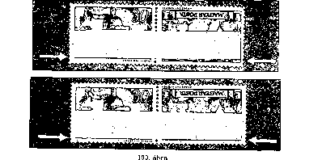

At State Printing House, printing started with a 50-stamp roller. After the print containing 50 postage stamps was produced, the sheet was rotated 180 degrees and placed into the press again to receive the second printing. This manufacturing process did not work out due to the difficulties in fitting of the second pressure. The generated waste, the heavily shifted 50-piece parts were separated along the perforation line in the middle, and were handed over to the Post Office as semi-sheets without the reverse pairs, for the reasons of economy. This explains the occurrence of the semi-sheets even today. However, when the halves of the sheets were shifted only few tenths to 1 mm relatively to each other, they were transferred to the post as full 100-piece sheets for sale. An instance of such shift of 1 mm is shown in Figure 199, the upper reverse pair.
Later, in order to overcome the above difficulties, the sheets were printed with a roll of 100 postage stamps (50 in base and 50 in inverted positions). In this case, when the image was transferred on pigment paper, the perfect fit of the twin 50 stamp images did not cause any problems. A copy of this second 100-piece print is shown in Figure 199, bottom postage stamp pair. Here, the lower and upper edges of the two images match.
These postage stamps were marketed in sheets of 100 pieces and semi-sheets of 50 pieces.
These postage stamps were produced on 0.1 mm thick, white, "A" quality, X-watermarked treasury printing paper.
Watermark: A/1,2.
Gumming: white
Perforation 12:12, comb perforation. The size of the stamps up to perforation is 37x26 mm. Non-perforated pieces (□) were phase II impressions. placed on the market.
Payment for Postage Some of the larger denominations of the series were actually used for postage for a few months. The postal use of 12, 24 and 140 kreuzer denominations officially introduced on January 10, 1946 was very rare.
Since the nominations of the series were produced very slowly, just as their introducing into circulation, Regulation 135.123 / A. 4 of The Ministry of Commerce and Transport authorized covering postage by cash.

POSTAGE STAMPS FEATURING LETTERS AND NUMERALS I
The first. postage fee increase implemented when "Felszabadulás" (Liberation) stamps were issued on 1 May 1945, which was followed by a further four postal fee increases in 1945, as a result of the general price increase and the consequent rapid inflation.
The "Reconstruction" general-purpose series of postage stamps, which was continuously put into circulation from November 7, 1945, was unable satisfy the associated expectations. The paying for postage demanded more and more stamps, but the existing postage stamp stock could not guarantee the postal services for a long time. Therefore, the Minister of Commerce and Transport issued Regulation 143.525 / A. 4. of 2 January 1946 (PRT 1946/2). This regulation provided that – for the reasons of economy and because of the tariff strategy and in order to overcome the difficulties resulting from the shortage of postage stamps – postage of certain domestic mail items be covered by postage stamps containing only letters and numbers. The regulation provided for editing a series of 8 denominations of such stamps as of January 7, 1946.
This regulation was withdrawn at the same time as the date of its issue;. the red text on the first page of the Official Journal read as follows (P.R.T. no. 2): “Regulation 143.525 / A.4. (Issuance of letter and number postage stamps) is entirely invalid. Other provisions are being made. "
The revocation of the regulation was explained by a new tariff increase expected on 14 January 1946. However, it should be noted that the regulation both issued and revoked on 2 January mentioned a series of 8 denominations, the 6th and the 7th one being Cs.5-I/ 30f Hcs Cs.10-I/ 80f H.
The amending Regulation was finalized on 9 January 1946 and was published as
II. Ad 143.525 / A (P.R.T. No. 3 of 1946). This new regulation of 14 January 1946, referring to the need of economy and pricing policy reasons, introduced only 6 denominations (Hl. I., Hip. I., Tl. I., Tip. I., Any. I., Ajl. I.) . In contrast to the previous revoked regulation, new face values and selling prices were set for individual stamps.
This set of 6 postage stamps could be sold without limitations to the public.
In addition to the above mentioned 6 denominations, post offices received further 2 face values: Cs 5-T / 30 f H and Cs.10-1 / 80 f H. The revoked regulation provided that these 2 denominations be used for tariff zones III-IV-V. The newer regulation provided that these 2 denominations be used for 5 and 10 kg packages, their price being 3000 and 6000 kreuzers respectively.
The description of the use of these two denominations as per the issuing regulation is the following: "Cs. 5—1. és Cs. 10—I. postage stamps can only be used for adhering on delivery notes of packages by postal administration, that is, they can be used for internal franking, and cannot be sold to the public – if done otherwise, this will fall under disciplinary liability. The package delivery notes with these stamps must be handled and retained by the delivery offices in the prescribed manner, but separately from the other delivery notes. Further action regarding these delivery notes shall be taken later.
Information mentioned above provides explanation why these denominations Cs. 5—1. and Cs. 10—I. have not been mentioned in the Announcement attached to P.R.T."
These two stamps are the first ones in the history of the Hungarian postal stamps which were produced explicitly for parcel delivery. Parcel postage stamps were initially used only internally by the Post Office, but later they were sold to the public, and could even be used for franking any postal item.
These parcel postage stamps differ in their nature from the parcel postage stamps used abroad. The latter were adhered to the parcel itself or, in two parts, glued to the border line between the delivery note and the coupon. Therefore, due to their nature, their sale and other features, these Hungarian parcel postage stamps cannot be considered as actual parcel postage stamps. Therefore, they are not classified in a separate group.
The first two parcel postage stamps. could only be used in postal administration for a short period of time because the Ministry of Commerce and Transport withdrew them from circulation by Central Circular 208.042 / A (P.R.T. 1946/12) of 22 January 1946 as of 20 February 1946, providing for the immediate return of the delivery of notes handled separately.
For their replacement, Regulation 204.588 / A. No. 4 (P.R.T. 1946/8) was issued. It confirmed the withdrawal of the postage stamps featuring the Hungarian Holy Crown of 30 f and 80 f. Cs. 5-1. és Cs. 10-I. for the purposes of domestic use as of January 22, 1946, and the portrait of Zsuzsanna Lorenzffy from "Nagyasszonyok" (Noble Ladies) series was introduced for 70 f, Cs. 5-1. és Cs. 10-I. Continuous supplies of the latter were promised.
The latter two parcel postage stamps were already sold to the public at post offices, and the delivery notes with these did not have to be handled separately.
One may rightfully ask why it was necessary to ban the sales of the so-called (by collectors) “parcel postage stamp pairs” Cs. 5-1/30 f H, és Cs.10-1/80 f H), which were used internally by the Post Office. Why was it important to withdraw them within such a short period of time, and why was it important that post offices return the already used and unused stocks?
The explanation for this is that the base stamp of each denomination represented the former state form, the Hungarian Kingdom, its symbol being the Hungarian royal crown. On the other hand, as the drafting of the new constitution and the shaping of the new state, the Republic of Hungary, was ongoing, and the proclamation of the new constitution and the new state form were expected soon (which came on February 1, 1946), the publication of these two stamps did not seem desirable.
Since the postage stamps featuring. letters and numerals, Series I, were. sent to the post offices in the first days of January as enclosed items, and they were introduced in circulation in the January of 1946
, the use of the “internal use parcel postage stamp pairs” for the internal use within the Post Office was a bridging solution.
In spite of the strict ban, the “internal use parcel postage stamp pairs” and the delivery notes to be handled separately were obtained by collectors within days. In order to prevent further abuses, they were ordered to be promptly returned on February 18, 1946. Post offices had to send back these delivery notes to the Postage Stamp Warehouse as official registered mail, with indication "Bsz.", and with the information on the number of copies; the fact of sending had to be recorded in a protocol.
These postage stamps were introduced by Regulation ad 143.525/A. 4 of 9 January, 1946, as of 14 January, 1946: Hl. I., Hip. I., TI. I., Tip. I., Any. I., Ajl. I. és a „belkezelési csomagpár”, a Cs. 5-1/30 f H és a Cs. 10-1/80 f H, továbbá a 204.588/A. 4. sz. rendelettel 1946. január 28-ával a kiegészítésként kiadott Cs. 5-1/70 f N cs a Cs. 10-1/70 fN jelű két csomagbélyeget.
These stamps were withdrawn on January 22, 1946, based on the central circular confirmed by Regulation 204.588 / A. No. 4. The other 8 denominations were withdrawn by Regulation 233.703 / 4. as of 30 June 1946, but practically the postal service ran out of them earlier.
The parcel postage stamp pair for internal postal use was produced in the following amounts: 836 800 and 819 200 copies. After their withdrawal from the market, the mail destroyed most of them.
TÁBLÁZAT BESZÚRÁSA 155OLDAL

These postage stamps were sold at post offices and postage stamp vendors’, except the parcel postage stamp pairs for internal postal usage. The parcel postage stamp pairs, to which an erroneous print belonged too, were distributed to collectors in exchange for 30 variants of 100-piece sheets or 60 variants of 50-piece bulks.
Later, the Philately Company started selling them.
At this time, the Post Office introduced the sale of stamp novelties by way of pre-ordering. Regulation 132.707 / Bgi. published in À P.R.T. no. 7 of 1946 contained provisions on this. Their summary follows below: Once the regulation was issued, it was obligatory to order postal stamps. of the same quantities for a calendar year. The quantities ordered could not be modified during the year. The subscription can be renewed between 1 November and 30 November each year. The subscriber was obliged to pay the continuous payment. Should there be a delay in payment, the subscription would lose its validity and could only be renewable in the following year.
The price of novelties was equal to the nominal value + 50% handling fee. Association members received a 15% discount on the association certificate, but they could use this discount up to a maximum of five series. Once membership certificate is presented, stamp traders received a 25% discount from the handling fee for up to 50 series.
The Post Office reserved the right to provide only a limited number of subscriptions for certain items (e.g. blocks).
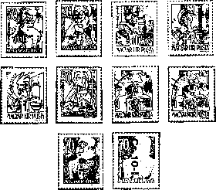
Figure 200

Face Values of the Series
TABLAZAT 157 Old
Watermarks and watermark positions are the same as on the basic stamps: X, A/1,2. 15-teeth comb perforation

Overprint
In order to produce the series, the Post Office would again use Military Leaders seriesthe previous edition of “Hadvezérek” series, denominations 1, 4, 10, 30 and 80 fillers,"Nagyasszonyok” series, denominations 20, 50 and 70 fillers, and а series I of auxiliary stamps, denomination 8 P / 20 f N.
The postage stamps of the series were overprinted in the State Printing House from 100-piece type on fast intaglio press.
As we could see in the list of the series, when this overprint was created, phase 1, the base coloration, was omitted. The only colored postage of the series to which basic coloration was applied was denomination 8 P / 20 f N of auxiliary series II. The basic knowledge on the overprinting of this color is the same as what we know about auxiliary series II.
As regards overprints, it must be noted that not only the type of letters and numerals used was different from the ones used for earlier prints, but the print quality was significantly lower than that of the earlier printing. The letters and numerals of the overprints, irrespectively of the large number of prints due to the large number of copies, were bounded by blurred lines, while the ink of the overprinting was not always satisfactory either.
More than 30-40,000 pressures cannot be produced even using high-quality type in intaglio printing press. This is why the re-typing of the overprints of the copies produced in large numbers became necessary. The application of these was proved by the verifications of the measurements of the full sheets. The size difference across the entire sheets is not large, usually from a few tenths of a millimeter to 1-2 mm.
The above mentioned details apply to the following two postage stamp series featuring letters and numbers mutatis mutandis.
The letters and numbers used for typing usually did not display significant differences, so instead of their detailed discussion, note the dimensions of the individual overprints because they are essential in order to recognize. counterfeits.
Overprint Hl. I
The overall width of the overprint is 10.9 mm, its height is 3.4 mm. The overall width of the letters is 1 mm, their height is ......mm.
Overprint Hlp. I
The overall width of the overprint is 14.9 mm and the height is 3.3 mm. The vertical parts of the letters. and the roman "I" are 1 mm thick, the full stops are 1x1mm squares. The damage of the base stamp, 8 P / 20 f N, can be seen on the 4th and 20th postage stamps.
Overprint Tl.I
The overall width of the overprint was 10.8 mm, while its height 3.2 — 3.3 mm. The letters are usually 1 mm thick, while the horizontal line of "T" is only 0.8 mm thick. In the case of this overprint, thinning down to 0.8 mm is also common, especially at the end of the vertical line of letter "T", before encountering the upper horizontal line. The same size change is typical of squared full stops used in abbreviations, which is explained by the huge number of copies of over 12 million. The roman "I" is 1 mm thick, the full stops are 1x1mm squares.
Overprint Tlp. I
The overall width of the overprint was 13.7 mm, while its height 3.3 mm. Letters and Roman "I" are 1 mm wide, while the horizontal line of letter "T" is 0.8 mm thick. The full stops are well-drawn squares 1x1 mm.
Overprint Any. I
The overall width of the overprint was 15.4 mm, while its height 3.3 mm. Letter. "n" is 2.4 mm high. Letters “Á" and "v" are 0.8 mm, the other letters and the Roman "I" are 1 mm thick. The dimensions of the square full stops vary between 0.8 and 1 mm.
On stamps 55, 58, and 89 of the sheet, overprint "Any" is erroneous. On the 55th stamp there are white spots on letter "A". In letter "n" of the 58th stamp, in letter "y" of the 89th stamp we can detect minor discontinuities in the prints (Figure 201).
Overprint Ajl. I
The overall width of the overprint was 13.6 mm, while its height 3.3 mm; the height if “j” is 4.2mm. Lines of “A" are 0.8 mm, the other letters and the Roman "I" are 1 mm thick. The full stops are squares of. 1x1 mm.
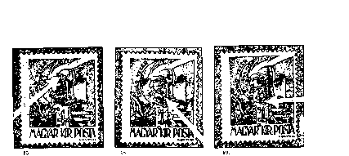
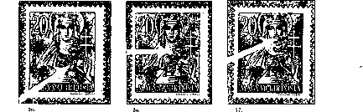
Figure 201
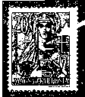
SB.
Figure 202

At this overprint, there are also signs of wear and indentation, mainly due to imprinting. Thus, on the 20th stamp of the sheet, a triangle is seen in the place of the first square-shaped full stop. On the 39th postage stamp, the bottom of the letter “j”, while on the 77th postage stamp, the horizontal line of letter "A" is discontinuous, due to indentation. On the 56th stamp of the sheet, there is a white spot resulting from an injury, as well as a white stain in the tip of the letter "A".
Cs. 5-1. Overprint While the first full-sheet overprint of 30 fillérs differs in width. from the widths of the second full-sheet print of 70 fillérs, the letters and numerals of the two prints do not show any significant difference except for some injuries. Therefore, the distinguishing between two overprints is not possible when examining individual stamps, with only few exceptions.
The overall width of the overprint was 7.2-7.3 mm; the height of “C” and the numerals is 3.3 mm; the height if “s” is 2.6mm. The letters and the numerals are of different thicknesses, but rectangular and square letters and and numerals are always 1 mm thick, and all points are squared (Figure 215).
31
Figure 203

Characteristic Features
- Denomination Cs.5-X/30 f H
The overall width of the overprinted sheet was 194.5—195.5 mm.
The overall height of the overprinted sheet was 244.2—245.1 mm.
In this denomination, the only characteristic feature appears on the 31st stamp of the sheet. In the lower, inner part of "5”, there is a slight printing discontinuity (Figure 203).
B) Cs. 5-1/70 f N denomination
The overall width of the overprinted sheet: 197.5-198mm
The overall height of the overprinted sheet: 244-245 mm.
For this denomination, there are three typical features in the sheet generated inby three indentations. On stamps 34, 59, and 79, in the overprint, one the lower right-hand side of "5" there are small discontinuities resulting from indentations (Figure 204).

Overprint Cs. 10—I.
In this denomination, we have such typical features of both the 80 and 70 base values, which allow us to distinguish between the two types of the 100-piece overprint sheets.
' 34. 5Я. ' 79. . •
Figure 204

The overprint size is the same for both base values, i.e. the total width is 18.3 mm, the letters and numerals are also the same 3.3 and 2.6 mm high. The thickness of the bent letters and digits varies significantly within one figure, but rectangle and square numerals and letters, with the exception of the hyphen, are always 1 mm thick, keeping in mind the fractions of paint deficiency. It should also be noted that the first full stops in the overprint are square in each case (Figure 217).
A) A Cs, 10 —1/80 f H denomination
Two types of this denomination are distinguished, typical for the whole overprinted sheets, i.e. 100 imprints.
Type (edition I)
The overall width of the overprint is 196.8 mm.
The total height of the overprinted sheet is 246.5 to 246.8 mm.

Characteristic Features
- In this type of 100-piece overprinted sheet, all full stops (the second ones too) are of square shape, in each postage stamp (Figure 206 left-side block).
- The color of the overprinting is dark red.
- There is only one characteristic feature on this sheet which resulted from an injury. On the 99th stamp of the sheet, the bottom of “1” in "10" is diagonally discontinuous, left-to-right. This corrupted numeral type must have been used mistakenly, and, as we will see, it appears regularly on further overprints (Figure 205).
Type II (Edition II)
The overall width of the overprint is 197.6 mm.
The total height of the overprint is 246.6 mm.
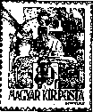
90
Figure 205

Characteristic Features
- The most characteristic feature of this type (edition II) is that the second full stop on stamp 75 of the sheet is circular, which is different from the previous type.
The square-shaped second full stop appears on on the sheet only on each postage stamp of the first and the seventh vertical lines, and on stamps 72, 82, and 92, and 9 and 19. Therefore, in type Cs 10 -I we need to distinguish two subtypes of overprints of 100 pieces, namely:
IIa subtype, with Cs.10-I, in which both prints are square in the overprint. (Figure 206), that is to say, of the same shape as all of the overprints of type I 100-piece type.
IIb subtype where the second point is circular (Figure 206), and this appears as a new drawing in the overprint of the postage stamps 2-8, 12-18, 22-29, 32-39, 42-49, 52-59, 62- 69, 73-79, 83-89, and 93-99 of the sheet, namely on 75 postage stamps all together (Figure 206, right-side block of four pieces).
Fig. 206, the block of four pieces, shows the postage stamps 1, 2, 11 and 12 of the sheet. On the 1st and 11th postage stamps Ila type appears, while on stamps 2 and 12, the subtype Ilb can be seen.
- The color of the overprinting is cinnamon-red, which is lighter than the overprint of Type I.
- On the 99th stamp of the arc, there is also an excellent example of the discontinuous “I” illustrated in Figure 205. But while the second point is square-shaped there, in Figure 207 it is already circular, corresponding to the Type II (Figure 207).
d) In case of this overprint, there were two typical injuries that occurred during printing. On stamp 4 of the sheet, in the middle of the left outer side of letter "C", and on the 58th stamp on the right side of the numeral “I”, there is a discontinuity deriving from the two indentations. (Figure 207).
B) Cs. 10-1/70 ÍN Denonmination
This 10kg overprint was made with the same 100-piece type as the 80-fillér parcel basic stamp from series "Hadvezérek" Type II (2nd edition), so the overprint dimensions indicated therein refer for the entire sheet of the "Nagyasszonyok”, as well as for the individual stamps.

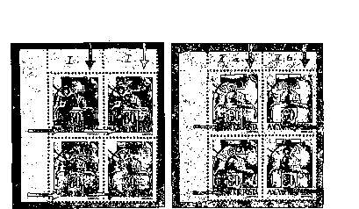
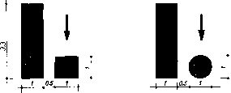
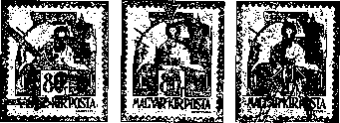
99 48. 58.
Figure 207
о

IIa  Figure 206 | IIb

Characteristic Features
- On the 99th stamp of the arc, the characteristic error of type I of 10 kg parcel postage stamps in “1” is also present here (Figure 208).
- Also, on the 48th stamp of the arc, the deficiency of "C" shown in Figure 207 appears here as well. However, in this denomination, new damages occurred during printing. Thus, on the 43rd stamp in the middle of letter "C" there is a small white spot, while on stamp 66, on the upper and outer sides of the same letter there is a slight discontinuity resulting from indentation (Figure 208).
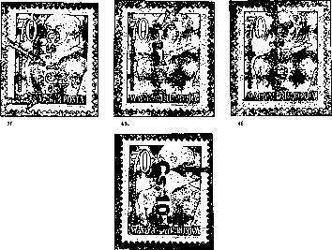
Figure 208

- Fracture, damage of “1” in "10" is also frequent. Thus on top of the 58th stamp outlined above (Figure 209), the damage of the right or the left or both sides of the vertical line of “1” can be seen on the postage stamps 9, 18, 27 and 38 of the sheet.
If we compare the damage to the 58th stamp of Figure 209 with the 58th stamp of Figure 207, we can see that this “1” has now suffered another injury, this time on its left side.
- The damage to “0” in "10" appears on two postage stamps. On the 3rd stamp of the arc, the right outer side of “0” is slightly deficient, while on the 36th postage stamp, on the right, there is a small white spot in “0” (Figure 209).
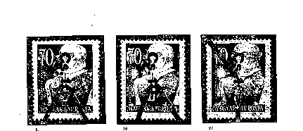
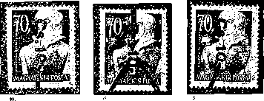
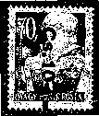
Figure 209

As shown in the figures above, there are two main types (editions) of Ca. 10-I ( 100-piece overprint): type I and II. In case of this edition and also later on, our resesheet covers, where possible, the defining of whether overprinting was done with one or multiple type. Investigation into this in case if this edition was even more pronounced, as subtypes Ha and Ilb were found. Unfortunately, there are no official data in this regard, so for Cs 10-I we can only deduce the types of overprint types from the stamp material available to us.
It would be most appropriate to accept the assumption according to which (as proved by several overprints) types I and II of Cs 10-I were printed using two separate 100-piece types, perhaps at the same time, at the same time.
However, the acceptance of this assumption is challenged by the 99th stamp of the two sheets. As shown in the figures, on the 99th postage stamp the typical error of type I, namely the discontinuity of “1” in. “10” had already appeared, and this error constantly recurs in all 10 kg parcel postage stamps, as we will see in Series II of the parcel postage stamps. Since miracles rarely occur, and they recur even less frequently, we have to conclude that the Type II of 100-piece overprint was made from the first 100-piece overprint, and for some unknown reason, probably due to disintegration, 75 pieces of square full stops were exchanged for circular one. due to disintegration. This assumption is supported by other, regularly repeating but growing in numbers overprint damages of letters and numerals.

Versions of overprinting
Color: red or black Five stamps were overprinted by red color. This color is cinnamon red, which, with the exception of the 10 kg parcel postage stamp overprint, does not show any significant color variation. The other five stamps of the series received black overprint. The black color in the overwhelming majority of the overprinted prints is deep black, not shining at all; some overprints are slightly glossy.
A few millimeters of overprint slippage and slanting are more commonly occurring, while postage stamps without overprint at all are unknown.
Figure 210
Partial overprinting deficiencies are mainly due to incomplete ink supply. See Figure 210. In case of several sheets of Type. 1, on each stamp of the last horizontal line, the Roman "I" and "Â" are hardly noticeable, while on Any. I, the Roman "I" and "Â" are known without full stop/dot too.
Out of the ten values of the series, four values also occurred with reverse overprint (bottom-up text). These are the following: Any. 1/1 f H, Hip. 1/8 P/20 f N, Cs. 5.-1/70 f N and Cs. 10—1/80 f H. Among them, the first, the third and the fourth issues entered collectors’ circulation within a short time, while the second one on our list, Hip Denomination I, was discovered only in later years (Figure 211).
The other erroneous print of the series, Ajl. I overprint, occurred on postage stamp 54. When composing the 100-piece type, the piece 54, the worker mixed up letters "j" and "1”, so instead of. “Ajl. I”, “Alj. I.” appears (Figure 212).
Figure 211
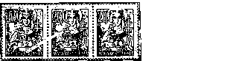
Figure 212
Having discovered the erroneous print, the Post Office exempted the postage stamp 54 already in the warehouse, and as a result, post offices did not receive full sheets, nor postage stamps 54. Nevertheless, the contemporary press communicated that full Ajl. I sheets entered collectors’ circulation. These sheets could only be illegally entered into collectors’ circulation. For the first time, in 1950, the Philatelic Company handed over the mass prints to organized collectors in exchange for bulk stamps. The pieces sold later in blocks of 9 postage stamps came from all sheets left in the postage stamp warehouse, which became the property of the above mentioned company after the latter was formed.
Number of copies: 2,680 pieces of 9-piece blocks
Because 40,699 sheets were overprinted with erroneous “AjI. I”, the number of the prints (after the official destruction of 10,000) was 28,019 postage stamps.
Repeated overprints rarely occurred, e.g. I. false double twin.
Rear-side prints are mostly strong prints or ink transfers by sheets or equipment of red overprinting, complete or partial.
Franking: as regards franking, the official issuing regulation referred to provided that - in the event of any change in the tariff - the purchase of the series could not be used to obtain any unlawful material gain or cause damage to the treasury - the postage stamps of the series may continue to be used up to the applicable rates on the date of issue of the regulation.
Of course, during this period, other stamps of previous editions could also be used for the franking of the consignment types specified in that regulation, but the postage stamps of Sseries „I. Betű- és számjegyes” (Series I of postage stamps featuring letters and numerals) could only be used until February 1, 1946 for the mail types that corresponded to the signs indicated on them.
The types of consignments specified in the regulation, for which cash franking had temporarily been allowed by Regulation 133.123 / A. No. 4 of December 14, 1945, which was published in P.R.T. of November 14, 1946, again became subject to franking exclusively by postage stamps, as soon as the postage stamps. of this series had arrived at the post offices.
The denominations of the series are common, especially as of February 1, 1946 as part of mixed franking and in large quantities on single consignments. Regulation 205.800 / A. 4 introducing the second series of postage stamps featuring letters and numerals also urged the use of the first such series.

Forgeries
The erroneous impressions of series Alj. I., the postage stamp pair for parcels used to exclusively internally in the Post Office, the denominations Cs 5-1 / 70 f N, Cs 10-1 / 80 f H printed in reverse fashion, which were not sold to the public, were forged shortly after they appeared – for collectors.
Below, we will briefly describe the most important points which, along with some experience, will make it possible to recognize forgeries. At the outset, however, it should be noted that all known forgeries, including a number of hardly recognizable, dangerous ones, is not possible in the present study. However, if we use the detailed size comparison methods described here, detection of forgeries will always be possible. In case of any well-done forgery, it is certain that one of the many dimensions of the overprint will be erroneous. If the total width of the overprint and the type of signs used is the same, there will certainly be an error in one of the distance ranges - if only that of a few tenths.
In the comparative process, it is also important to know that the real overprint is always of proper dimensions, despite the slight or somewhat incomplete prints resulting from ink shortages or natural wear of the fonts.
For examining inverted overprints, as a reference, we use stamps with a standard overprint position and orientation.
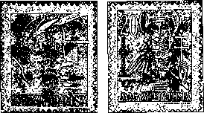
Forgeries
Figure 213

Any.I. forgeries were printed from type.
The prints are weak; at the rear side only the prints of the dots are protruding. Their color and the size of each font used in the type are the same as those of the real ones. Dangerous forgeries!

Characteristic Features of Forgeries

a) On the edges of the overprint, there is a dark, thin strip of ink, similar to the Auxiliary Series I.
- The total width of the overprinted prints varies from 15.7 to 16 mm in the case of continuous copies, instead of the regular 15.4 mm.
- The distance from the left of letter "A" to the first dot is 9.9 to 10 mm, instead of the 9.8 mm on real overprints.
- The distance from the left edge of the first dot to the right edge of the second dot is between 5.8 mm and 6 mm, instead of teh authentic 5.6 mm.
- The distance between the first dot and the Roman "I" is 0.2 mm. On forgeries, it is 2.4 mm, instead of the authentic 2.2 mm – this is a striking difference.
- Finally, on the real overprints, the lower left corner of the letter "A" is usually slightly curled, while on the forgeries it is angular (Figure 213).

The forgeries Alj. I. were printed from type, but still the prints are weak, rarely protruding on the rear side. Their color approximates the color of the real overprints, but is still slightly darker, and slightly cinnabar red instead of cramped red.
This color difference is the most noticeable under the umbrella lamp. But the difference in the size of the overprints is more relevant than the color, so the recognition of forgeries does not cause any difficulties.

Characteristic Features of Forgeries
- The overall width of the overprint is 14 mm instead of 13.6 mm.
- Letter "A" is more pointed than its original; its height and that of letter “l" is 3.5 mm instead of 3.3 mm.
- Letter “j" is 4.9 mm high instead of 4.2 mm.
- The overall width of “Alj.” is 8.4 mm instead of 8.2 mm.
- The thickness of Roman “I" is 1.2 mm instead of the standard 1 mm.
- The distance from the left edge of the first ■-shaped dot to the right vertical edge of the second dot is 6.6 mm, instead of the authentic 6.4 mm.
3 Forgeries with CS 5-1 overprinting occur in fairly big numbers both in case of regular and inverted overprinted stamps of 5 kg parcels of stamps and the 70-fillér denomination of "Nagyasszonyok" (reverse overprinting, top-down text). Since both forgeries have been traded at the expense of collectors at the same time, and their nature is the same, we are discussing them together.
Many of these two postage stamps were forged several times, but dealing with less sophisticated ones is unnecessary because their recognition is not it difficult (Figure 214, first 30-fillér base value stamp). They were printed using carved rubber one by one.
Much more dangerous is the 5 kg parcel postage stamp forgery that was produced by letterpress printing in blocks or sheets, with relatively accurate observing of the rows and spacing. In this case, the printing force was reduced to smaller than the original, so the inscription on the reverse side is rarely protruding.
The black color of the overprinting most often cannot be distinguished from the original, since in case of this denomination the occurrence of both glossy and not glossy pieces is also common. The exceptions are the copies overprinted with overly diluted black ink or those overprinted with black color with lacquer gloss. In these cases, the quartz lamp will not help, as. it does not break the black color.
To detect forgeries, comparative measurements must be done this time too.

Characteristic Features of Forgeries
- The overall width of the overprinting of the forgeries ranges between 15.4 and 16 mm, while that of the authentic postage stamp overprints is 15.9—16 mm (Figure 215).
- The width of "C" is 3.2 mm, its height 3.3-3.7 mm, instead of the width of 3.4-3.5 mm and a typically steady height of 3.3 mm. The first characteristic feature of the forgeries is Feature 1, the aperture in “C” shown in Figure 215. The outer width of the aperture varies between 0.8 and 1.2 mm, and its ends are aligned towards the center point, as opposed to the permanent 0.7 mm aperture in the authentic postage stamps, and the endings on the latter are always parallel lines.
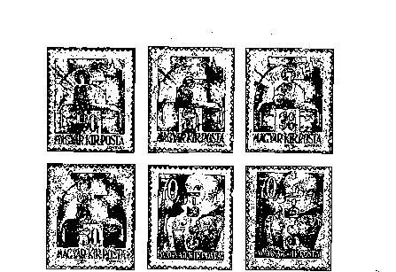
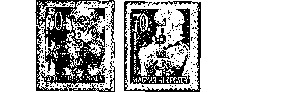
Forgeries
Figure 214

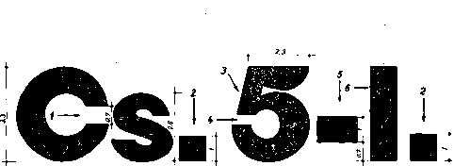
-j
to
"Valódi Hamisítvány
• 215. ábra
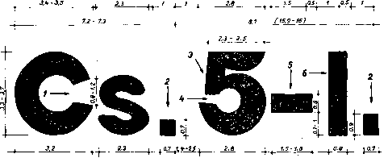
7- 7.3 ■ в. к-вГ7 (tS.b- 16)

For the sake of completeness, it must be mentioned that there are also forgeries with the letter "C" of the same shape and size as the letter "C" of the real overprinting (see Figure 214, the second stamp of the second row). In such instances, the false overprints can be identified by sesheeting for the features discussed below.
- The width of the letter "s" is 2.3 mm both on the forgeries and the true overprints. Its height varies from 2.6 to 2.8 mm on the forgeries, as opposed to the constant 2.6 mm of the true postage stamps.
The letters "s" are varying in shape and thickness, their ends are blurred, while on the authentic overprints the middle part of the letter is thicker than the lower and upper parts, and the ends of the letter end are horizontal lines, except for a few cases.
- The second most characteristic feature is the variable size and shape of the two dots in the false overprints (marked as 2 in Figure 215). While on the real overprints, the second dot is always a 1x1 mm square, which may sometimes be bordered by slightly defective lines, its size not changing, the dots of the forgeries vary in shape and size.
From 0.7x0.7mm square to 0.7x0.9mm vertical or horizontal rectangle, there are many variations. If the first dot is approximately 1 x 10 mm square, the second one would be remarkably rectangular. These variable shapes and sizes are shown in detail in Figure 214.
- Numerous versions of “5” are known in forgeries. Detailed analysis of these is unnecessary in the present resesheet, as distinguishing these requires very accurate measuring instruments that are not yet accessible to everyone.
However, there are some of the features of “5” which can be easily observed with a simple magnifying glass. One of the features in Feature 3 in Figure 215 - the vertical part of “5”. In forgeries, the left outer edge of the vertical part is either absolutely vertical or forms an angle of just a few degrees with the imaginary vertical line, while in the case of authentic overprints, this stem bends to the right of the imaginary vertical line - the difference is visible, 8 to 10 degrees.
In Figure 215, the opening shown in Feature 4 is bordered by parallel lines on the authentic overprints, while in the case of counterfeits, these two border lines are usually cohesive.
- The third major distinctive feature after “5” is the size and position of the hyphen. While in the case of authentic overprints, the hyphen is always 1.5x1 mm in lenght and rectangular, with the lower horizontal edge is at 0.7 mm above the baseline, the width of the hyphen on forgeries varies between 1.5 and 1.8 mm, the thickness is generally 0,8 mm, and the lower edge takes place at 0.7 to 1 mm from the baseline (shown as 5 in Figure 215).
This hyphen is often lumbar trapezoidal instead of a rectangle.
It is to be noted that this 0.8 mm thick hyphen is the only font. on the forgeries that always differs from the 1 mm thick rectangular hyphen in the real overprints.
- False overprints feature the Roman "I” 0.8 mm wide, compared to the standard 1 mm width standard (as shown in Figure 215). Although I have a 1 mm wide Roman "I” occurs on false prints too, as can be seen on the 3rd stamp of the second row in Figure 214, considering the other features the recognition of the forgeries is not difficult.
Figure 216
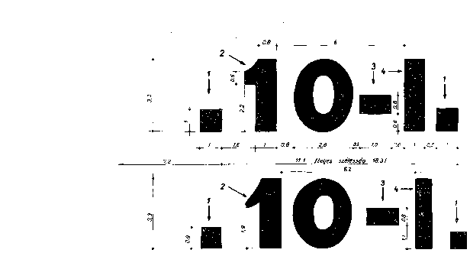
Forgery
I 0.9 l te-2 I / y0.6^
_2,a_
7- 7A
1ГА-119 /teljes
1.5 ^ 0,Q ^ O.B I Q.e I 0.8 I
szélesség 18, k-19,3 Ì
é-

Characteristic Features of Forgeries
- The overall width of the overprinting of the forgeries ranges between -18.4 and 19.3 mm, while that of the authentic postage stamp overprints is 18.3 (Figure 217).
- The information on the letters "C" and "s" is the same as in the case of the 5 kg parcel postage stamps, especially as regards the aperture of “C ".
- In this case, the second most characteristic feature of counterfeits size of the two dots: 0.8 to 0.9x0.8 to 0.8 mm, as opposed to the constant 1x1 mm of the genuine overprints (as shown in Figure 217).
- One of the most characteristic features of fake overprints of the 10 kg parcel postage stamps is the shorter part of the “1” in "10". In genuine overprints, the shape of it is bordered by a horizontal and a vertical rim and an inwardly curved arc. By contrast, on the fakes it is an irregular and variable shape that resembles a "hanging nose" (denoted by “2” in Figure 217). We find regular-shaped “1” among the forgeries too, but there the distance between the first dot and “1” is 2 mm, as opposed 1.6 mm of the true overprints. (Feature 3 on Figure 216).
- The hyphen after “10” is 1.5x0.8mm rectangular, which is the same on both fakes and genuine overprints. However, on the fakes its lower edge is at 1.1mm from the baseline, while on the genuine postage stamps it is at 0.8 mm from the baseline.
- Finally, the Roman "I" is mostly 0.8 mm wide, instead of the standard 1 mm (Feature 4 in Figure 217). Sometimes there is 1 mm wide Roman "I" on fakes, although their occurrence is very rare.
In addition to the forgeries mentioned above, we also know the reversely overprinted forgeries listed below, noting that reversely printed genuine copies are not known. These forgeries were produced by printing to defraud collectors. The general feature of these fakes is that the printing took place using rollers, and the ink ran to and dried at the edges of the letters. By contrast, in the letters printed by State Printing House on the fast press the ink was uniformly distributed. However, the most secure way of detecting forgeries is a detailed comparison of dimensions in this case too.

5 Forgeries Hl. I
Characteristic Features of Forgeries
- The overall width of the overprint is 11.8 mm, while on the genuine prints 11.9. Although this difference is insignificant, other dimension differences are more pronounced.
- The distance from the left edge of “H” to the right edge of the second (square-shaped) dot is 6.8 mm, instead of the authentic 6.6 mm.
- The distance between the first dot and the Roman “I" is 2.1 mm, instead of the authentic 1.5 mm.
- The distance between the left side of the first, sqare-shaped dot to the right side of the next dot of the same shape is 5.9 mm instead of the regular 5 mm.

6 Forgeries of Type Tl I
Characteristic Features of Forgeries

- The overall width of the overprint is 10 mm, while on the genuine prints 10.8.
- The distance from the left edge of “H” to the right edge of the second (square-shaped) dot is 6.2 mm, instead of the authentic 6 mm.
- The distance between the first dot and the Roman “I" is 2.2 mm, instead of the authentic 2 mm.
These overprints were produced with heavily diluted ink – they are easy to distinguish not only from the deep black but also from dim black originals.

7 Forgeries of Type Tlp I
Characteristic Features of Forgeries

- The total width of the forgeries is the same as that of the genuine overprints - 13.7 mm, but everything mentioned earlier about the black color stands for these stamps as well.
- The distance from the left edge of the letter "T" to the first square dot is 9.7 mm instead of the genuine of 9.5 mm.
- The largest dimension difference is found between the first dot and the Roman "I". This distance on forgeries is 1.3 mm instead of 1.6 mm on the genuine overprints.
The height of the overprinting of these forgeries is the same as that of the genuine ones - 3,3 mm.

1946: POSTAGE STAMPS FEATURING LETTERS AND NUMERALS II
In the event of further postal price increase, which was unavoidable because of the inflation, at the same time when Series I of postal stamps featuring letters and numbers was produced, a provision for the distinguishing mark 2 was issued for the next series.
As the new tariff increase was introduced by Regulation 204,800 / A. 4 (P.R.T. 1946/9), the Ministry of Commerce and Transport issued Regulation 205.800/A. 4 (P.R.T. 1946/9), which entered into force on February 1, 1946 (on the same day). It provided for the issuance of Series 2 of postage stamps featuring letters and numbers, with the remark that postage stamps Cs. 5 - 2 and Cs. 10-2. will be received by post offices within a few days.
Similarly to the postage stamps of Series I, the denominations of this series could only be used in domestic postal traffic and initially the types of mail indicated on the stamps had to correspond to the mail items.
The same regulation urged for the quickest possible use of the Series I of the postage stamps featuring letters and numbers.
The reason for the delayed issuance of two kinds of the parcel postage stamps belonging to the series lies in the fact that overprinting (as in case of the parcel postage stamps for internal use of Series 1) started on the base stamps of the denomination of 30 and 80 fillérs featuring the Hungarian royal crown. As a result of withdrawing Series I by a Circular on January 22, 1946 from the use in intra-administration, the overprinting of the two same and identical base stamps of Series II was stopped; the overprinting of the still missing 70-fillér denominations Cs. 5—1. and Cs. 10—1. belonging to Series I started.
They were ready and issued on 28 January 1946. Only after the production of these two stamps could Series II. 24 H. and 80 N. fillér base parcel postage stamps be printed.
The instruction issued previously to use the postage stamps of the series only for the types of consignments corresponding to their mark was modified by Regulation 206.500/A issued on February 5, 1945, (P.R.T. 1946/11). According to this regulation, the postage stamps of Series II could be used for for any domestic consignment up to their face value - if necessary with other stamps in circulation.
Post offices, however, were instructed to continue to use these postage stamps primarily for shipments that correspond to their mark, for simpler mail processing.
The postage stamps which had not been issued, those 30- and 80-fillér ones featuring the Royal Crown and meant for parcels in Series II were destructed, with the exception of the pieces in the Stamp Museum. Nevertheless, some of the pieces were illegally let into collectors’ circulation. An owner of a block of 20 pieces of Cs. 5—2/30 f H
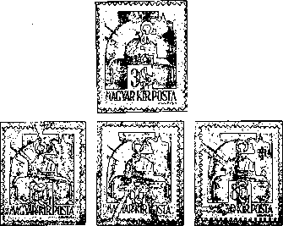
48 68 09
Figure 218

Figure 219
noticed this so far unknown overprinting only after erroneously exchanging 15 pieces in the July and August of 1956 on the Quick Exchange in MABÉOSZ - after having sold a pair of these postage stamps as if they belonged to Series I. A copy from this source is shown in Figure 218.
These two denominations, which are officially considered as proofs, are discussed here partially due to the historical accuracy, and partially because they are noteworthy because they provide indispensable guidance on the type version of the 10kg parcel overprinting and the manufacturing order of these types.
We can conclude that in 10kg parcel postage stamps of Series I of the postage stamps featuring letters and numbers printed first as Type I on 80-fillér base stamps (sheets of 100 pieces), the second dot used in the abbreviation is always square. On the other hand, on the postage stamps of Type II printed on the same base postage stamps and later on the base stamps of 70 fillérs for the parcelsl of 10 kg, on 75 postage stamps of the sheet the second dot is not a square but a circle of 1 mm diameter. That is why Type II of "Cs. 10-I” had to be separated into two sub-types.
The occurrence of these two types can be detected also when looking into the full sheet of 10 kg parcel postage stamps of Series II, which were not issued, as mentioned earlier. There are square dots on the same 25 stamps of the sheet, and round ones on 75 postage stamps of the sheet. In addition, three typical features may already be found on this print, the ones which have already been described when looking into the earlier produced 10 kg parcel postage stamp produced on the base stamp of 70 fillérs, of Series I. Namely, the letter "C" of the 48th stamp and “1” and “2” of the stamps 58 and 99 are are discontinuous (Figure 218).
Consequently, the printing order of the 10 kg parcel postage stamps and type versions of the 100-piece type may be defined as follows:
Cs. 10—1/80 f H; Type I
Cs. 10—1/80 fH; Type II a and b
' . 3. Cs. 10—2/80 fH; Type III a and b
4 Cs. 10—1/70 f N denomination; Type II a and b
6. Cs. 10—2/80 f N denomination; Type III a and b
The other features of the parcel stamps listed under points 3, 4 and 5 are due to subsequent fractures and injuries, but the slanting fracture of “1” of the 99th stamp is nicely visible in all five overprints.
The type versions IIa and IIb found in the entire overprint, i.e., the. 75 square second dots were modified to round dots when the postage stamps listed in Point 2 were printed; this remained unchanged in subsequent three instances of overprinting.
Six denominations of the series were introduced by Regulation Issued on 205.800 / A. 4 as of 1 February 1940; the two parcel postage stamps were issued after a few days late.
Although they were withdrawn from circulation by Regulation 233.703 / 4. (P.R.T. 1946/38) as of 30 June 1946, they eventually fell out of use earlier, due to their depreciation.

180 OLDAL
Number of Copies
Hl. 2/40 f/10 f H Hip. 2/8 P/20 f N Tl. 2/I0f/4 f H Tip. 2/4 f H Any. 2/1 f H Ajl. 2/12 f H Cs 5-2/24 fH. Cs 10—2/80 f N.
3 920 000 pieces 1 150 000 pieces 9 500 000 pieces
696 000 pieces 1 945 000 pieces
360 000 pieces 1 930 000 pieces 1 964 000 pieces
These postage stamps were traded at post offices, postage stamp dealers, as well as at collectors' office of the Post Office for the face value + 25% or 50% handling fee.
Face Values Of The Series
Letters and Numerals | Face value | Base stamp | Color of Overprint | Base impression  Color
Hl. 2 | 2 Ò00 P | 40 f/10 f H ( Auxiliary II) | red | blue
Type. 2 | 1 500 P | 8P/20 f N ( Auxiliary II) | red | blue
TI 2. • | 3 000 P | 10 f/4 f H (Auxiliary Series I) | black | blue
Type 2 | 2 000 P | 4 f H | black | —
Any. 2 | 500 P' | 1 f H | red | —
Alj. 2 | 6 000 P | 12 fH | red | —
Cs. 5—2. | 10 000 P | 24 fH | black | —
Cs. 10—2. | 15 000 P | 80 fN | black | —

Watermarks and watermark positions are the same as on the base stamps: X, A/1, 2 Perforation: 15 teeth, comb

Overprints
In order to produce the series, the Post Office would again use “Hadvezérek” (Military Leaders) produced earlier, the denominations of 1, 4, 12, and 24 fillers, “Nagyasszonyok” (Noble Ladies) series, the denomination of 80 fillers, and, due to the shortage of the postage stamps, the already once overprinted series of Auxiliary Stamps I, denomination 10 f/4 f H and Auxiliary Stamps II , denominations 40 f/10 f H and 8 P/20 f N.
The postage stamps of the series were overprinted in the State Printing House from 100-piece type on fast intaglio press. Newer basic coloring was not produced. The information pertaining to the basic coloring of the three denominations of the series is the same as the what has already been described.
The text of the overprint of Series II differs only in the following: at the end of the text the serial number "2” appears in Arabic.
From the results of looking into entire overprints, we can conclude that when this overprint was being produced, partially the 100-piece types of the first edition were used, and the Roman “I” was replaced with Arabic “2” at the end of the text. This procedure was mainly used when smaller quantities were to be printed. (eg Cs 10-2.), and especially in those cases where the type was suitable for further overprinting. Otherwise, a new type was made, which was reproduced in the case of large number of denominations (eg TI.2), in order to allow printing on more than one machine simultaneously.
The summary of what is known about each overprint follows below.
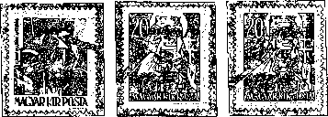
Cl. 1. 09.
Figure 220

Overprint Hl.2
The overall width of the overprint was 12.2 mm, while its height 3.3 mm. The letters are 1 mm thick, while the thickness of “2” varies. The apparent thinning of individual prints is related to ink failure. Dots used for abbreviations are everywhere square-shaped.
On the 1st stamp of the sheet, a slight defect occurred in the overprint during the printing. The horizontal line of letter "H" was pressed at its top, at the left (Figure 220).
The overprint damage of Base Stamp 58, 40 f / 10f H, is also quite frequent.

Overprint Hlp 2
The overprint is of the total width of 17.2 mm and of the total height of 3.3 mm. The letters are 1 mm thick, while “2” is of varying thickness. The dots are 1x1 mm squares.
On the 1st stamp of the sheet, the right vertical line of letter "H" is depressed at the bottom, on its outside. Similar damage can also be seen on the 59th stamp in letter "L" (Figure 220).
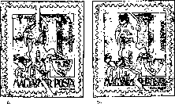
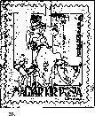
The two defects of the base stamp 8 P / 20 f N often appear here too, on the 4th and 20th postage stamps of the sheet.
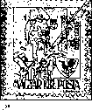
Figure 221

Overprint Tl 2
The overall width of the overprint was 12.1 mm, while its height 3.3 mm. The letters are 1 mm thick, while “2” is of varying thickness. The dots are usually 1x1 mm squares; worn, almost round-shaped dots are also common.
Taking into account the large number of copies of this denomination and the results of looking into the prints of the entire sheets, we have come to the conclusion that this denomination has been produced using several types. Two full-sheet overprint differences have already been established, but further details are still being recorded. Below is a description of these two full-sheet overprint types.
The overall width of the overprint is 197 mm, while the height 242 mm.

Characteristic Features
On the 35th stamp of the sheet, letter "Д” is deformed in its upper third part - it is indented on its left side. Similar defects are found on many stamps of the sheet, just as the frequent thinning of the vertical line of letter "T" before the horizontal line (Figure 221).
On the 6th stamp of the sheet, the horizontal line of "2", the end of the base is truncated; on Postage Stamp 16, the base is curling downwards, while on Postage Stamp 56, the slanting line is indented before merging into the lower horizontal line (Figure 221).
The Type II overlay is 197 mm wide and 240 mm high.
The difference between the two overprints is not only the total height of 2 mm|
but also Type II does not share the above characteristics of Type I. Type II is characterized by rounded dots, instead of the square-shaped ones.
It should be noted that both plates of base stamp 10 f / 4 f H were overprinted, so all characteristics of Auxiliary Plate I can be found in this type. Likewise, all versions of the base stamp can be found.

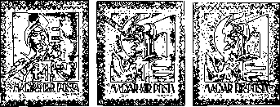
78 67 6

Overprint Tlp 2
The overall width of the overprint was 15.1 mm, while its height 3.3 mm. The letters are usually 1 mm thick, while the dots 1x1 mm squares.
In this denomination, the only characteristic feature appears on the 78th stamp of the sheet. There is a small indentation in the lower part of the loop of the letter "p" (Figure 222). “Filled" prints are frequent too, due to the clogging of the middle of "p".

Overprint Any. 2
The overall width of the overprint was 16.7 mm, while its height 3.3 mm. Letters “A” and “y” are 0.8 mm thick, while letter “n” 1 mm. The width of “2” is 0.8-1 mm. The dots are square-shaped, their size not always reaching 1x1 mm.
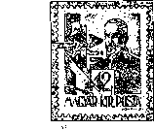
An identification mark can be found on the 67th stamp of the sheet The connecting curved part of letter "n" is firmly depressed at the bottom and on the right (Figure 222). Damage to the dots is frequent, and the absence of the second dot may occur, as shown in Figure 222 on the 6th postage. stamp of the sheet.
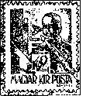
80
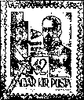
20

Overprint Ajl. 2
The overall width of the overprint was 14.7 mm, while its height 3.3 mm. Letter “j" is 4.2 mm high. Lines of “A" are 0.8 mm, the other letters are 1 mm thick. The thickness of the lines of “2” is 0.8-1 mm. The dots are 1x1 mm, square-shaped.

Characteristic Features
On the 58th stamp of the sheet, the right side of letter "A" is slightly damaged, and on the 77th stamp the horizontal linking line is depressed at its left side (Figure 223).
On the 80th stamp, the upper outer portion of the right line of letter "A" was depressed forming a curve, while on the 20th stamp the first dot turned into a triangle standing on its angle, due to the diagonal damage (Figure 223).

Overprint Cs. 5-2.
The overall width of the overprint was 17.5 - 17.7 mm, while its height is 3.3 mm. The dots are 1x1 mm squares. Otherwise, the inscription with the hyphen is exactly of the same shape and size as on the overprints of the 5 kg parcel postage stamps of Series I of the postage stamps featuring letters and numerals, as shown in Figure 215.
Regardless of a few tenths of a millimeter difference in the overprints of the entire sheets, which may be negligible in case of the already perforated and gummed sheets, the examination of the identification features suggests the conclusion that these overprints were produced using a new type, disregarding the new numeral “2” at the end of the inscription. While on the whole sheet of Cs. 5 — 1/70 f N typical deficiencies can be found on Postage Stamps 34, 59, 79, these do not appear on the entire sheets of Series II of 5kg parcel postage stamps. On the other hand, there are new, typical features such as injuries that are described below.

Characteristic Features
The overall width of the overprint is 197 mm.
The total height of the overprint is 245.5 mm.
a) On Postage Stamps 6, 20, 47, 48 and 57, in the upper part of letter "C", there are various depressions resulting in white spots (Figure 224).
b) On the stamps 23, 62, and 83 of the sheet, the letter "s" shows the same print discontinuity as shown in Figure 225.
c) In "5”, three faults turn up regularly. There are depressions in the following places: on the 59th postage stamp, the upper part of the numeral; bottom of the 75th postage stamp; outer lower edge of the numeral on the 44th stamp (Figure 226). In the latter, the lower part of “2” is also damaged.
d) Another damage to "2" occurs on the 54th postage stamp of the sheet, in the form of a circular impression on the upper part of the numeral (Figure 226).
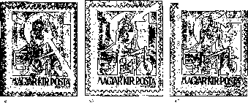

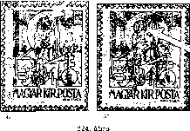

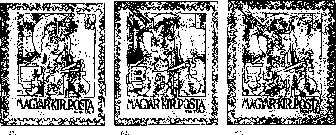
Figure 225

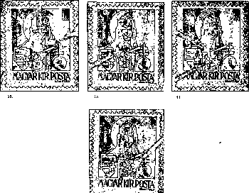
Figure 226

Overprint Cs. 10- 2
The overall width of the overprinted sheet is 198 mm.
The overall height of the overprinted sheet is 248.7—249 mm.
The overall width of the overprint (Cs. 10 — 2.) is 19.5 mm.
With the exception of the latter two sizes, which derive from the larger size of “2” than that of the Roman “I”, the overprinting of "Cs. 10 -2" is exactly the same as that of 70-fillér "Cs. 10-I". Since the text of the overprint has changed, in our list it will be considered Type III among 10 kg parcel postage stamps featuring letters and numerals.
The two subtypes of the overprint of Cs 10 - 2 here are also located at the same places as in Cs 10 -I, i.e. square dot (Type IIIa), on each stamp of the 1st and 10th vertical row of the sheet and on the postage stamps 82, 92, 9, and 19 - in 25 places altogether.
The second dot of the other stamps of the sheet is round (Type III b), as shown in Figure 227.
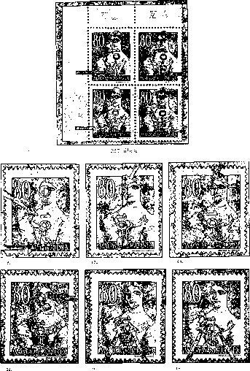

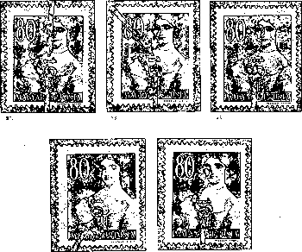
Figure 228b

Characteristic Features
Characteristics of Cs. 10 - 2 overprints are the same as those of the 70-fillér base stamp values Cs. 10 -I. Therefore, instead of repeating the already listed identification features, they are shown only on figures (Figure 228a, b).

VERSIONS OF OVERPRINTING
The information known about the red and black prints is the same as that already provided at the 1st series of these postage stamps.
The same applies to the overprint slippages and the partial missing overprinting.
Reverse overprints have turned up in two denominations: Any. 2. and Cs; 5 — 2. (Figure 229). It should be mentioned, however, that the the most part of the reverse overprints of Any. 2 that we have so far examined is did not prove to be genuine.
Postage Stamp 19 of TI.2. is the collectors’ favorite but rarely occurring erroneous print. On some of the sheets, the overprint "T” is missing, so the wrong text is just "1. 2” (Figure 229).
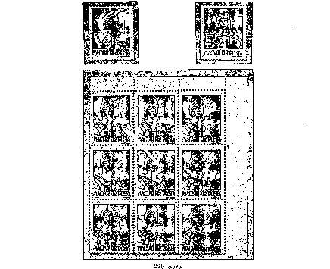
This erroneous print is likely to be the result of deficient typing, which was noticed and repaired already in the printing house. Because of the size of the overprint type, the size of the entire overprinted sheet (197 x 239.5 mm) and the absence of the four features characteristic of the 1st print, this sheet containing the erroneous print can be included into Type II of the overprint TI. 2. Taking into account the base stamp, the Auxiliary Stamp Series I can be found on each of the 10-fillér platen types.
"The Data Pool of Hungarian Postage Stamps" mentions an erroneous print of "TI. 2.” without “2” on Postage Stamp 80. However, since its repeated occurrence has not been proved, this defective printing must therefore be considered as a unique occurrence.
An interesting print is kept by the Stamp Museum, namely a complete sheet of “Hadvezérek”, 50-fillér denomination, overprinted by Any. 2. - it was noticed during the quality check.
While other versions of the overprints are rarely encountered, versions of the base stamp 10 f / 4 f H are very frequent, also in combination with special identification features of this overprint.
Franking
As already mentioned in the introductory part of the edition, Series II of the postage stamps featuring letters and numerals became also available for the franking of other types of consignments as of February 5, 1946, even in the form of a mixed franking, besides the franking of the consignment types originally indicated on them. Their occurrence is most common in the latter form.
Forgeries
After the appearance of the reverse overprint of Cs. 5—2., it soon became known not just for collectors but also for counterfeiters of these specialties. Thus, after the appearance of genuine reverse prints in the collector's circulation, their forgeries also appeared.
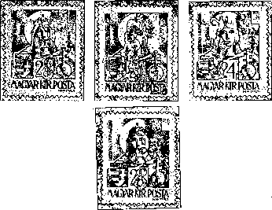
Forgeries
Figure 230

Characteristic Features
Recognizing a part of the 5 kg reversely overprinted forged stamps belonging to Series II does not cause any particular difficulty.
- The overall width of the overprint is 19 mm instead of 17.4 mm - thus it is wider than the genuine overprint by 1.6 mm.
- The information pertaining to letters “C” and “s” is the same as listed for the forgeries of parcel postage stamps of 5 kg parcels of Series I, in points b) and c), as well as the features shown in Figure 215.
- A very important feature of forgeries is the distance 1.6-1.8 mm between the first dot and “5”, instead of the regular 1 mm.
- The information pertaining to “5” is also the same as the information provided for the forgery of Series I, in point e).
- The distance from the right edge of the first dot to the end of the dash is 6.9 mm instead of 5.7 mm.
- However, the most characteristic feature of the most part of forgeries is the thinning head of the "2", 0.4 mm thick. As you can see in Figure 230 (2nd and 4th), this essential difference is visible also with the naked eye. The difference between it and the genuine “2” (1st, 0.8 mm thick) is easily distinguishable. Regular-shape “2s” are also known among the more dangerous forgeries, but even on the overprints the spacing is different from the genuine. (Figure 230, Postage Stamp 1).
- The distance from the right edge of the dash to the right edge of the second dot is 4.9 mm instead of 4.5 mm.
- The dots are 0.9-1x0.9-1 mm squares.
Forgeries of the reversely overprinted Any. 2 are rare. Their recognition is made possible by a detailed dimension analysis done with genuine and regularly positioned overprints.
2 Forgeries of the present edition of denomination TI. 2. to defraud post office are also known. One piece of the six "TI" stamps attached to a mixed-franking letter sent on Msheet 13, 1946, in Magyarszombatfa, is a simple forgery. “TI. 2.” was written by an ink pen on denomination 10f / 4f H of Series I of the auxiliary stamps, which are otherwise the base stamps of this denomination. The accepting post office processed and forwarded the letter. Falsification was not discovered by the delivery office in Zalaegerszeg either.

1946: KÖZTÁRSASÁG (REPUBLIC 1946)
This series of two stamp denominations was issued to commemorate the codification of the Republic of Hungary on 1 February 1946.
The image was designed by György Konecsni.
These stamps were introduced by Regulation 208.000/Bgi. (P.R.T. 1946/11)
on February 12. The stamps were planned to be issued on February 1, 1946, but were only issued on the 12th, due to technical difficulties. Thus, on February 1, 1946, the Post Office used only a "republic" memorial hand stamp made of rubber in six post offices of Budapest (Budapest 4, 7, 57, 62, 72 and 114).
These stamps were withdrawn by Regulation 233.703 / 4. (PRT 1946/38) as of June 30, 1946; however, due to the depreciation of the money, their postal usage was practically gone much earlier.
These postage stamps were sold at post offices without any limitation.
Number of Copies 2 445 000 pieces of perforated postage stamp pairs
Figure 331

Face Values Of The Series

3 thousand pengő, brownish red
15 thousand pengő blue

The image is the same on both denominations. The image is not framed; in the middle, there is an oval shape, in which there is a female figure representing the Republic and a male figure representing the Hungarian nation liberated from slavery. There is also inscription "RESPUBLICA HUNGARICA” and the value numeral and denomination on the two sides. The image is of rectangular shape, 37 x 26 mm.
These postage stamp were printed in the State Printing House, with single color grid, on 100-piece sheets.
For each of the denominations, one or two printing errors are known. On the 31st stamp of the 3000-kreuzer denomination, a small color dot appears before the “ezer” (thousand), which can be seen as a letter. Its cause is cylinder correction on the diapositive carried out to remove contamination there (Figure 232).
On the 5th stamp of the 100-piece sheet of 15 000-kreuzer denomination, the letter “R" of “HUNGARICA” is replaced by "K". Figure 232 This erroneous letter is a slide error generated by the step-and-repeat in the production process described below. When retouching images - when colored or white stripes were eliminated - the retouch brush paint splashed white on the head of the letter "R", producing a colored stain there, which then was transferred on the printing roller.
On these postage stamp images without frames reaching up to perforation we can often see dark stripes of the same colour as the postage stamp image parallel to the perforation at the side of the postage stamps. These stripes were generated as a result of the grid intaglio printing related, a few-tenths-of-millimeter overlap due to step-and-repeat, which can rarely also be seen as negative, in the form of a white strip. In Figure 232, this version can be seen on the right vertical side of the 3000-kreuzer postage stamp and the lower horizontal edge of the 15000-kreuzer postage stamp.
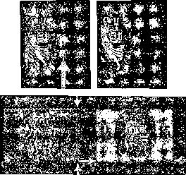
Figure 232

Paper: the stamps of the series were printed on white, 0.9 mm thick, X-watermarked treasury paper.
Gumming: white
Watermark: A/1,2.
Perforation: 12:12, 1/2 comb perforation. Non-perforated pieces (□) were Phase II impressions placed on the market.
Franking: postal items sent using these denominations of the series are quite frequent. It may be noted that, according to a new tariff increase introduced on February 1, 1946, the 3,000-kreuzer denomination was produced for the franking of the long-distance letters.

1940: LOVASFUTÁR (EQUESTRIAN COURIER)
A general-use set of 13 postage stamps, the appearance of which was strongly influenced by the pressure of inflation and the producing of the postage stamps trying to catch up.
Regulation 207.800 / Bgi. published in P.R.T. No. 12 of 1946 introduced - as of 18 February 1946 - general-use denominations of 1, 3, 4, 6, 10, 15, 30 and 50 thousand kreuzers. On this day, however, only the denominations of 4 and 15 thousand kreuzers appeared. The printing of the 1, 3, and 6 thousand kreuzer denominations was terminated because of their low face value, which became out-of-date in the meantime.
Regulation 211,000 / Bgi. (PRT 1946/15) replaced the above mentioned four denominations by 20, 80, 100 and 200 thousand kreuzer denominations, simultaneously with the tariff change of Msheet 1, 1946. These postage stamps had to appear on Msheet 6, 1946.
Regulation 218.600 / Bgi, which entered into force on April 3, 1946, required the issuance of the 500 and 800 thousand kreuzer denominations on 5 April 1946, as a result of the tariff increase on April 1, 1946. (P.R.T. 1946/22)
Finally, the last two stamps of 160 and 640 thousand kreuzer denominations were issued on April 12, as Regulation 219,600 / BGI of the same month (P.R.T. 1946/23) provided.
The images were designed by György Konecsni.
The Post Office placed them on the market only later, due to their delayed manufacturing. They were placed on the market on the dates listed below.
The series was officially withdrawn only on June 30, 1946 by Regulation 233.703 / 4. (P.R.T. 1946/38), but they actually dropped out of use earlier, due to their depreciation.
These postage stamps were sold at post offices.
Figure 233

Face Values And Number Of Copies Of The Series; Actual Dates Of Entering Circulation
4 thousand P | brownish orange | 5,148,000 pieces | 18 February 1946
10 thousand P | red | 4,052,000 pieces | 25 February 1946
15 thousand P | blue | 3,026,000 pieces | 18 February 1946
20 thousand P | brown | 4,176,000 pieces | 8 Msheet 1946
30 thousand P | red violet | 4,045,000 pieces | 8 Msheet 1946
50 thousand P | greenish gray | 4,040,000 pieces | 27 February 1046
80 thousand P | ultra marine blue | 2,038,000 pieces | 14 Msheet 1946
100 thousand P | carmine red | 4,090,000 pieces | 18 Msheet 1946
160 thousand P | greyish green | 1,984,000 pieces | 15 April 1946
200 thousand P | green | 6,040,000 pieces | 27 Msheet 1946
500 thousand P | brownish red | 1,990,000 pieces | 5 April 1946
640 thousand P | brownish olive green | 1,728,000 pieces | 15 April 1946
800 thousand P | violet | 2,980,000 pieces | 6 April, 1946

The postage stamp image is the same on old postage stamps. The image is frame-free, and depicts a galloping equestrian with a wheat kale and inscriptions “MAGYAR POSTA” (HUNGARIAN POST) and “ezer P” (thousand P). Below, there are darker shade value numerals. , , ,
The image is of a rectangular shape, with the distance up to perforation of 22X26 mm. These postage stamp were printed in the State Printing House. The stamp image was produced by raster (grid) intaglio printing in the 1st round, while the value numerals were produced in the 2nd round using the 100-piece type, letterpress printing technique.

These postage stamps were marketed in 100-piece sheets.
- Printing specialties
Dark, uneven stripes on the edges of the stamps occur in the case of these postage stamps too (Figure 234). Their origins are the same as in the case of the "Köztársaság" (Republic) series.
The differences in the edition are mainly related to the 2nd run, the relief printing. The following are frequent: shifts of numerals, protruding numerals on the rear side, and color transfers by sheets, as well as minor damage to numerals (Figure 234).
A smaller shade version of the color of the postage stamps can also be observed.
These postage stamps were produced on 0.1 mm thick, white, "A" quality, X-watermarked treasury printing paper.
Gumming: white
Watermark: A/1,2.
Perforation: 15 teeth, comb. Non-perforated pieces (□) are Phase II prints. Out of 640 thousand P denomination, pieces without perforation at the bottom turned up (Figure 234). •
Figure 234

Franking: postal items sent using these denominations of the series are quite frequent. In determining the nominal value of the stamps, the Post Office took account of the changes occurred in the meantime 1946 III 1-, III. 16-, III. 26-, IV. 1-, and IV. 11 tariff increases. The nominal value of these postage stamps was adjusted to these increases.
So when placing them on the market, the 4,000-kreuzer denomination, for example, was applicable for 500 g local letters and 250 g long-distance letters; the 15,000-kreuzer denomination was applicable for foreign letters of 20g; the 30,000-kreuzer denomination was applicable for the registered letters abroad; the 20,000-kreuzer denomination was applicable for the 20g long-distance letters, the 80,000-kreuzer denomination was applicable for foreign letters of 20g and finally the 160,000-kreuzer was applicable for 20g long-distance letters; 640,000 kreuzers were required for sending foreign letters of 20g .
The postage stamps of the series could also be used in mixed franking.
1946 POSTAGE STAMP ANNIVERSARY OF 75 YEARS
The set of 4 stamps, issued on the occasion of the 75th anniversary of the first Hungarian postage stamp, for postal personnel welfare, with a 100% surcharge (5 million P).
The postage stamp image was designed by Vera Harsányi and Péter Székely.
These postage stamps were introduced by Regulation 233,100 / Bgi. (P.R.T. 1946/25) issued on May 1, 1946. They. could be used for franking until June 30, 1946 (233,703 / 4 P.R.T. 1946/38), but had dropped from postal traffic much earlier due to their depreciation.
Number of copies: 150,000 full perforated series.
They were only sold in a full series, a single series to a buyer; they were marketed in Budapest, at post offices number 1 in those towns where there were several post offices, as well as in the municipal offices of Berettyóújfalu, Mátészalka and Szikszó. They were also sold at ORBEK IV, at the temporarily set post office - for a coupon attached to the admission ticket to the exhibition. The price was 15 million on May 1, 20 million on May 2 and 3, and 30 million on May 4 and 5, 1946.
The remaining stocks were returned on 8 May by post offices to the Postage Stamp Warehouse.
Figure 235

Face Values Of The Series
500+500 thousand kreuzers green
1+1 million kreuzers brown
1.5+1.5 million kreuzers brownish red
2+2 million kreuzers greyish blue
The image in the same on all four postage stamps. Against a clear background, a lying lion is carrying a Hungarian coat of arms, as if it were an open book. Behind it, there is a hammer. At the top „MAGYAR POSTA” (Hungarian Post Office) appears.
Above the upper edge of the colored base text „75 ÉVES A MAGYAR BÉLYEG” (THE HUNGARIAN STAMP IS 75 YEARS OLD) appears, its color matching the base color.
The postage stamp images are horizontally arranged, their size being 32.8 x 22 mm.
These postage stamp were printed in the State Printing House. The stamp image was produced by raster (grid) intaglio printing in the 1st round. The value numerals were produced in the 2nd round using the 100-piece type, letterpress printing technique.
The value numerals are of the same color as the stamps, but of more vivid shades, and smaller or bigger shifts are common.
It was marketed in 100-piece sheets.
These postage stamps were produced on 0.1 mm thick, white, "A" quality, X-watermarked treasury printing paper.
Gumming: white
Watermark position: A /1, 2
Perforation: 12-tooth comb perforation. Non-perforated pieces (□) are Phase II prints. The size of the stamp up to perforation is 37 x26 mm.
Franking: the series were bought for collector purposes, so we can hardly see them used for franking. Letters sent using these denominations of the series are very rare!
Commemorative postage stamps

1946: MILLION
As a result of the tariff increase of 1 May 1946 and the subsequent three tariff increases, the Ministry of Transport provided for the issuing of new postage stamps by its Regulation 223. 600 / Bgi. (P.R.T. 1946/25) as of May 1, 1946: 1, 2, 3, 4 and 5 million kreuzer denominations.
This was followed by further 3 denominations, 10, 20 and 50 million kreuzers, as of May 17, 1946, provided by Regulation 227,500 / Bgi. (P.R.T. 1946/30).
The image was designed by György Konecsni.
Figure 236
They were placed on the market later than provided by their issuing regulations, since they were manufactured by later deadlines.
The series was officially withdrawn as of June 30, 1946, but it actually dropped out of use earlier, due to its depreciation.

These postage stamps were sold at post offices.

Denominations and Number of Copies
1 million P | red | 2,010,000 pieces | 1 May, 1946
2 million P | bluish violet | 2,040,000 pieces | 13 May, 1946
3 million P | brown | 1,700,000 pieces | 13 May, 1946
4 milion P | grey | 2,020,000 pieces | 1 May, 1946
5 million P | red violet | 1,750,000 pieces | 13 May, 1946
10 million P | green | 2,382,000 pieces | 17 May, 1946
20 million P | carmine red | 2,866,000 pieces | 20 May, 1946
50 million P | brownish olive green | 2,832,000 pieces | 20 May, 1946

The postage stamp image is the same on old postage stamps. In the horizontally arranged rectangle bordered with a colored and the white line, there is a Hungarian coat of arms between two stylized wheat sheaves with inscription “MAGYAR POSTA” (Hungarian Post Office). and the value indication „MILLIÓ P” (million kreuzers). Below, the value numeral takes place.
The image is of a horizontally arranged rectangular shape, its size 22x18.
These postage stamp were printed in the State Printing House. The stamp image was produced by raster (grid) intaglio printing in the 1st round, while the value numerals were produced in the 2nd round using the 100-piece type, letterpress printing technique. The color was of dark shade.
The specialties that occur in the series are mainly due to the 2nd round of the printing: shifts of numerals, printing protruding on the rear side, and ink transfers by sheets.
Figure 237

Due to the occasional omission of the 2nd round, the very rare speciality associated with this edition appeared, the postage stamps of 1 million kreuzer without the numeral (Figure 237). The printing of the value numeral "1" is, according to our knowledge, missing from four complete sheets, probably due to the sheets sticking one to the other. The resulting faulty sheets were not discovered either during gumming or the quality control, which was easily possible with the red color of the stamp. Thus the sheets entered postal traffic. The following story related to the. discovery of one incomplete sheet demonstrates an excuse for the Post Office.
A well-known collector in Budapest famous for his eye in recognizing specialties purchased inflation sheet fragments at the beginning of 1950s. A sheet of 1-million kreuzers containing 90 pieces was amount of them. He folded it and bound with 10 same-denominated stamps to reach the total of 100 pieces. The ribbon of the bundle, however, opened in a few minutes, and the contents fell apart. It was only then that the owner, surprised, noticed that the numeral was missing from 90 pieces.
Who knows how many collections have these 90 stamps been part of since May 1, 1946. This sheet fragment containing 90 postage stamps was sold disintegrated; one piece is shown in Figure 237. On top of this, we know about the existence of another entire 100-piece sheet.
These postage stamps were marketed in 100-piece sheets.
These postage stamps were produced on 0.1 mm thick, white, "A" quality, IX-watermarked treasury printing paper.
Gumming: white and yellowish
Wateramk IX was previously used in 1941, for "Széchenyi" Commemorative Stamps series, for which smooth, white, 0.09 mm thick paper was used. The difference in quality and thickness between the two kinds of paper proves that in order to accommodate the growing demand in postage stamps, watermark roller IX was taken from storage and installed again. *
Watermark position: B/1,2. .
Perforation: 15, comb. Distance up to perforation: 26 X 22 mm. Pieces without perforation are Phase II impressions let into circulation.
Franking: these stamps followed the tariff changes of May 1, 10, 20, 1946. In this period their use was quite frequent.

1946: Text stamps III
It was a general use series containing 8 determinations. It was sequel to the series featuring letters and numerals; for easier understanding there were no abbreviations but full words. The series was introduced to the postal traffic on May 1, 1946, and it was the third series of one and the same day.
Regulation 233.400 / Bgi. (P.R.T. 1946/26) warned post offices that these postage stamp packs sent earlier containing newer postage stamps should be opened only after special provision. This provision, however, similarly to the instruction issued for the processing of the parcel postage stamp pairs, was not observed everywhere, so some of them were went to collectors even before putting them into postal use. However, the hoped-for, unjustified financial gain was not obtained this time.
In accordance with the issuing regulation, post offices and the public could only use these domestically, primarily for the franking of the kinds of the mail items as referred on the stamps, as well as on other mail items up to their nominal value.
These postage stamps were introduced by Regulation 233.400/Bgi (P.R.T. 1946/26) on May 1, 1946. They dropped out of postal use much earlier than 30 June 1946, due to the depreciation of their value.
Figure 238
Number of Copies
Local post cards | 490,000 pieces
Local letters | 403,200 pieces
Long-distance post cards | 850 000 pieces
Long-distance letters | 3 997 000 pieces
Forms 20 g | 1,940,000 pieces
Registered | 6,300,000 pieces
Parcel 5 kg | 1,500,000 pieces
Parcel 10 kg | 840,000 pieces

These postage stamps were sold at post offices.

Face Values Of The Series
Title  ' . ' | Face value | Base stamp | Base impression  Color | Overprint  Color
Local postcard | 800,000 P | 100 f N | blue | red
Local letter | 1,200,000 P | 20 f H | blue | black
Long distance postcard | 1,200,000 P | 4 f H | — | black
Long distance letter | 2,000,000 P | 18 f II | — | red
Nyomtatvánv 20 gr | 400,000 P | 60 f/8 f H (Auxiliary II) | yellow | black
Registered | 4,000,000 P | 24 f N | — | red
Parcel 5 kg | 6,000,000 P | 2 P/4 f H (TI.Auxiliary) | blue | red
Parcel 10 kg | 8,000,000 P | 30 f N | blue | black

Overprint
For saving reasons, the Post Office used the existing stock to create this series of postage stamps. The following were overprinted: “Hadvezérek” (Military Leaders). 4, 10 and 18 fillérs, “Nagyasszonyok” (Noble Ladies). 20, 24 and 30 fillérs, Auxiliary Series I 60 f / 8 f, and finally Auxiliary Series II 2 P / 4 f.
Overprinting was carried out by the State Printing House in one or two rounds, using the type of 100 pieces, with letterpress technique.
For the sake of consistency, the initial coloring in the 1st run was carried out only on the denominations of which the majority of the stock had already been colored for previous issues but no overprinting of a new value was applied to them yet because. of the rapid inflation. . Among them, there were a number of well-known sheets colored in the Athenaeum Printing House. These were the following base stamps: „Hadvezérek” (Military Leaders series), the denomination of 10 fillérs, „Nagyasszonyok” (Noble Ladies), he denomination of 30 fillérs. The information pertaining to them is the same as described at the corresponding editions.
In Round 2, a new, textual overprint was made with grotesque fonts, different from the ones above, and sometimes using several types of 100 pieces, in case of those denominations which were produced in large number of copies. This appears obvious from the dimensional changes of the entire sheets, including the thinner and gloss free black letters in the long-distance postcard and the 10 kg parcel denominations.

VERSIONS OF OVERPRINTING
- The cinch-red color of the overprinted images does not display any significant color difference. The black color of the overprinting is mostly lacquer-shiny, but gloss free black colors are also common, which proves the use of several kinds of black ink.
- In this edition the shifting of the overprints in any of the directions is typical. Out of these, the collectors favour the shifts to the left or the right, as shown in Figure 239. The shift covering the whole postage stamp image is a rarer speciality. Such overprint shift resulting in completely missing overprinting on an entire postage stamp image may be seen in the Figure presenting the local letter (Figure 239a).
- Double overprints also turn up, also on denominations other that presented in Figure 239b (registered letter, parcel of 10 kg).
The reason why complete fonts are missing from the overprint is most usually the lack of ink supply.
- In the case of this issue, we have neglected describing in detail individual overprints, as the overprint types have not yet been completely identified, unlike the earlier mentioned ones.
Therefore, we are only confined to presenting some of the most typical minor errors that occur in the overprints, mainly from damages or depressions.
On the 67th stamp of the local letter sheet, a slight imprint on the left side of the first letter “H” appears (Figure 240).
On the 20th and 63st postage stamps of the long distance postcard, the first letter "á", on the 37th the second letter “á”, on the 24th stamp the first letter “l”, on the 51st the third letter “l”, and finally, on the 86th stamp the letter "g" was slightly damaged (Figure 240).
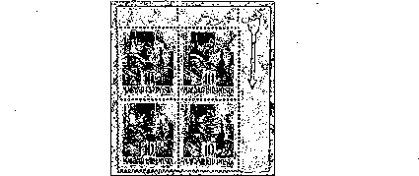
Figure 239a
Figure 239b
- In the denomination of the parcel of 10 kg special overprint features are found. These are the imprints of the "blank" filling of the spaces in the inscriptions of the postage stamp. In the overprint, the "blank" filling sometimes loosened, lifted, and resulted in regularly repetitive impressions. That is why there are frequently signs resembling the square brackets at the beginning or the end of the text.
Similarly, there are often thin lines “underlining” a single letter or a full word, usually in the seventh vertical line. A few examples of these are shown in Figure 240.
- It is the reverse impressions that are in the focus of the collectors’ interest (inscription bottom-to-top). Presumably, some of these were deliberately produced and put in circulation.
Reverse overprints of the following denominations are known: long distance postcards, forms 20 gr, registered mail, parcel 10 kg (Figure 241).
Postmarked reverse overprinted copies of the long-distance postcard are also known. It should be noted that reverse overprints of this denomination occur with the earlier mentioned thinner letters.
- The most valuable rarities of the series are the “other” erroneous prints resulting from erroneous overprinting; three of these are known.
1 The Auxiliary Series I reversely overprinted on 60 f / 8 f H, and then overprinted with „Nyomtatvány 20 gr” (Form 20 g) was already mentioned by Volume II of the Data Pool of Hungarian Postage Stamps. However, we must add that the reversely overprinted sheet missed then of 60 f / 8 f H has already turned up since then (see Figure 163).
Such reversely overprinted 60 f / 8 f H sheets, after returning the sheets of "filler" denomination, or having just been stored in the Postage Stamp Warehouse in the original package, were not discovered when handed over to the State Printing House for overprinting (Figure 242).
2 A real erroneous print of the 10 kg parcel postage stamps is also known. It was created by mix-up: the Series I of Auxiliary Stamps of the same base value but overprinted by 30-filler nominal value was mixed in "Nagyasszonyok" (Noble Ladies) to be overprinted. Thus the erroneous print was generated: “Csomag 10 kg/30 fj30 f A7” instead of „Csomag 10 kg/30 f N”. Number of copies is not known. Since, due to the lack of stamps, when the parcel postage stamps of 10 kg parcels were printed, even 50-piece half-sheets of 30-fillér denomination of. „Nagyasszonyok” were overprinted, it is not excluded that this false overprint is of such origin (Figure 242) .
3 The third erroneous print, which came to light only in 1963, is a complete sheet of 20 gr forms, from which the 60-fillér overprint usual in Auxiliary Series I was missing. Thus, overprint. „Nyomtatvány 20 gr” was applied only to the 8-fillér denominations of the base-colored „Hadvezérek” (Military Leaders).
By examining this sheet, it may be concluded that the overprinting is missing because the sheet stuck to the upper sheet of the Auxiliary Series I. On the most part of the sheet, on its rear side, the red ink of the red 60-fillér printing appears clearly, transferred by the sheet. The owner of this sheet discovered the erroneous printing in 1951, looking into a recently purchased and originally packaged block (100 sheets).
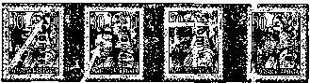
Figure 240

Figure 241
Figure 242

His attention was caught by clearcut lack of the red color in the overprint. The separation of this entire sheet. has taken place only in recent years when several pieces have been sold. Thanks to the courtesy of the owner, we can present a copy of this erroneous print here (Figure 242).
Out of the prints on the rear side, the strong prints are the most frequent (Figure 243, Image 1). Well-legible protruding prints or caused by ink transfer by sheets often occur. Partial or entire color transfers by equipment are less frequent, especially in case of the postage stamps overprinted with black ink. A partial black color transfer by equipment is shown in Figure 243, Image 2.
Their watermark is the same as the watermark of the base stamps: X.
Watermark orientation: A/1,2
Perforation: 15-teeth comb
Franking: the denominations of the series are frequent on mail items from the day of their introduction, namely May 1, 1946, until the 1 June 1946, especially in mixed franking.
Forgery: as already mentioned, the sheets of 10 kg parcel postage stamps were sometimes separated into two parts horizontally, and these 50-piece halves were overprinted. Thus, when the lower half of the sheet was overprinted, the horizontal sheet edge was overprinted too.
Such sheet edges have become popular among collectors of specialties. Therefore, forgers forged such edges too. However, the prints produced by them, as shown in Figure 243, Postage Stamp 1, are primitive, so their recognition does not cause any difficulty when compared to the real overprints, as seen on Postage Stamp 2.
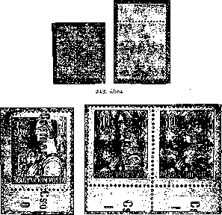
Figure 196

1946 MILPENGŐ (million kreuzers)
Instead of the inflation nominal value containing six zeros, the Post Office used “million-kreuzer” denomination, omitting zeros ("milpengó”).
Regulation 229. 400 / Bgi. (P.R.T. 1946/33) provided for the first such denominations: 100, 200, 500 and 1000 “milpengős” of the series on 24 May 1946. This was followed by the issuance of 2,000, 3,000 and 10,000 “milpengős” (Regulation 231,300 / Bgi., P.R.T. 1946/35) as of 1 June 1946 - on the same day when the 18th tariff increase was imposed. Finally, the denominations of 20 000, 30 000 and 50 000 “milpengős” were introduced as of 14 June 1946, by Regulation 233.400 / Bgi. (P.R.T. 1946/37 P.R.T.).
The image was designed by György Konecsni.
The denominations of the series, unlike the issuing regulations, were issued with delay, due to which they were postmarked later.
The series was withdrawn by Regulation 239.592/2. (P.R.T. 1946/43.) as of 13 June 1946, but practically the postal service ran out of them earlier.
These postage stamps were sold at post offices.
Figure 244

Face Values And Number Of Copies Of The Series; Actual Dates Of Entering Circulation

brownish red
brownish red
brownish red
brownish red
brownish red
brownish red
brownish red
brownish red
brownish red
brownish red
brownish red

844,000 pieces
890 000 pieces
3 446 000 pieces
3 826 000 pieces
3 310 000 pieces
3 148 000 pieces
3 260 000 pieces
3 228 000 pieces
2 044 000 pieces
2 130 000 pieces
1 830 000 pieces
100 milpengő 200 milpengő 500 milpengő
1000 milpengő
2000 milpengő
3000 milpengő
5 000 milpengő
10 000 milpengő
20 000 milpengő
30 000 milpengő
50 000 milpengő

24 May, 1946
25 May, 1946
27 May, 1946
4 June
1946
4 June
1946
8 June
1946
4 June
1946
8 June
1946
17 June 1946
17 June 1946
18 June 1946

The postage stamp image is the same on all postage stamps. In the vertically arranged, irregular eight-sided frame bordered by colored and white lines, inscriptions "MAGYAR POSTA" and "MILPENGŐ” appear. Within the frame, the Hungarian coat of arms, decorated with a tape on the top takes place. On the tape, a white "1946" appears, under the coat of arms there is the nominal value of a dark shade.
The postage stamp has cut off corners, its rectangular shape is 18X22 mm.
These postage stamp were printed in the State Printing House. The stamp image was produced by raster (grid) intaglio printing in the 1st round, while the value numerals were produced in the 2nd round using the 100-piece type, letterpress printing technique.
The brownish-red color of the stamp in produced in the 1st round does not show any significant differences. The light colors appearing on some, mainly postmarked copies, and which turn up in collectors’ circulation, were the results of. chemical changes - they were triggered by either light or water. There are some colored spots or lines in the prints in the same way as in the case of 200-milpengő denomination, the "S" in the "POSTA” may be missing, or the colored stripes on the white stamp edges of the 30,000-milpengő denomination. However, these are not typical phenomena.
In the 2nd round, the numerals were printed using relief technique, their color varying from from pale to Indian red.
Clogged numbers are common, as shown in Figure 245, in the first and in the second stamp, denominations of 3,000 and 30,000 milpengős. On the third stamp of the figure, the third zero of 30,000 is clogged, so it reads “30 080”. These deviations reoccur on the sheets.
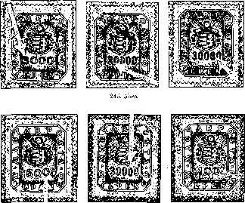
Figure 240

In this edition, the dislocation of the numerals also occurred. As shown in Figure 246, the second zero of the “5,000” takes place 0.5 mm upwards, while the third digit of “30,000” is slid down by 0.3 mm on the 99th stamp of the sheet. Horizontal slides of zeros are also known. In our Figure, one of the rows, probably the lowest one, of the 100-kreuzer sheet was overprinted upon.
The rear-side protruding impressions of the fonts slid down or up, left or right are very common.
These postage stamps were marketed in 100-piece sheets.
These postage stamps were produced on 0.09 — 0.1 mm thick, white, "A" quality, IX-watermarked treasury printing paper.
Watermark orientation: A/1,2
Gumming: white or yellowish
Perforation: 15 teeth, comb The size of the stamps up to perforation is 26x22 mm. Non-perforated pieces (□) were Phase II impressions placed on the market.
Franking: The denominations of the series could be used for franking until the end of June from the day they were actually issued.
During this period, Regulation 233.703/4 (P.R.T. No. 38 of 1946) was issued, which provided for withdrawing of all denominations smaller than 100 milpengős, either those featuring letters and numbers, those overprinted with text, as well as all postage due postage stamps as of June 30, 1946.
Under this Regulation, from 1 July 1946, only milpengő and higher denominations could be used for franking. The entire sheets extracted from the market were to be returned to the Postage Stamp Warehouse by the post offices. In accordance with this regulation, the fragments were glued to newspapers or waste paper, then postmarked at one of the corners for cancellation, and sent to the Postage Stamp Office of the Post Office.

1945 BILLION POSTAGE STAMPS
General-use series containing of three denominations
The image was designed by György Konecsni.
These stamps were introduced by Regulation 236.200/Bgi. (P.R.T. 1946/41) as of 27 June, with a view to ensure franking of mail items in accordance with Regulation 235.700 / 4. providing for the 21st tariff increase as of 24 June, 1946.
The denominations of the series could be used for franking under the issuing regulation as of June 27, 1946. Although they were withdrawn from circulation by Regulation 233.592/2. (P.R.T. 1946/43) as of 13 July 1946, they eventually fell out of use earlier, by 1 July.
These postage stamps were sold at post offices. Delivered stocks ran out by July 1, 1946.
Figure 247

Face Values Of The Series and Number of Copies

100 billion pengő olive/red 1 916 000 pcs
200 billion pengő olive/red 1 858 000 pcs
500 billion pengő olive/red 1 900 000 pcs
The postage stamp image is the same on all postage stamps. Medium-shaded; „MILLIARD P” in the lower half of the area up to the teeth, with a light wavy tape at the bottom; there is a round circle containing the nominal value numeral, with baroque decorations on both sides, with a horn and a Hungarian coat of arms. Over the horn, inscription "MAGYAR POSTA" takes place.
The image is rectangular; its size is 22x26 mm.
These postage stamp were printed in the State Printing House. The stamp image was produced by raster (grid) intaglio printing in the 1st round, while the value numerals were produced in the 2nd round using the 100-piece type, letterpress printing technique.
The image produced in the 1st round may be of lighter or darker shade. Frequently observed thin dark lines along the perforation are typical of grid intaglio printing.
Light shade differences occur in nominal value numerals printed in the 2nd round. The shifts of the fonts and too strong and protruding printing are common.
On one of the 200-billion-denominated postage stamp sheet, the first stamp is also known without a nominal value number. This erroneous print resulted from the fact that a foreign piece of paper stuck to this part of the sheet, so the stamp was printed upon in blank, colorless manner.
These postage stamps were marketed in 100-piece sheets.
These postage stamps were produced on 0.09-0.1 mm thick, white, "A" quality, IX-watermarked treasury printing paper.
Watermark orientation: A/1, 2
Gumming: white or yellowish
15-teeth comb perforation Non-perforated pieces (□) were Phase II impressions placed on the market.
Franking Postal items sent using these denominations of the series are rare. Forged “sent items” might occur.

1946 TRILLION DENOMINATIONS
Instead of the inflation nominal value containing twelve zeros, the Post Office used “trillion-kreuzer” denomination, omitting zeros.
The postage stamp image was designed by Vera Harsányi and Péter Székely.
Regulation 237.400/Bgi. introduced a series 1, 2, 5, 10, 20, 50, 100, 200, 500, and. 1000 trillion kreuzers as of 3 July 1946 (P.R.T. 1946/42.).
The further denominations of the series were planned to be introduced by Regulation 237.800/Bgi. as of 10 July 1946 (P.R.T. 1946/43.) – 10 000, 50 000,100 000 és 500 000 trillion kreuzers.

1, 2, 5 and 10 trillion P *
on 3 July 1946 on 5 July 1946 on 7 July 1946 on 10 July 1946 on 11 July 1946 on 13 July 1946
20 trillion P
50, 100, 200, 500 trillion P
1 000 trillion P
100 000 trillion P
10 000, 50 000 and 500 000 trillion P

The series was withdrawn from the postal service on July 13, 1946, by Regulation 239.592 / 2. (P.R.T. 1946/43), which provided for the withdrawal of all regular kreuzer denominations on July 13. So the denominations of 10,000, 50,000 and 500,000 trillion kreuzers were withdrawn from circulation on the date preceding their actual placing on the market.
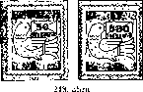
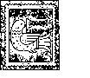
These stamps were sold by post offices in 25-piece quarters of sheets, as the sale of full sheets was banned (except to big users) by Regulation 235 238 / Bgl. (P.R.T. 1946/43) in order to prevent speculation. Entire sheets went on sale later. As regards the denomination of 500 000 BP (trillion kreuzers), only the post offices located in Budapest received them.
Face Values Of The Series and Number of Copies
1 trillion kreuzers | greyish/red | 1,080,000 pieces
2 trillion kreuzers | greyish/red | 1,098,000 pieces
5 trillion kreuzers | greyish/red | 1,080,000 pieces
10 trillion kreuzers | greyish/red | 1,046,000 pieces
20 trillion kreuzers | greyish/red | 940,000
50 trillion kreuzers | greyish/red | 1,660,000
100 trillion kreuzers | greyish/red | 1,048,000 pieces
200 trillion kreuzers | greyish/red | 1,010,000 pieces
500 trillion kreuzers | greyish/red | 1,070,000 pieces
1000 trillion kreuzers | greyish/red | 1,034,000 pieces
10,000 trillion kreuzers | greyish/red | 568,000
50000 trillion kreuzers | greyish/red | 578,000
100 000 trillion kreuzers | greyish/red | 623,000
500000 trillion kreuzers | greyish/red | 569,000

The image is the same in all values: a stylized white dove, a white letter with a red value number in its beak. Medium-shade strip with "MAGYAR" at the upper part and "POSTA" at the lower one; dark-colored inscription; under the envelope, a white indication of the denomination “BILLIÓ P" takes place. The image is of a rectangular shape, its size 18.5X22 mm.
These postage stamp were printed in the State Printing House. The stamp image was produced by raster (grid) intaglio printing in the 1st round, while the value numerals were produced in the 2nd round using the 100-piece type, letterpress printing technique.
The grey color of the overprinted images does not display any significant color difference.
The versions of this edition resulted from the letterpress numeral slips, clogging, and strong or protruding impressions, as shown in Figure 249.
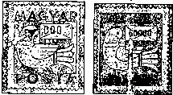
Figure 249

It is seen in Figure 249 that “1” “1000” is slid to the left and merged into the base color, while on the denomination of 50 000 BP “5” is clogged and seems “6”.
These postage stamps were marketed in 100-piece sheets.
These postage stamps were produced on 0.09 — 0.1 mm thick, white, "A" quality, IX-watermarked treasury printing paper.
Watermark orientation: Aj 1, 2.
Gumming: white or yellowish
Perforation: 15 teeth, comb. The size of the stamp up to perforation is 22X26 mm. Non-perforated pieces (□) were Phase II impressions placed on the market.
The denomination of 50 BP has turned up without bottom perforation too.
Franking Mail items franked with the denominations of this series represent very high philatelic value as the majority of these postage stamps became outdated already when placed on the market due to the rapid depreciation of their value. Many forged “sent” letters of this edition were produced.

1946: 100th ANNIVERSARY OF THE RAILWAY
The first authorized railway line in Hungary. After the First Hungarian Railway driven by horses between Pozsony and Nagyszombat, the Hungarian Central Railway Company built the first railway line between Budapest (Buda / Pest / Nyugati) and Vác (Vác) (9th in Europe). The first train started from Budapest on July 15, 1846, at 4 o’clock p.m., carrying Governor of Pest József and his family. At 5 o'clock, they arrived at Vác.
To commemorate the 100th anniversary, the Hungarian Post Office issued a series of four denominations.
The images were designed by György Konecsni.
These stamps were introduced by Regulation 239.000/Bgi. (P.R.T. 1946/43)
on 15 July 1946. It was the first Hungarian kreuzer series for revenue. These postage stamps were withdrawn by Regulation 242.015/Bgi. (P.R.T. 1946/46.) as of July 13, 1946. However, they dropped out of postal service earlier, due to there depreciation.
Number of copies: 100,000 full perforated series.
They were only sold in a full series, a single series to a buyer; they were marketed in Budapest, at post offices number 1 in those towns where there were several post offices, as well as in the municipal offices of Berettyóújfalu, Mátészalka and Szikszó, in exchange for revenue ticket.
Figure 250

Face Values Of The Series
10,000 revenue kreuzers brown
20 000 revenue kreuzers blue
30,000 revenue kreuzers green
40 000 revenue kreuzers carmine red

The postage stamp image always takes place in the same frame. On the bottom of the frame there is a white inscription "MAGYAR POSTA", at the right, above, and at the left side of this inscription, text “100 ÉVES A MAGYAR VASÜT 1846-1946” (The Hungarian Railway is 100 years old 1846-1946) takes place, partly white, partly colored. In the upper left corner, the indication of the nominal value takes place. There are various drawings inside the frame.
Denomination of 10 000 AP: First Hungarian steam locomotive Coqueril produced in Belgium, with the "Vac" carriage.
Denomination of 20 000 AP: World-renowned steam locomotive of Hungarian design and manufacturing MÁVAG, a424-series.
Denomination of 30 000 AP: Based on the Hungarian invention and patent, an electric locomotive Series V 44 produced in 1942, in GANZ-MÁVAG – the world's first single-phase, period-gear, short-closed 4000 horsepower at start , 3200 constant. horsepower.
Denomination of 40 000 AP: 240-horsepower "Árpád" type of rail bus, Ganz - Jendrassik patent, GANZ Works
The image is of rectangular shape, 33 x 22 mm
These postage stamp were printed in the State Printing House. The stamp image was produced by raster (grid) intaglio printing in the 1st round, while the value numerals were produced in the 2nd round, of the same color as the base coloration but darker shade, letterpress printing technique.
251. i'ibm

Out of 40,000 AP denominations, a very rare print has turned up. This sheet was not printed upon as it was stuck to the sheet over it. This mistake was not noticed, and this non-printed sheet was sent to Terézvárosi Torna Club, Postage Stamp Section, for distribution. This erroneous sprint was detected only after the majority of the postage stamps has been distributed. Today it is one of the most successful erroneous prints.
It was marketed in 100-piece sheets.
These postage stamps were produced on 0.1 mm thick, white, "A" quality, X-watermarked treasury printing paper.
Watermark orientation: A/1, 2
Gumming: white
Perforation: 12-tooth comb perforation. The size of the stamps is 37x26 mm. Non-perforated pieces (□) were Phase II impressions placed on the market.
Franking: postal items sent using these denominations of the series are rare.
Commemorative postage stamps
This was a general-use postage stamp series containing 10 denominations introduced by the Post Office at the time of the the switch to the revenue pengő, after having withdrawn from circulation regular pengő denominations by Regulation 239.592/2 as of July 13, 1946 (P.R.T. 1946/43).
The image was designed by György Konecsni.
Regulation 239.600/Bgi. introduced a series 5, 10, 20, 50, 80, 100, and 200 thousand revenue pengő postage stamps as of 13 July 1946 (P.R.T. 1946/43).
The introducing of the 500,000 revenue pengő denomination was provided for. by Regulation 241,000 / Bgi. as of July 20, 1946, while the introducing of 5 million tax pengő denomination was provided for by Regulation 241,100 / Bgi. as of July 24, 1946, by the Ministry of Transport (P.R.T. 1946/45).
As opposed to the above listed regulations, these denominations were introduced only later, after their being manufactured with delay:

on 16 July, 1946 | 5 and 10 thousand AP (tax pengő)
on 17 July, 1946 | 20 and 50 thousand AP (tax pengő)
on 19 July, 1946 | 80 and 100 thousand AP (tax pengő)
on 20 July, 1946 | 200 thousand AP (tax pengő)
on 23 July, 1946 | 50 thousand AP (tax pengő)
on 26 July, 1946 | 1 and 5 million AP (tax pengő)

The stamps of this series were withdrawn by Regulation 242.015 / 2 as of July 31, 1946, when the new currency, forint, was introduced (P.R.T. 1946/46).
These postage stamps were sold at post offices.
Figure 252
Face Values Of The Series and Number of Copies
green/black

green/black

green/black

green/black

green/black

green/black

green/black

green/black

red/black

red/black
5 thousand tax pengős
10 thousand tax pengős
20 thousand tax pengős
50 thousand tax pengős
80 thousand tax pengős 100 thousand tax pengős 200 thousand tax pengős 500 thousand tax pengős
1 million tax pengős
5 million tax pengős
1 494 000 pieces
3 980 000 pieces
1 841 000 pieces
1 938 000 pieces
1 940 000 pieces
1 956 000 pieces
726,000 pieces
428 000 pieces
1 004 000 pieces
960,000 pieces

The postage stamp image is the same as the one on the “BILLION” series. The only difference is the lower value number and the "adópengő" (tax pengő) inscription printed upon words „ezer”, „millió”, and „MILLIÁRD P”.
These postage stamp were printed in two rounds in the the State Printing House. The stamp image was produced by raster (grid) intaglio printing in the 1st round, while the value numerals were produced in the 2nd round using the 100-piece type, letterpress printing technique.
There are not any significant color variations in the green or red color of the image. The color lines along the perforation are the already mentioned feature of the grid intaglio printing. Prints shifted in the 2nd run, as well as the impressions on the rear side often occur. The ink transfer is frequent by sheets, not by equipment.
These postage stamps were marketed in 100-piece sheets.
These postage stamps were produced on 0.09-0.1 mm thick, white, "A" quality, IX-watermarked treasury printing paper.
Watermark orientation: Aj 1, 2
Gumming: white or yellowish
Perforation: 15 teeth, comb. The size of the stamps up to perforation is 22X26 mm. Non-perforated pieces (□) were Phase II impressions placed on the market.
Franking: thousand-pengő denomination is rather frequent on sent mail items, while million-pengő one is rare. The million-pengő denominations in collections, if hand stamped, were stamped as a favor.
Chapter III
INFLATION PERIOD FRANKING 1945- 1946

During the 1945 and 1946, the country experienced the deterioration of the inflation,. its dimensions became unique even from the world-wide prospective. The Hungarian Post tried to cope with the situation by issuing postage stamps, despite the technical difficulties, and sometimes lagging behind. Between 1 May and 24 July 1945, there were 27 general postal tariff increases related to the inflation.

These fourteen months have resulted in unexpected and abundant “postage stamp yield”: 20 general-purpose and commemorative editions including 218 denominations, to the utmost annoyance of the public and the postage stamp collectors. Probably this enormous flow of the new postage stamps resulted in the decreasing of the philatelists studying these editions, at least while they were available almost unlimited. The shortages of supplies and other obstacles amidst newer and newer tariff increases the postal service workers into extremely difficult situations – after several tariff increases they finally started to receive only multiplication numbers for calculation postage. The calculation of the postal fee, its checking, and, not the least, the obstacles and shortages in the supply of the postage stamps, adhesive labels, and other items created a continuous challenge for the employees of the Post Office. Despite all these difficulties, especially the initial delivery difficulties, the rapid forwarding of postal items was ensured.
Although the general information on franking pertaining to the individual editions has already been mentioned, it is still necessary to summarize what we know about this period, looking into more detail when talking about individual aspects. We must do this also because undoubtedly the most interesting and most valuable but still the most neglected material of the past twenty years falls into this period. It is almost inconceivable that the letters and the postal items of this period were largely destroyed, becoming victim of bulk postage stamp collection, the so called "bundling". The mail that survived turning into paper waste was mostly "lost" during the changeover of the “internal-use pairs" and “Alj". Foreign philatelists had recognized the philatelic value of this material much earlier, and we "owe" it to this fact that a part of this mail material escaped abroad at the end of the 1940s, and thus escaped destruction.
To the best of our knowledge, specialist periodicals did not do anything in order to estimate and rescue the extremely rare and valuable philatelic material discussed here, with a single exception.
Perhaps today is the last opportunity to find the inflation mail still in Hungary, identify its categories and setup an overall system, thus. saving this significant philatelic material from the final destruction.
The quest for mail is the responsibility of the broad camp of Hungarian stamp collectors. . The relevant guidelines for setting up the system will be described below. Hopefully, the evaluation of this mail will take place within the foreseeable future in a catalog that will be linked to the monograph. Finally, we would like to point out that, as a matter of fact, the material from the last months of 1944 to the May of 1945 is linked to this inflation material, since the mail, its varieties, and, last but not the least, its rarities deserve special attention.

1. Chronological categorization
From the last months of 1944 to 31 July 1946, postal items can be divided into two large chronological groups.
- Mail franked with former tariffs (1 July 1943), from November 1944 to May 1, 1945.
- Variable, inflation tariffs and postage stamp editions from 1 May 1945 to 31 July 1946.
Two subgroups may be distinguished among the mail items sent with the previous tariff and earlier editions of postage stamps.

А/l Courier mail service
As we have already mentioned, the first Soviet Union troops crossed the Hungarian border on September 23, 1944, and thus the territory of our country became a battlefield. Operations have temporarily paralyzed the civilian life and, as a consequence, the operation of the postal service. This transitional period lasted for a relatively short time, as, as described in Chapter “Road Guard Courier Mail Service in Hungary in 1944-1945”, on 2 November 1944 in Gyula, which was first liberated in the eastern part of Hungary, a temporary postal service, the Courier Mail Service, was established within the framework of the Gyula State Sheetitectural Office. Similarly, temporary postal service would probably exist in other counties.
The temporary postal service in Gyula was initially the only of such kind, and carried out services in the whole of Békés County in November and December 1944 alone. The professional postal service, which kept gradually reviving as the rail traffic was being set up, increasingly restricted the area of operation of the courier service, and the operation of the latter slowly merged with the redesigned professional postal service.
There is distinct boundary between the two postal services, neither in the terms of time, nor in the terms of space. The resesheet into this found that even in the April of 1945 this courier service forwarded the postal items to most of Békés County municipalities, as shown in Figure 253.

A letter written by the Szeged Post Office to the office of the deputy head of the municipality communicated that the Ministry of Trade and Transport considered the "courier service in Gyula" as terminated on May 15, 1945. This date also indicates the end of the courier service and the commencement of the professional postal service at national level.

Otherwise, the types of franking, the postage stamps that could be used for postage, the special rubber hand stamps used for cancelation, and the arbitrary increase of the tariff have already been described. This irregular tariff increase is illustrated by the distance letter in Figure 254. In the upper right corner of the postage due letter taken over in Debrecen and processed and delivered by the State Sheetitectural Office in Gyula, there is a note of 80 fillér long-distance letter postage due, which was arbitrarily raised from 30 fillers.

A/2 Professional postal service
Within this subgroup, we have to distinguish between the postal services that were usually deployed in the liberated areas, usually from the east to the west, temporarily, first based on civil initiative and then set up as postal service and the postal service of the Hungarian Royal Mail in the yet non-liberated areas, typically located to the west of the former. Drawing precise distinction line between these two areas is rather difficult.
For the purpose of facilitating chronological delineation, see our Table 1. E2 indicates the date of the liberation of the larger localities of our country, after which these places were continuously connected to the reorganized postal service (page 17).
The spatial boundary always depended on the time and coincided with the front line, however, with the encirclement of Budapest on 26 December 1944 and its siege of nearly 60 days, a northeastern-southwestern front line emerged from Miskolc to Budapest and Székesfehérvár to Balaton. It only moved in the Msheet of 1945.
Taking into account the above factors, the following distinction of postal items becomes necessary in this subgroup:
- Items sent by temporarily set up postal service and then by redesigned professional postal service.
- Mail sent by the former. professional postal service (Hungarian Royal Mail).
ad a) As it was already mentioned at messenger postal service, in Békés County, which was liberated first, the first postal service was the one provided by road guards - it operated though temporarily, still for longer period. Simultaneously with the restoring of the railroads, the temporary and later the professional Postal Services network was set up - its area of operation remaining limited to the railroads and the surroundings.
Postal mail (mail szükség levélzárlatok) and postal consignments at our disposal prove that postal employees, registrars and subordinates who had chosen not to be evacuated (against the order of the military and civilian authorities), captured the first opportunities to put the mail services into operation. For the items sent at distance, in addition to the only occasionally operating courier service railroad carriers carrying warships on the restored railroads could provide opportunity. Postal zárlatokat, which mostly fit into envelopes rather than mailbags, were transmitted by train drivers of these trains. to the destination stations - it should be noted that it was done in a very short time.
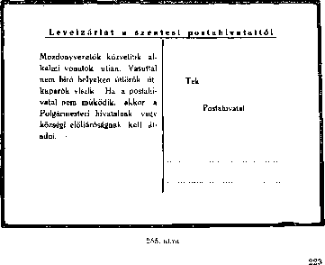

о
These temporary zárlatok were initially simple handwritten envelopes. However, soon official, printed-text folios appeared as shown in Figure 255. The introducing of these and the text was probably ordered by of the Ministry of Commerce and Transport of the Interim Government of Debrecen, to the already freed postal administrations (Debrecen, Szeged, Pécs). We have reliable data proving that the letter levélzárlatot in. Figure 255 was used by the post office in Szentes since the beginning of October, 1944.
During our resesheet, we came across such and equal-text levélzárlattal, sent to Albertirsa (Pest County) by the post office of Nagykőrös (Pest County) on December 13, 1944. Since January 1945, there have been a number of mail levélzárlatai in {Cegléd, Monor, Pilis, Szeged and Szolnok}, which are the proof of the provisional initiation of the professional mail service.
These temporary levélzárlatok were created with the same text, either by handwriting or by printing, if there were ways for the latter. As a curiosity, we should mention that on all known letter levélzárlaton, the word "útőrök" (road guards) is misspelled as “úttörők” vagy ,,úttörők” (pioneers). The typo must have been made in the issuing regulation, from where it was then quoted erroneously. This temporary mail levélzárlat also proves the existence and recognition of roadside courier services.
The surveyed mail shows that in December 1944, besides the official - although not yet vigorous - mail, private mail was also resuming in the already liberated eastern, northeastern regions, and the part between the Danube and the Tisza (eg Albertirsa, Mezőtúr, Makó, Kecskemét, Pilis). This postal service kept expanding in January 1945. Following the liberation of Budapest on February 13, 1945, the postal services of these regions reached out to the capital city.
Despite the fact that the letter sent to Gyula (Figure 253) on April 5, 1945 in Kunágota was sent and delivered by a road guard courier operating in the county, the letter put to mail in the same county, in Endrődöregszöh, on 28 February, 1945, also to Budapest addressed to the International Red Cross was delivered by the professional new service company (Figure 256). We see similar cases in the southern, then in the northern parts of the country, after the liberation of Baja on October 21, 1944, and of Tokaj on November 23, 1944.
It is not unnecessary to mention that in Budapest, on the 8th of February, 1945, the new Budapest Post Office was established in Pest, even before the full liberation of Budapest. The setup of the postal service in Budapest followed the one in Debrecen and Pécs.
The data available so far demonstrate that in this area post offices, as postage stamps were lacking, mostly required cash for covering postage; most of the mail was directed to Budapest.
ad b) During this period, the former professional postal service of the western and northwestern parts of the country carried out regular postal traffic for a longer period - however, it was limited to a smaller area until the country was completely liberated on 4 April 1945.
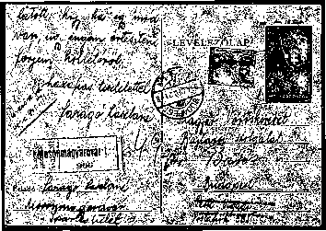
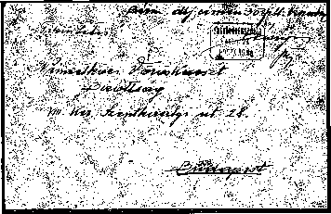
Figure 250
15 A magyar bélyegük monogréflAja V,
225

Between Budapest and those parts of the country the postal service operated until the last days of December 1944, whereas on December 25, 1944, the siege ring was closed around the capital. Perhaps one of the last and surviving postal items sent to the capital is the registered long distance postcard shown in Figure 257, which was delivered to Mosonmagyaróvár on 22 December 1944 and which arrived at Budapest on December 24, according to the arrival stamp. The delivery of the card was likely to have taken place after the full liberation of Budapest, at least we can conclude so from the formal administration note on the card: „Keresőre felvéve 1945. III. 24.” (Filed for sesheet)
The postal service of the settlements of the Transdanubian counties had been in operation until the front reached these localities, and after their liberation, they kept being involved in the redesigned national postal service. It should be noted that the old Postal Directorate in Sopron operated until the last day of Msheet 1945.
Initially, the previous, still valid postal stamps had been used, which we have already listed in detail, while during the transitional period cash was used here too.

В / Variable inflation rates and expenditures for mail from 1 May until on 31 July, 1946
The major part of our chronological categories will contain the postage stamps of the fourteen-month period of the actual inflation beginning from the first general tariff increase, the first post-war postage stamp issue, namely from 1 May until 31 July 1946, that is, the introduction of the new currency.

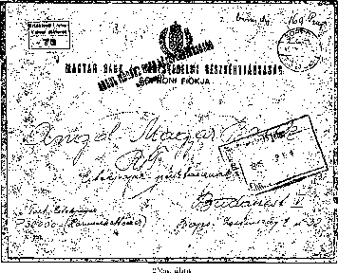

The 27 general postal rate increases are shown in Table 2, which demonstrates the most important kinds of rates (pp 246-249). These 27 groups form the backbone of the categorization of this period. Subgroups within each group can be formed as follows:
- kinds of mail,
- the stamps used for franking,
- Postmarks produced by hand stamps (use of supplementary and auxiliary hand stamps, commemorative postmarks),
- The use of adhesive labels and other necessary postal items.
1. The sorting by type of consignment is facilitated by Tables 2, 3 and 4.

Most common types of consignment were domestic local and long-distance postcards and mail items, ordinary or registered. There were fewer express or money mail items, of which a sample is shown in Figures 258 and 259a, b. 159/5000. The presented local express mail item was sent on August 4, 1945, duly franked according to the second postal rates increase; it was delivered on the same day. The money letter in Figure 259 a, b, which included 32,000 pengős, was franked by the branch of Sopron of the Angol Magyar Bank Rt. (English-Hungarian Bank Inc.). It was franked by 169 pengős on October 10, 1945, sent to Budapest.
!£•
With regard to this period, the circulation of postal traffic with European and overseas states is presented in Table 3 (p. 252), chronologically ordered. The postal service with European and overseas states resumed the earliest on August 6, 1945 with Yugoslavia, and then with Czechoslovakia on October 8, 1945. It is worth noting that although the official postal service with Romania resumed only on 17 November 1945, it was already during the first months of 1945, mainly in Gyula, that mail items were taken over and transferred to the regular Hungarian postal services, (Figure 1). Unfortunately, the mail sent abroad is virtually lost for the Hungarian collectors. 65/5000. We can only see a few examples of such mail today (Figure 260).
• The situation was similar as regards the air mail with some of the European and overseas states, as Table 4 shows (p. 253). The circulation of this kind of mail started on April 1, 1946.
76/5000. Prints rarely turn up, and are considered as specialties (Figure 261). The parcel delivery forms hardly ever turn up (Figure 2016), and it is difficult to estimate how great the damage of unnecessarily destroying this material is - it affected our philatelic values and resesheet work.
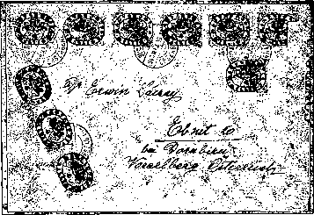
Figure 260

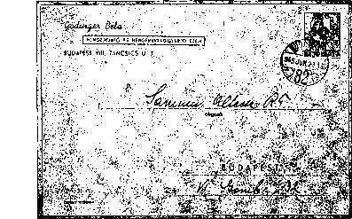

2 According to the stamps used for franking, the following subgroups can be set up:
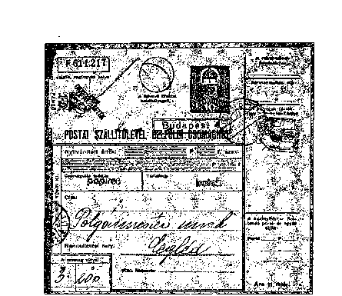
Figure 2b
a) Only postal items cancelled by earlier hand stamps.
The Postal Directorate instructed postal offices in the areas at risk of military operations to hand in postal items and stamps to the Postage Stamp Warehouse. However, this instruction could not be fully and everywhere executed during the rapidly changing military events, leaving some postal offices with a smaller or larger number of postage stamps. Likewise, stamps remained with the private postage stamp vendors and the public.
For the further use of these stamps and withdrawals from circulation, see Regulations 113.566 / A. 4 and 233.703 / 4. s. - these finalized the provisions after intermediate measures.
The following denominations were withdrawn from circulation on August 15:
1939/41/43 "Churches" Series I-II-III. 30, 40, 50, 70 and 80 fillers,
1941/42. "Horthy" Series II-III. (Landscape) 1, 2, 5 pengős,. 1943/44 Military Leaders series, 18 and 24 fillers (Patrona Hungária)
1944 St Margit, 30 fillérs,
1944 Red Cross, Series III, four denominations with surcharge.
Postal items sent using these series are rare from the year 1945, as the postmarks of the stamps mostly avoided collectors' attention.
Figure 262 shows a letter that was sent on August 22, 1945, although it was franked with the 2-penny denomination which had been withdrawn on 15 August, 1945.
Postage stamps which could be used until 30 July.
1943/44 Military Leaders series (without 18 and 24 fillérs),
Four denominations of "Kossuth L" series of 1944 and the 6 denominations of “Great Ladies" series of 1944.

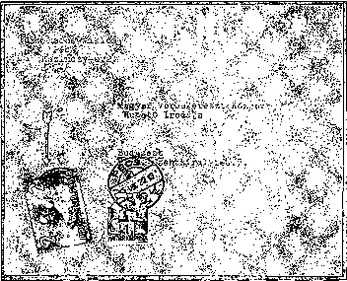

Figure 263

Since June 1, 1945, postal items canceled with the denominations of this series became rare. The possibility of using these in postal service ended with the 14th increase of the rates which followed the inflation, not the regulation providing for their withdrawal (No. 233.703 / 4). On Figure 263 we are presenting a letter with postage stamps of 1 pengő to cover the postage fee of 6 pengős; the postage stamps belong to Series “Military Leaders”; the cancellation took place on 29 October 1945.
b) Mail items sent using the denominations of the "inflation” postage stamps issued from 1 May 1945.
The largest quantity remained and so the most commonly known items were franked with the denominations of these editions. This finding applies to the 20 general-use and commemoration stamps described above and the 218 denominations of the 2 postage due postage stamp series.
In categorization of the franking we distinguish the following:
Franked with the postage stamps of this time series or individual stamps;
Franked with the postage stamps belonging to different series, the so-called mixed inflation mail items.
The mail items belonging to the first category mainly occurred at the beginning and the end of the periods concerned by rates changes. It should be mentioned that contrary to the public belief, mail items franked with only single. denomination of the proper value are much more valuable
than those franked with several denominations. The rarity of the franking by a single postage stamp is explained also by the fact that post offices tried to first get rid of the postage stamp series already on their stock but which were about to lose their validity (more pieces of which had to be adhered to the mail items) because they tried to also avoid the burden of handing in the already invalid postage stamps to the Postage Stamp Warehouse. This effort is understandable due to the increased work load on the post office employees. Generally, the regulations providing for the issuing of new editions also encouraged for the use of the previous editions. So the number of stamps used on a single envelope was often determined by the size of this envelope. It was not uncommon to even use entire postage stamp sheets folded to match the size of the envelope. We know, for example, a long distance letter sent on June 5, 1946, franked with “Távolsági levél” (Distance Letter) overprinted postage stamps of 400 million pengős worth. (2 million pengő/postage stamp).
An interesting form of individual franking is shown in Figure 264. On 26 June, a letter sent at Kerekegyház was franked by “POSTAGE STAMPS FEATURING LETTERS AND NUMERALS I”, as per Regulation 143. 525 / A (Denominations. Tl. I. and Ajl. I).

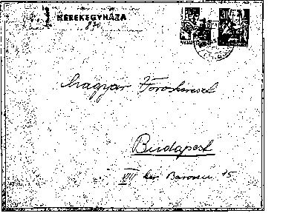

Mixed inflation franking of the second category is the most common, as aforementioned. It is the size of the mail items that also determined the unlimited use of the previous editions. And so, while still using these, the higher denominations of the newer editions (relative to the formerly existing denominations), were also used. The rarity of the mixed inflation franking is in direct proportion to the time elapsed between the editions used and the number of changes in tariffs.
- Mail items franked in mixed manner with earlier and inflation editions.
As mentioned above under (a), some of the previous postage stamps could be used for franking. The deadline for their use was set by their depreciation, as opposed to the regulation withdrawing them from the market. Therefore, they were also used in combination with newer inflation editions, especially in the form of mixed franking.
While the combination of the 16 denominations of “Hadvezérek” (Military Leaders) and Auxiliary Series I was rather frequent, the combination of the former with Auxiliary Series II was much less commonly used.
An example of this is shown in Figure 265 - a local registered letter sent on October 15, 1945.
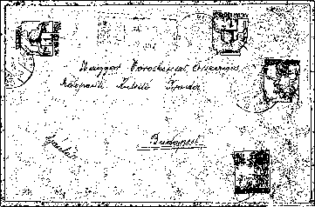

Figure 266

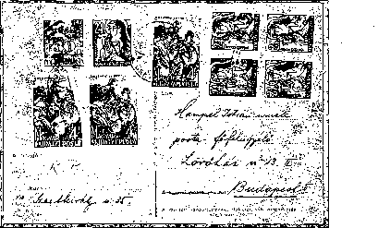

The other stamps, which could be used up to 15 August 1945 and up to 30 June 1946, are rarely found in mixed franking. In Figure 266, the 50-fillér denominations of “Templomok III" (Churches) used on 11 August 1945, four days before being withdrawn from circulation are seen; in Figure 267, "Kossuth I." series of 4 fillérs and the “Nagyasszonyok" (Noble Ladies) 24-fillér denominations are seen, used on 21 August 1945.
d) Mail Items Franked by Cash
The general lack of stamps that took place both initially and subsequently resulted in the most varied forms of cash usage.
As mentioned earlier, “Felszabadulás" (Liberation) series, which was issued on 1 May 1945 and which was the first to reflect the new raised postage stamps rates, did not even temporarily help to overcome the ever-increasing stamp shortage, as these postage stamps were bought for stamp collectors purposes. Thus, mail items franked by cash with manual notes (Figure 268), postmarked (Figure 269), or with machine postmark (Figure 270) are known not only from the first half of 1945 but also from the later period.
Regulation 135-123/A. 4. published in P.R.T. No. 40 of 14 November 1946 allowed for covering mail in cash referring to the difficulties in producing postage stamps. A registered letter from this period franked by cash is shown in Figure 271. It was accepted in Pécs on December 1, 1945, for 360 pengős in cash. This provision would only be withdrawn by the regulation introducing. POSTAGE STAMPS FEATURING LETTERS AND NUMERALS II, namely Regulation II. ad. 143 525 / A. 4.
e) Use of necessity stamps for franking
Some post offices sometimes used, albeit irregularly, some other kinds of stamps: revenue stamps, tax stamps, statutory fee stamps, and so on, instead of the missing postage stamps. In other cases, they have simply taken over mail items with these kinds of stamps adhered to them. The local registered letter presented on Figure 272 was sent on 7 August 1945, franked by stamps worth 7 pengős; however, these were statutory fee stamps instead of postage stamps. Very rare franking rarity
f) Mail items franked with non-official, locally issued postage stamps:
In order to cope with the postage stamp shortage at the beginning of 1945, post offices - irregularly - included into circulation editions newly or formerly overprinted by them, using them for franking. This voluntary and irregular postage stamp editing was banned (ban published in P.R.T) as soon as the 4th Department of the Ministry For Commerce And Transport got to know about these instances.
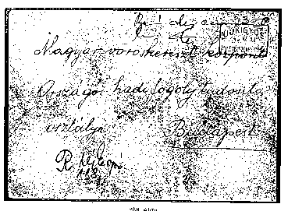

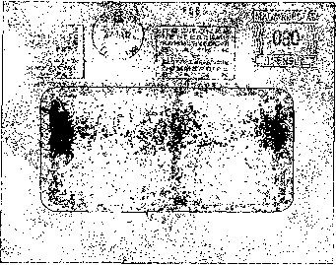
Figure 270

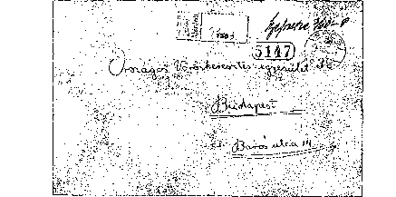

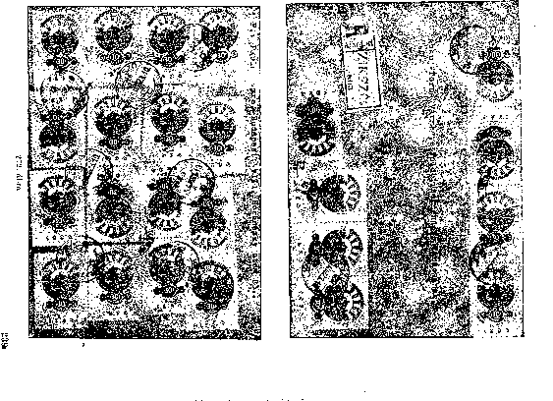

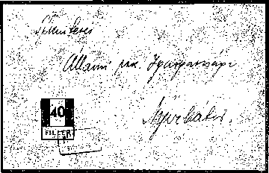
Figure 273

We will be dealing with the introduction of these local editions, the so called postage stamps from Nyiregyháza and Abony, in a later volume. In Figure 273, we only show a local letter sent in Nyirbátor on February 9, 1945, with a postage stamp of 40 fillérs, directed to Nyíregyháza.

3 Replacement and auxiliary stamps, commemorative stamps
Due to the war, many post office hand stamps were lost or destroyed. Before these were replaced, the relevant post offices received hand stamps from the corresponding postal directorates as per Regulation 133.301 / B. No. 4-. We can set up a separate category for the mail items postmarked by replacement or auxiliary hand stamps at post offices in this period. A detailed description of these stamps is given on pages 477 to 488 of Volumes I; their scope of application is described in Volume VI, in the section dealing with postmarks. Solely for the purpose of illustration, in Figures 274 and 275, a letter from Simontornya is presented with a replacement hand stamp applied to it and a piece of postcard from Jánoshalma with replacement and auxiliary hand stamps applied to it are presented.
The detailed list of commemorative stamps used from 1 May 1945 to the end of July 1946 is also included in the abovementioned section. Their occurrence is nowadays rare, especially on letters.

4 Application of Emergency Labels
We can also create a separate collection category for the adhesive labels used in this period, especially for the different kinds of labels on registered letters.
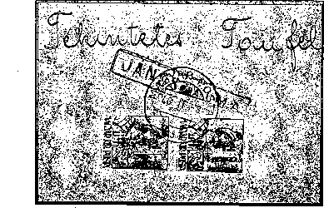
Figure 274

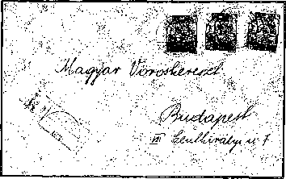
Figure 276

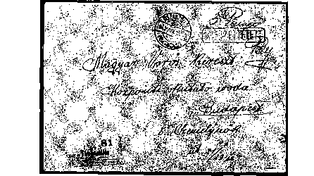

- The post office name stamped with a hand stamp halved by covering one of the halves (Figure 276).
- The name of the office is indicated by a rubber stamp (Figures 257, 265 and 266), with a metal stamp (Fig. 272), or in handwriting.
- The use of the hand stamp of another office indicated in handwriting (see Figure 269: Debrecen, Karcag).

- Hand-drawn label with official head stamp (Figure 264).
- Handwritten and drawn label on the mail item (Figure 268).
- Pre-made and adhered hand-drawn and written labels (Figure 274).
- The use of other labels for registered mail (see Figure 277, label for parcel).
Likewise, we can classify and categorize other franked by cash, postage due, “do-it-yourself” post office labels.

Forgeries of Inflation-Period Franking
At the end of the 1940s, counterfeiters took advantage of the domestic and foreign interest in the mail items of the inflation period, and produced and put into circulation numerous forgeries aimed at deceiving collectors.
Counterfeiters used the denominations of the rarely occurring „Milliárdos”, „Billiós” and „Adópengős” (Billion, Tax Pengő) series, applying postmarks to them (eg with the hand stamp “Budapest 507”, system Kr9, two bands, non-decorated Ky subgroup). So, these items need to be thoroughly reviewed. But for the same reasons, the parcel stamp pair for internal handling could not avoid being forged. Some of these were adhered to parcels and postmarked retrospectively, but there were also instances such as those shown in Figure 278, where both the overprints of the stamps and the stamps themselves were counterfeits.
Here, however, we have to distinguish between counterfeits and philatelic items that were over-franked but were actually sent and processed by the postal service. The latter are relatively rare, and have philatelic value due to the postage stamps used and the original postmarks.
Recognizing some of the counterfeit items requires a lot of practice, and the detailed description of these is not possible within the limited scope of this publication. Instead, we will describe those considerations that are applicable in each case, and the correct use of which can largely help to separate the vast majority of actually processed mail items from counterfeits.
1 The first step is to review and compare the validity of the postage stamps used on mail items with the date hand stamp used. It is for this reason that we described in detail the actual date of the entering into circulation, which, as we have experienced, does not often correspond to the date indicated in the issuing regulation and thus appearing in our catalogues and price listings.
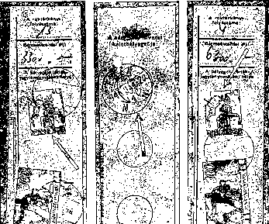

Figure 278

Some stamps of general-purpose series, due to the technical and material difficulties, usually kept being included in the Postage Stamp Warehouse and then to the post offices from the printing house only much after they had been printed, continuously, at the time when their actual use took off. So, the information provided on the earliest dates is the information on the dates when the postage stamps were actually marketed. Post offices farther from Budapest or small ones. often received their stamp supplies late.
The date of withdrawal of the postage stamps from circulation is also described at individual series. It is worth mentioning that in this period we can find mail items franked with overdue postage stamps or without postage due stamps, just as in any other period.
2. It is important to check the rates for mail franking, for which
we have designed Table 2. This table contains the rates which were valid until 1st May 1945, as well as the first rate increase on 1st May 1945 and all subsequent 27 postal rates increases. This table is an indispensable help.
The experience so far has proved that the post offices most frequently applied the changing rates properly. Occasionally, we can come across overpaid franking which must have had occurred because of the shortage of smaller denominations. On the other hand, insufficient amount of franking frequently occurs too. The reason for the latter in the first place is the fact that the regulations allowed for a "grace period" for the mail sent and franked by the public which was delivered to the mail boxes, when the new rates were introduced.
Otherwise the regulations of the time several times called upon post offices to collect the missing amount of the postage upon delivery. However, with the inflation soaring this in fact could not be implemented.
The postage in 1 to 23 columns of the table provide the rate in pengős.
Here we tried to use such series of numbers which also appeared on the postage stamps in circulation of the given period. In order to stay in harmony with the issuing regulations, the rates in Columns 25 to 27 are provided tax pengős (adópengő - AP).
Although not many people remember what Tax Pengő was, it was important means for the state to collect taxes at the time.
The currency crisis of 1945-1946 was grave even from the global prospective. It was in these circumstances that the constant face-value stamp was issued for collecting taxes - it did not depend on the collapse of the currency. It was introduced as of 28 May 1946. The denominations were: 50 000, 500 000 and 1 000 000 Tax Pengős. Revenues were paid using combinations of these.
On top of what was listed, other denominations were also produced, as for example the ten million tax pengő denomination 279. As it is known in connection with the general transition to the tax pengő, Regulation 239. 300/4 issued on 12 July I946 quoted the rates already in tax pengős, July 25, 1946, is already debiting the franchise fees, even though the former “simple pengő" postage stamps were withdrawn by Regulation. 239.592 / 2. only as of 13 of the same month, and the new tax pengős were introduced as of the same date b Regulation the 239.600 / Bgi.
We know that the first two denominations of this series actually came out on July 16th.
246
Serial Number Of Rate Change |  |  |  | 1 | 2 |  | 3 | 4 | 6 | 6 | 7
Number of Regulation |  |  | 226.600/4/1943. | 79/1945— IV. КЕМ | 105.037/A. 4. |  | 127.000/A. 4. | 134.000/A, 4. | 138.000/A,4. | 144.10/A. 4. | 204.800/A- 4.
Validity |  |  | 1943 From 01/07 | 1945 From 01/05 | 1945 From 02/07 |  | 1945 09 From 18/ | 1945 09 From 01/ | 1945 09 From 16/ | From 14/01/1946 | 1946 From 01/
Value in pengős of 1 golden frank |  |  |  |  |  |  | 2 700 P | 3 300 P | 7 000 P | 85 000 P | 110 000 P
 | Local Mail | Up to 20 g | 0.20 P | 0.50 P | 2 | P | 0 P | ( 40 P) | ( 80 P) | 400 P | 2 000 P
 | Local Mail | Up to 250 g | 0.36 P | 1 P | 3 | P | 8 P | ( 50 P) | ( 100 P) | 600 P | 2 000 P
 | Local Mail | Up to 500 g | 0.50 P | 1.50 P | 4 | P | 10 P | 60 P | ( 120 Kr) | ( 900 Kr) | (4000 Kr)
 | Domestic mail | Up to 20 g | 0.30 P | .4.•20. | S | P | 1946 | ( 60 Kr) | ( 120 Kr) | 600 P | 3 000 P
 | Domestic mail | Up to 250 g | 0.00 1* | 2 P | 4 | P | ( 15 Kr) | ( 90 Kr) | ( 180 Kr) | ( 900 Kr) | 4,000 Kr
 | Domestic mail | Up to 500 g | 0.80 P | 3 P | 0 | P. | 20 Г • | ( 120 Kr) | ( 240 Kr) | (1200 Kr) | 6 000 P
 | Overseas | Up to 20 g | 0.30 P |  | 20 | О | ( 40 P) | ( 240 Kr) | ( 500 Kr) | 3 000 P | 15 000 P
 | further | each 20 g | * | — ' | 12 | P* | ( 24 Kr) | 140 P' | 300 Kr | 1800 P | 10 000 P
Û.  Â | Local Mail |  | 0.12 i> | 0,40 P | 1,60P |  | 5—2. | ( 24 Kr) | ( 50 P) | . 300 Kr | 1 500 P
is | Domestic mail |  | 0.18 P | 0,60 P | 2 | P | 6 P | ( 40 P) | ( 80 P) | 400 1* | 2 000 P
s  2 | Overseas |  | 0.18 P | — | 12 | P® | ( 24 Kr) | ( 140 Kr) | 300 V | •1 800 P | 10 000 P
$ | Domestic mail |  | Local Mail 0.50 P | Local Mail 1.50 P | \ & | О | ( 20 Kr) | ( 120 Kr) | ( 240 Kr) | 1,200 P | 6. 100.
 | Overseas
7 |  |  | 0,70 P |  | 20 | Г® | ( 80 P) | ( 480 Kr) | (1000 Kr) | 6 000 P | 30,000 Kr
Urgent mail, local and domestic (letter base fee X5)*®* |  |  |  | Local mail 1.50 P Domestic mail 3 P | 10 | P | ( 30 Kr) | ( 200 Kr) | 400 P | 2 000 P | 10 000 P
Form |  | . Up to 20 g | 0.04 P | 0.10 P | 0.40 P |  | 2 P | 12 P | 30 P | 150 P | 500 P
Form |  | Up to 100 g | 0.18 P | 1 P | 1,00 P |  | 5 P | 30 P | 60 P | 300 P | 1,000 P
Form |  | Up to 500 g | 0.48 L* | 1.50 P | 8 | p | 10 P | 1946 | ( 120 Kr) | 600 P | 2000 P
Form |  | Up to 1000 g | 0.80 P. | 2.50 P | 5 | p | ( 20 Kr) | (120 Kr) | ( 240 Kr) | 1 200 Г | 3 000 P
Form |  | Up to 2000 g | 2.40 1* | 7.50 P | 10 | p | 30 P | 200 P | 400 P | 2400 P | 6.1.6
Form |  | Up to 3000 g | 3.20 P | 10 P | 14 | p | 40 P | 240 P | 500 P | 3,600 P | 10 000 P
 |  |  |  |  |  |  |  | 200, 300, | 400, 600,
 |  |  |  |  | 8, 10, 14, |  | 203009 | 300, 300, | 600, 600,
Обо mag |  | Up to 5 kg | 1 P | — ' , | 18 P«* • |  | 30, 30 P | 300 P | 600 P | 3 000 P | 10 000 P
Parcel |  | Up to 10 kg | 1.10 P | — | 10 | 15.20. | 30, 60, 60, | 300, 600, | 600, 1200, | 6 000 P | 15 000 P
 |  |  |  |  | 25 P |  | 60, 80 P | 600, 600, | 1200. 1200,
 |  |  |  |  |  |  |  | 600 P | (1200 Kr)
Postcard price |  |  |  |  |  |  |  |  |  | ( 100 P) | 300 P
® Only to Yugoslavia from 6th August 1945 (113 533/A 4. 6s 125 026/A 4).
•• Parcel price zones: I, II up to 50 km, III up to 100 km, IV up to 150 km V up to 150 km; Urgent letter only in Budapest, five times regular price until 1 February 1947

247
Serial number of rate change |  |  | 4 APRIL 8 | 0 | 10 | 11 | 12 | 13 | 14 | 15
Number of Regulation |  |  | 207.260/A. 4. | 213.400/Д. 4. | 216.200/А. 4 | 217.400/4. | 218.800/4. | 220.600/4. | 223.000/Д. 4. | 226.200/4.
 |  |  |  |  |  | 1946.17. | 1946.ГУ.
Validity |  |  | . From 1 | From 16/ | From 26 | From 1 | From 11 | From 26 | 1946 From V.1 | 1946 From V.10
1 огаму frani értéke pengőben • |  |  | 800,000 Kr | 1 600 ООО P | 2 200 ООО Р | 3 600 ООО Р | 9 ООО ООО Р | 12 ООО ООО Р | 50 ООО ООО Р | 150 ООО ООО Р
 | Local Mail | Up to 20 g | 10 000 P | 20,000 Kr | 30 ОООР | 40 ООО Р | 80 ОООР | 250 ООО Р | 1 200 ООО Р | 6 million P
 | Local Mail | Up to 250 g | 15 000 P | 30,000 Kr | 45 ООО Р | 60 ОООР | 120 ОООР | 375 ООО Р | 2 ООО ООО Р | 10 million P
. | Local Mail | Up 500 g | 20,000 P | 40,000 P | 60 ОООР | 80 ОООР | 160 ООО Р | 500 ОООР | 3 ООО ООО Р | 15 million Р
 | Domestic mail | Up to 20 g | 20,000 P | 40,000 P | 60 ОООР | 80 ОООР | 160 ООО Р | 500 ОООР | 2 ООО ООО Р | 10 million P
 | Domestic mail | Up to 250 g | 30,000 P | 60,000 P | 90 ОООР | 120 ОООР | 240 ОООР | 750 ООО P | 3 ООО ООО Р | 15 million Р
 | Domestic mail |  | 40,000 P | 80,000 Kr | 120 ООО Р | 160 ООО Р | 320 ООО Р | 1 ООО ООО P | 4 ООО ООО Р | 20 million Р
 | Overseas | Up to 20 g | 80,000 Kr | 160,000 Kr | 240 ООО Р | 320 ООО Р | 640 ООО Р | 2 ООО ООО Р | 8 ООО ООО Г | 40 millió Р
 | furtherrr | each 20 kg | 60,000 P | 100,000 Kr | 150 ОООР | 200 ООО Р | 400 ООО Р | 1 250 ООО Р | 5 ООО ООО Р | 25 million Р
a.)  S  о | Local Mail |  | 8,000 Kr | 16 000 P | 21 ООО P | 32 ООО Р | 64 ОООР | 200 ООО P | 800 ОООР | 4 million Р
8 | Domestic mail |  | 16,000 Kr | SO 000 г | 45 ООО Р | С0 0С0Р | 120 ООО Р | 375 ОООР | 1 200 ООО Р | 6 million Р
> | Overseas |  | 50,000 Kr | 100 ООО P | 150 ОООР | 200 ООО Р | 400 ОООР | 1 250 ООО Р | ' 5 ООО ООО Р | 25 million Р
3 | Domestic mail |  | 40,000 P | 80 ООО Г | 120 ООО Р | 160 ООО Р | 320 ООО Р | 1 ООО ООО Р | 4 ООО ООО Р | 20 million Р
< | Overseas |  | 160,000 Kr | 320 ООО Р | 480 ООО Р | G40 ООО Р | 1 280 ООО Р | 4.000 ОООР | 16 ООО ООО Р | 80 million Р
Urgent mail, local and domestic |  |  | 60.000 P | 100 ООО P | 150 ООО Р | 200 ООО Р | 400 ООО Р | 1250 ООО Р | 5 ООО ООО Р | 25 million Р
Form |  | Up to 20 g | 8,000 P | 6 ООО Р | . 9 ООО Р | 12 ООО Р | 24 ООО Р | 75 ООО Р | 400 ООО Р | 2 million Р
Form |  | Up to 100 g | 6 000 P | 12 ООО Р | 19 ООО Р | 24 ООО Р | 48 ООО Р | 150 ОООР | 600 ООО Р | 3 million Р
Form |  | Up to 500 g | 10 000 P | 20 ООО Р | SO ООО Г | 40 ООО Р | 80 ООО Г | 250 ООО Р | 1 ООО ООО Р | 5 million Р
Form |  | Up to 1000 g | 10 January 15 000 P | 30 000 Р | 45 ООО Р | 60 ООО Р | 120 ООО Р | 375 ООО Р | 4 ООО ООО Р | 10 million P
Form |  | Up to 2000 g | 30 000 P | 60 ООО Р | 90 ООО Р | 120 ООО Р | 240 ООО Р | 750 ООО Р | Я ООО ООО Р | 15 million Р
Form |  | Up to 3000 g | 60 000 P | 100 ООО Р | 150 ООО Р | 200 ООО Р | 400 ООО P | 1250 ООО Р | 5 ООО ООО Р | 25 million Р
Parcel* |  |  | 50,000 Kr | 100 ООО Р | 150 ООО Р | 200 ООО Р | 400 ООО Р | 1250 ООО Р | 6 ООО ООО Р | 30 millió Р
Parcel* |  |  | 80 ООО P | 160 ООО Р | 240 ООО Р | 320 ООО Р | 640 ООО Р | 2 ООО ООО Р | 8 ООО ООО Р | 40 million P
Parcel* |  | Up to 20 kg | 130 000 P | 260 ООО Р | 360 ООО Р | 620 ООО Р | 1040 ООО Р | 3 250 ООО Р | 16 ООО ООО P | 80 million Р
Postcard price |  |  | 2 000 P | . 4 ООО Р | С ООО Р | 8 ООО Р | 16 ООО Р | 50 000 Р | 300 ООО Р | 15 million Р
*In accordance with uniform rates in all price zones as of 14 February 1946

182
Serial number of rate change |  | 16 | 17 | 98.98. |  | 20 | 21
Number of Regulation |  | 228.200/4. | 230.000/4. | . 231.600/4. . | 232.000/4. | 234.100/4. • | 235.700/4.
Validity |  | 1046. From 20/5 | 1946 From 27/5 | 1946 VI From 01/ | 1946 VI From 11 | 1946 VI From 17 | 1946 VI From 24
Value of 1 golden frank in pengős |  | 1 billion P | 4000 milpengős | 12000 milpengős | 200000 milpengős | 1500000 milpengős | 20 billion P
Letters | Local Mail up to 20 g, local mail up to 250 g, local mail up to 500 g, Domestic mail up to 20 g, domestic mail up to 250 g, domestic mail up to 500 g, overseas up to 20 g, each further 20 g | 24 millió P 40 millió P 60 millió P 40 millió P 60 millió P 80 millió P 160 millió P 100 millió P | 72 millió P 120 millió P 180 millió Г 120 millió P 180 millió P •240 millió P 480 millió P 300 millió P | 210 millió F 400 millió P 600 millió P 400 millió P fiOO millió P 800 millió P 1 600 millió P ' 1 000 millió P | 2 400 müpengö 4 000 milpeiigö 6 000 milpeiigö 1 000 mllpengÓ  6 000 milpcngö 8 000 müpengó- 16 000 müpeugö 10 000 müpeugö | 12 000 milpengö 20 000 milpengö 30 000 müpeugö 20 000 müpengö 30 000 müpengö 40 000 müpengö 80 000 müpeugö 50 000 milpengö | 240 miUiárd 1* 400 milliárd F ООО milliárd P 400 milliárd P 600 milliárd Г 800 milliárd P 1600 milliárd Pe 1 000 milliárd V*
a.)  _3  1  .►  О | helybe .  Domestic mail  Overseas | 16 millió P 24 millió P 100 millió P | 48 millió P 72 millió P 300 millió P | ICO millió P 240 millió P 1 000 millió P | 600 milpengö  400 müpeugö 10 000 milpengö | 8 ООО milpengö 12 000 müpengö 50 000 milpengö | 160 milliárd P 240 milliárd P1 000 milliárd Pe
Registered | Domestic mail  Overseas | 80 million P | 240 millió P 060 millió P | 800 uiiüióP 3 200 millió P | 8 000 milpengö 32 000 milpengö | 40 000 milpengö J60 000 milpengö | 800 milliárd 1J 3 200 milliárd Г “
Urgent mail, local and domestic |  | 100 million P | 300 million P | 1000 million P | 10 000 milpengö . | 50 000 milpengö | . 1000 milliárd Pe
Form up to 20 g, Form up to 100 g, Form up to 500 g, Form up to 1000 g, Form up to 2000 g, Form up to 3000 g |  | 8 millió P 12 millió P 20 millió Г 40 millió P 60 millió P 100 millió P | 24 millió P 30 millió P 60 millió P 120 millió P 180 millió P 300 millió P | 80 millió P 120 millió P ' 200 millió P 400 millió P 600 millió P 1 Ű00 millió P | 800 milpengö  200 milpengö  000 milpengö 4 000 milpengö 6 000 milpengö  10 000 milpengö | 4 0U0 milpengö 6 000 milpengö 10 000 milpengö 20 000 uiilpeugő 30 000 iniljeugő 50 000 milpengö . | 80 müliárd P 120 milliárd P 200 müliárd P 400 milliárd P 600 milliárd P 1 000 müliárd P*
Parcel up to 5 kg Parcel up to 10 kg Parcel up to 20 kg |  | 120 millió P 160 millió P 320 millió P | 360 millió P 480 millió P ООО millió P | 1 200 millió P 1 600 millió P 3 200 millió P . | 12 000 milpengö 16 000 milpengö 32 000 miipengő | C0 000 milpengö 80 ООО milpeugő 160 000 milpengö . | 1 200 milliárd P* . 1 000 milliárd Р» 3 200 müliárd Pe
Postai levelezőlap ára • |  | fi millió P | 18 millió Г | 0 million P | 600 milpengö | 3 000 milpengö | 60 milliárd P
» 1 ООО milliárd = 1 billió

Serial No. of Rate Change |  |  | 22 | 23 | 24..• | 25 | 26 | 27
Number of Regulation |  |  | 237.500/4. | 238.000/4.' | 2S8.GOO/4. • | 239.300/4.' | 240.800/4. | 241.600/4. | I. ad 238.200/4.
Validity |  |  | 1946 From 01/07 | 1946 07 From 4 | 1946 07 From 8 | 1946 From 12/07 | 1940 07 From 18/ | 1946 07 From 24 | 1946 From 01/08
in pengős |  |  | 10000 million P | 1 trillion P | 30 trillion P | 2000 trillion P | 6 quadrillion P | 150 million golden pengős
 | Local Mail | Up to 20 g | 24 ООО billion P | i 200 BP*® | 60 000 BP*® | 10 000 AP | 50 000 AP | 200 ООО AP | 0,30 Ft
 | Local Mail | 260 g-ig | 40 ООО milliárd P® | 2 000 PR®® | 100 000 BP»» | 20 000 AP | 100 000 AP | 400 ООО AP | 0,60 Ft
 | Domestic mail | Up to 500 g | 60 000 billion P | 3,000 BPB* | 150 ООО BP®» | 30 000 AP | 150 000 AP | ООО ООО AP | 1 Forint
 | Domestic mail | Up to 20 g | 40 000 billion P | 2,000 BP* | 100,000 BP | 20 ООО AP | 10O ООО Al* | 400 ООО AT | 0,60 Ft
 | Domestic mail | Up to 250 g | 60 000 billion P | 3 000 BP®® | 150 000 BP®» | 30 000 AP | 150 ООО AT | 600 000 AT | 1,20 Ft
a.) | Domestic mail | Up to 500 g | 80 000 billion P | 4,000 BP»® | 200 000 BP*" | 40 000 AP | 200 ООО AP | 800 000 AP | 2 Ft
 | Overseas | Up to 20 g | 160 000 billion P | 8,000 BP“® | 400 000 BP*® | 80 000 AP | 400 ООО AP | 1 600 000 AP | 1 Ft
 | further | each 20 g | 100 000 milliárd Р» | ÖOOO ВР"» | 250 000 BP»® | 50 000 AP | 250 000 AP | 1 000 000 AP | 0,60 Ft
Q.  3  *s | helybe. |  | 16 000 milliárd P“ | 800 BP ® ® | 40 000 BP*® | 10 ООО A P | 50 000 AP | 200 000 AP | ’ 0,20 Ft ’
 | Domestic mail |  | 24 ООО milliárd P" | 1 200 BP®* | 60 000 BP“® | 10 ООО AP | 50 000 AP | 200 000 AP | 0,40 Ft
> ' 3 | Overseas |  | 100 000 milliárd P« | 5 000 BP®® | 50000 BP«® | 50 000 AP | . 250 000 AP | 1 000 OOO.AP | 0,60 Ft
a.) | Domestic mail |  | 80 000 billion P | 4.000 TiP®® | 200 ООО BP®® | 40 000 AP | 2O0 000 ЛР | 800 000 AP | 1,40 Ft
 | Overseas |  | 320 ООО milliárd P® | le ooo bp®® | 800 ООО BP*» | 160 000 AP | 800 000 AP | 3 200 000 Ai* | 2 Ft
Urgent Domestic and Local Mail |  |  | 100 ООО billion P | 5 000 BP®® | 250 000 BP®» | 50 ООО AP | 250 000 AP | 1 000 000 AP | 3 Ft (külter. 6 Ft)
Form |  | Up to 20 g | 8 000 milliárd P® | 400 BP®• | 20 000 BP"“ | 5000 Al* | 25 ООО AP | 100 ООО AP | 0,12 Ft
Form |  | Up to 100 g | 12 000 milliárd P® | 600 BP«® | 30 000 BP*° | 10 000 AP | 50 000 AP | 200 ООО AP | 0,30 Ft
Form |  | 600 g-ig | 20 000 milliárd P® | 1000 BP®“ | 50 000 BP“* | 20 000 AP | 100 000 AP | . 400 000 AP | 0,60 Ft
Form |  | Up to 1000 g | 40 ООО milliárd P* | 2 000 BP«* | 100 000 BP®* | • 30 000 ЛР | 150 000 AP | 600 000 AP | 1,50 Pt
Form |  | Up to 2000 g | 60 ООО milliárd P® | 3 000 BP®® | 150 000 BP»® | 40 000 AP | 200 000 AP | 800 000 AP | 2,80 Ft 3,50 Ft
Form |  | Up to 3000 g | 1Ò0 000 milliárd P" | 5 000 BP»® | 250 ООО BP** | 50 000 AP | 250 000 AP | 1 ООО 000 AP
Parcel |  | Up to 5 kg | 120 ООО milliárd P® | 6 000 BP®* | 300 000 BP»" | 60 OUO AP | 300 000 AP | 1 200 ООО AP | 3 Ft
Parcel |  | Up to 10 kg | 160 000 milliárd P* | 8 000 BP*® | 400 000 BP®" | 80 ООО AP | 400 000 AP | 1 600 ООО AP | 4 Ft
Parcel |  | Up to 20 kg | 320 000 milliárd P* | 16 000 BP"® | 800 000 »P®“ | 160 OOO.AP | 800 000 AP | 3 200 ООО AP | 8 Ft
Postcard price |  |  | ' 6 ООО milliárd P® | 300 BP®» | • 15 ООО BP®" | 5 000 AP | 25 000 AP | : îoo ooo ар | 0,08 Ft

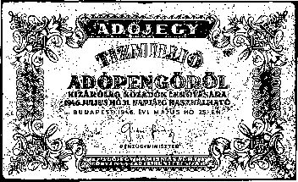
Figure 279a

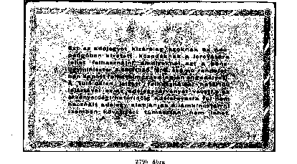

In addition to postal rate increase, in the table, we listed the quotations of the National Bank of Hungary for 1 franc d'or, on the date of the change in the tariff. By demonstrating these exchange rate changes, we intended to illustrate the real values of postal fees. They also illustrate the surcharges of air mail launched on 19 April 1946.
Regulation 106.446 / A. of 26 June 1945 provided for using hand stamps upon arrival
again, which suggests that the use of these stamps at the time prior to this regulation was ignored by the vast majority of post offices. This can be seen in a large number of postal items from the beginning of 1945. Despite this provision, even after June 26, 1945, the postmarks upon arrival were frequently missing, especially on local mail. The presence of arrival postmarks facilitates the correct recognition, but the lack of it alone is no evidence of the non-authenticity of the consignment.
It is more important to compare the dates of the postmarks and the validity of the postage stamps used. Regulation 215.898 / A.4 of 23 Msheet 1946 served to check the postage rates, which called attention of the post offices to use "clean and legible date hand stamps".
In-depth study and insight into postmarks of postal stamps used during this period is essential when examining inflation-period mail. This was not a simple task, and until this work appeared, only a few collectors were known. Now, however, for our volumes we have a detailed description of the postal stamps and their types, as well as the VI. Each collector has the option of having a volume. Based on the presentation of the stamps, we can accurately determine the type of stamps used by each post office during the period in question.
However, we should not forget that during the war, hundreds of postal stamps have been destroyed, lost or taken into the hands of unauthorized persons. Using the latter - albeit weaker - but we still have to count. The annulled or lost stamps are invalidated in the official post of the postal service, so their use exhausts the notion of forgery. Supplementary and auxiliary stamps issued by each postal administration were temporarily used to replace stamped stamps. However, we also know about cases where the post offices have made additional stamps themselves.
Finally, one important factor to mention is the stamps. Replacement of lost stamps with new types of crownless stamps, as well as those that had been used in the past and still temporarily employed during this period, were crowned. The last crown stamp was made in 1946 and was used on the 25th of April, while the first crown-stamp was also made in the same year and was used in Encs on May 2, 1946). It follows from the foregoing that the practice also proves that the bulk of the items in the inflation period were crowned, so we need to be careful with the Crownless.
After World War II, postal mails from abroad and mailing of postal connections were discussed above. In order to evaluate the authenticity of Byen consignments, table. This is a chronological list of postal relations with foreign countries from 6 August 1945 to July 11, 1946, and thus the commencement of leaf traffic.
For a similar purpose, which also shows the air mail service between Hungary and the European and overseas states indicated on the table, as of May 1, 1946, together with the airline fees to be paid.
It should not be neglected that, according to past experience, the remaining inflationary correspondence remained largely from the correspondence of authorities, institutes, institutions and commercial companies, banks and private companies. Módosítási javaslat. The correspondence of private persons in the time seems to have largely been destroyed over time, so we hardly ever encounter them. This finding also applies to the mailing activity of stamp collectors. During the occasional editions of this period, we mentioned that occasional stamps run on letters are hardly present. Even the so-called. philatelist freedoms are also rare. Looks like this is the only filatelia at this time. activity was the occasional stamp of individual stamps or possibly full series attached to sheets or sheets. Módosítási javaslat. The lack of a philatelic activity that volunteered then was partly due to the incomplete recognition of collectors, and last but not least the lost war and the extremely severe economic situation with inflation. Módosítási javaslat.
Table 3
A postai kapcsolatok felvételének időpontjai a külföldi államokkal az inflációs időszakban
1945. augusztus 6. | YUGOSLAVIA | (113.533/A. 4., 125.026/Л. 4.)
8 October 1945 | CZECHOSLOVAKIA | (132.449/A. 4.)
17 November 1945 | ROMANIA | (137.964/A, 4.)
20 November 1945 | AUSTRIA* | 3.4.
26 November 1945 | USA
 |  | (139.054/A. 4.)
26 November 1945 | GREAT BRITAIN AND IRELAND | (139.054/A. 4.)
26 November 1945 | FRANCE | (139.054/A. 4.)
26 November 1945 | POLAND | (139.054/A. 4.)
24 December 1945 | THE SOVIET UNION | (146.640/A. 4.)
21 January 1946 | BULGARIA | (144.308/A. 4.)
15 February 1946 | SWEDEN | (207.815/A. 4.)
1 May, 1946 | SWITZERLAND. | (223.094/A. 4.)
1 June 1946 | TURKEY | • (228.564/A. 4.)
11 July 1946 | BELGIUM | (238.998/A. 41)
11 July 1946 | THE NETHERLANDS | (238.998/A. 4)
11 July 1946 | NORWAY | (238.998/A. 4)
* 1945. XII. 1-tól 1946. From 12/01/1946, the mail service was temporarily suspended (141.141/A. 4., 201. 100/A, 4.). .

The Hungarian Post Office started mail traffic with the countries listed below, both European and other ones, as of 1st May 1946. (216.493/4).

Table 4

Surcharges to be paid on top of the regular postage fee:
AUSTRALIA | each 5 g | 1.50- | 2 golden franks
BRITISH INDIA, USA | each 5 g | 1.50 | golden franks
USA | each 5 g | 1 | golden frank
NORTH BORNEO | each 5 g | 1 | golden frank
CANADA | each 5 g | 1 | golden frank
NEW ZEALAND | each 5 g | 2 | golden franks
FRANCE | each 10 g | 10 | golden franks
IRELAND | each 10 g | 10 | golden franks
GREAT BRITAIN | each 10 g | -Д0 | golden franks
SWEDEN | each 10 g | 10 | golden franks
THE SOVIET UNION | each 10 g | -до | gold francs

The surcharges were due in pengős, at a conversion key valid on the date of mailing. For example, on the date of the issuing of the regulation, 1 gold franc was worth 20 million pengős. Airmail shipments were accepted only in Budapest, Post Office 72.
Chapter IV
POSTAGE STAMP EDITIONS 01/08/1946 -12/03/1950
1946 FORINT-FILLÉR
Most titles in the series have been printed several times because of the large demand, so the red and green colors of round 1 show a variety of shades. In this edition, due to the poor quality of the ink, particular attention to the color scales need to be paid. For this purpose, only unused or untouched copies should be used. Pieces soaked for a long time will lose color, fade, and the ink will drop off the paper after drying.
The reddish brown color of the postage stamps fades away due to sunshine. With chemical intervention, their color can be easily changed. By using these methods and by covering the value figures, the greenish base color postage stamps with red numbers were produced to mislead the collectors.
These are not erroneous prints but worthless fakes.
Pressed in the second round by intaglio printing from types, the value numerals were of the same color but different shade as the postage stamps - they are characterized by a number of specialties.
Slid numerals, which was caused by incorrect fixing of the sheets, are common, as well as clogs or curves (Figure 281).
In spite of careful and proportional casting of numerals, in the case of large number and repeatedly printed denominations, the dimensions of digits show deviations of a few tenths of millimeters in either direction, which are particularly noticeable in thicknesses.
The numerals of the denominations of the fillérs are 4.8 to 5 mm in hight, 0.6 to 0.8 mm in thickness; the numerals of forint denominations are. 4.7 to 4.8 and 0.6 to 0.7 mm respectively.

According to the abovementioned, three of the fillér denominations are 0.6, 0.7 and 0.8 mm in thickness, while two of the forint denominations are: 0.6 and 0.7 mm in thickness. However, the measurements should take into account the heavily inked

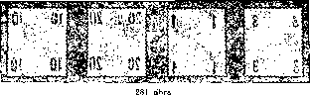

Figure 282

prints, which do not constitute a different type in spite of their different dimensions.
The findings listed above are supported also by the fact that we almost do not come across any dimension deviations in the denominations of 8 and 12 fillérs, as as well as 10 forints - these dimentions were produced in much smaller number of copies.
While the numbers were printed, the displacement of the two digits of the numerals resulted in the sliding of the digits relative to each other. But there are also known examples of single digit denominations where the relative slippage of the value number can be easily detected. These defective prints were usually discovered by the printing control early, and the abnormalities were immediately abolished.
The color shades were frequent in this edition.
These postage stamps were marketed in 100-piece sheets.
These postage stamps were produced on treasury. paper with watermark IX, of two quality grades, of multiple thickness.
However, before going into the detailed paper quality description of this edition, we have to say a few words about the quality classification of the postage stamp paper, especially the new design postage stamps that were issued after 1945.
In classifying postage stamp paper, the most important thing is to know that the two sides of any paper, especially watermarked postage stamp paper, are of different smoothness. During paper production - partly in order to reduce moisture - watermarked paper is sqeezed between the bottom of the top roller (mesh and smoothing ones). The still fairly wet paper during this procedure undergoes such structural change that remains preserved afterwards. Namely, on the upper surface of the paper, the fibers are compressed evenly by the paper roll - this surface of the paper becomes smooth. By contrast, the underside of the paper is smoothed by the mesh roller with an unequal (lukewarm) surface, so the paper will be grooved, either in stronger or weaker manner. Different degrees of smoothness on the two sides of the paper are noticeable, especially in watermarked paper, such as the kinds for billion pengős, million pengős, etc., as discussed above. Knowing this is a very important factor from the philatelic point of view, when classifying paper quality grades.
From the point of view of the printing industry, printing on the smoother side of the paper is the most advantageous in any printing process. Since this principle can not be fully achieved while cutting or further processing in a paper mill, and because, on the other hand, printers cannot devote much time to checking paper, mirror image watermarks are produced when printing is applied on both sides of the paper, both with regular and non-symmetric orientation.
By this, we have arrived to the point where we can get the most essential help. The analysis of the watermark orientation provides the basis for the classification in the most cases. It follows from the above that when printing is produced onto the smooth side of the paper, the watermark is an odd number (1 or 3), while when it is produced onto the bottom side, the number will be even (2 or 4).
The second important factor in examining the quality of the paper is looking into the quality of the gumming and, last but not least, the way the gumming discolors the paper. Therefore, when classifying paper, its color (primarily the so-called "greyish paper”) does not justify introducing another quality category - the gumming used on postage stamps in post-war years was very bad and of varying quality.
Likewise, a slight change in the thickness of the paper is not crucial if the raw material used for the production or its mixing ratio remained substantially the same. As we know, the average paper thickness of the raster intaglio postage stamps discussed in this volume varies from 0.08 to 0.1 mm, so we do not use a separate category to indicate this difference. It will only be indicated by bold letters. Other paper thickness will be indicated by lower case letters.
Lastly, we must not overlook the fact that due to the loosening of the fibers during the long soaking of the postage stamps, the thickness of the paper may also change.
After that, we will be able to discuss the paper quality types of this edition, which will also be used to compare the variations of later editions.
We distinguish quality type "A", which is 0.08-0.1 mm thick white or slightly greyish or discolored.
The other kind was identical to the previous one and also marked with “A”: it is strongly smoothed and porous on the one side and irregularly grooved on the other. All denominations of the series occur on this paper.
"Aa" quality: the same white paper but 0.07 mm thick. Up to now, only 30-filler denominations are known on this paper.
“B” quality, 0.12 mm thick, hard, greyish, medium-fine paper. Watermark is difficult to see. The 12 and 60 fillér and the 2 and 5 forint denominations are common but some other denominations are likely to occur on this paper too. This paper quality occurs several times in later editions, with another watermark.
Creases caused by paper jamming are rare.
Gumming: white or yellow.
Watermark and watermark position IX, which may be portrait (A) or landscape (B).
Watermark orientation: A/1, 2
10, 12, 20, 30, 40, 60 fillers and 1, 1.40, 2, 3, 5 and 10 forints,
B/1,2 : 8, 10, 20, 30, 40 and 60 fillers, and 1, 1.40, 2, 3, and 5 forint denominations.
As shown in our list, watermark (A) arranged as portrait occurs in all denominations issued in August.
In addition to the 8-filler denomination placed into circulation on the 9th of December, 1946, watermark (B) (landscape arrangement) is known on further 10 denominations, all except 12 fillers and 10 forints. As after the decrease of form fee from 12 fillers to 8 fillers, 12 filler denominations were no longer printed, it is now certain that the 12-fillér denomination well as a 10 forint denomination produced in a smaller quantity due to a smaller demand, do not exist with the landscape arrangement of the watermark.

Perforation: 15 teeth, comb Non-perforated pieces (□) are Phase II prints put on the market.
There are 40 filléres denominations with missing perforation at the bottom.
Note: The denominations of the series of 1.40 and 3 forints with overprints “Meghtitalmazás”, “Érvényes”, „1955” or “1956" and. „Z.—Fb" constituted the fee for the “authorization” to take over mail items at the post offices for the behalf of the persons to whom the mail items were addressed.
PEASANTS’ DAYS 1946
On September 7-9, 1946, the Hungarian Peasantry organized National Peasants’ Days in Budapest. For this occasion, the Post Office issued 3 denominations with a 200% surcharge to support the Hungarian Peasant Association.
The images were designed by György Konecsni.
These postage stamps were introduced by Regulation. 250.600 / Bgi. (P.R.T. 1946/54) on September 7, and were withdrawn from circulation by Regulation 264.583 / Bgi. (P.R.T. 1946/67) as of 15 November 1946.

100,000 full series were produced .
They were only sold between 7 and 30 September in a full series, a single series to a buyer; they were marketed in Budapest, at post offices number 1 in those towns where there were several post offices, as well as at the temporary post office at exhibition Industry for Agriculture, and at the municipal offices of Berettyóújfalu, Mátészalka and Szikszó, and finally until October 13, 1946 at the grape picking feast in Tokaj.
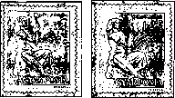
Figure 283
Denominations of the Series
30 fillérs ; - CÒ fillérs green
60 fillér-f l,20 forint red
1 forint (-2 forint blue

The postage stamp image is the same in all three denominations: a Hungarian bride in folk clothes kneeling on her right knee and holding a stylized wheat ear with stylized wheat sheaf. Inscriptions: “MAGYAR POSTA” and “ORSZÁGOS PARASZTNAPOK 1946” (Hungarian Post Office, National Peasants’ Days).
Value numeral and currency took place in the upper right corner. The image is of a rectangular shape, 25 x 30 mm.
These postage stamp were printed in the State Printing House, with single color grid, intaglio technique.
It was marketed in 100-piece sheets.
Made of 0.09 mm thick white, X-watermarked treasury paper of quality “A”.
Watermark orientation: B/1, 2 The orientation of “1” is rare.
Enyvezés fehér. .
Fogazat 3 2 1/4:12 fésűs fogazat. Fogazatig terjedő mérete 29 x35 mm. Fo- gazatlan példányok ( □ ) kereskedelmi forgalomba bocsátott II. fázisnyomatok.
Alkalmi bélyegzések. . ' -
. LÉGIPOSTA
Általános forgalmú, 8 értékből álló légiposta bélyegsorozat, amely hazánk idegenforgalmi nevezetességeit propagálja. .
The postage stamps were designed by: Béla Kálna - 50 fillérs, 1, 3, and 5 forints, Zoltán Nagy 10, 20, and 70 fillérs, as well as 1.40 forints.
These stamps were introduced by Regulation 210.500/Bgi. (P.R.T. 1947/12)
on Msheet 5, and withdrawn from circulation by Regulation 7619 / B-26 / III. 2.
as of April 30 (P.R.T. 1952/11).
These postage stamps were sold at post offices and private postage stamp vendors. Post offices were reluctant to order and use the postage stamps of this series probably due to their big shape. Regulation 232.250 / BGI. (P.R.T. 1948/13) addressed a number of complaints arriving from the public by instructing the post offices where air mail was sent regularly.
Otherwise, Regulation 212.012 / 4 of 1947 (P.R.T. 1947/16) provided that the postage stamps of the series be sold to the public only upon their explicit request.
Face Values Of The Series
10 fillérs | purple carmine | 3,067,000 pieces
1.20 fillérs | greyish green | 5,392,000 pieces
50 fillérs | reddish brown | 3,022,600 pieces
70 fillérs | olive green | 3,635,000 pieces
1 forint | blue | 4,305,400 pieces
1.40 forint | brown | 2,466,000 pieces
3 forints | green | 10,390,200 pieces
5 forints | violet | 852,000 pieces

Postage Stamp Images: a rectangular shape arranged as portrait, with colored and white frame lines rounded at angles, and variable images inside the frame.
10-fillér denomination: The eastern, old row of houses of Sopron Monastery. In the background, a town tower (fire tower) named Hűségtorony (Tower of Fidelity - name to commemorate the referendum held on 14 December 1921), whose foundations were laid down in the Árpád era. There is an airplane at the right side of the cloudy sky.
20-fillér denomination: Cathedral at the top of Esztergom Castle Hill designed by Khünel, a Viennese sheetitect, and built in 1822-1856 in a neo-classicist style. Hungary's largest 107 m long, 48 m wide, 100 m high and most beautifully situated church. There is an airplane above the church.
Figure 284

50-fillér denomination: Szabadság (Freedom) Bridge in Budapest, between the Dimitrov Square and the Gellért Square, designed using the winner plan by Fekettéházy J. Originally built in 1894-1896, the bridge was exploded on January 15, 1945 by the German troops, and then re-built in January-August 1946. View from the Gellért Hill. There is an airplane above, at the right side.
70-fillér denomination: In the valley of the river Színva, the romantic castle built in Lillafüred, today a union holiday resort. The Hámori Lake in the foreground, an airplane at the left side.
7-forint denomination: The group of buildings of the Agricultural Museum of Budapest called Vajdahunyad Castle. The Millennium Exhibition Building Group was built by Ignatius Alpár in 1902-1904, using the style of Vajdahunyad and Csütörtökhely Castles (Romanesque, Gothic and Renaissance buildings). One of the most outstanding creations of the Hungarian national sheetitecture. In the foreground, there is the City Park Lake (városligeti), while above, there is an airplane.
1.40-forint denomination: Dunaszoros védelmére IV (for the protection of Danube Delta) Visegrád Castle built by King Béla The so-called Solomon Tower, a remnant of the later version of the royal palace, the one built by King Charles Robert. (The name “Solomon tower” was a mistake, as the tower had not existed at the time of the king Solomon). The Danube River at the right side and an airplane in the high.
forint denomination: The Tihany bay of the Lake Balaton. Sailing boat in the foreground, the ancient Benedictine church and monastery (nowadays museum) on the mountain in the background. There is an airplane in the upper left corner.
5-forint denomination: This postage stamp image was designed by Imre Steindl - it was the House of Parliament as seen from the Castle Hill. It was built between 1882 and 1902, 268 m long, 118 m wide, 96 m high, on the Danube at the side of Pest. In the foreground, there is the Kossuth Bridge built for temporary use in 1945 - 1946. It was later closed down when the Chain Bridge reconstruction was completed a few years and then demolished.
In the top upper corner, there is an airplane.
White inscriptions on all images: “LÉGIPOSTA” (airmail) at the top, “MAGYARORSZÁG” (Hungary) at the bottom, value indication in the bottom right corner.
The image is rectangular, 22 x33 mm.
MBEOSZ in 1947 declared the series as the most beautiful postage stamps of the year, and rewarded the designers with silver medals.
These postage stamps were printed in the State Printing House, with a single color grid, intaglio printing technique.
One of the postage stamps of the sheets of 20 fillérs and 5 forints was let into circulation with printing error. These errors were quickly noticed and corrected, and they were no longer available in subsequent prints.
On the 97th stamp of the 20-fillér denomination, due to the dirt stuck to the copying or light-sensing glass scratch, a 2.6 mm long dark line of the “boat” shape was generated to the left of numeral “2” (Figure 285).
On the 91st stamp of the 5-forint denomination, due to the defect of the positive, at the top of “5” hook there is an attached a 0.6 mm vertical white line in the print (Figure 285).
In addition to the above, sometimes the discoloration of the side of the postage stamp where the image is, of the same color as the color of the image but of a fader shade may be observed. This is the result of the so-called “hard printing”.
These postage stamps were marketed in 100-piece sheets.
These postage stamps were produced on the paper with watermark IX,. of the treasury postage stamp printing quality. In this edition, besides the known "A" grade, a new psheetment-like paper was used - it was labeled "C".
Figure 285

We distinguish quality "A” paper, which varies in the thickness range 0.08-0.1 mm, and is white or greyish.
All the denominations occur on this kind of paper.
Quality “B”: greyish psheetment-like paper of 0.09-0.1 mm thickness, and probably with the addition of larger amounts of binding material. All denominations are known on this paper as well.
Quality "C" is the same as the previous kind but produced on very thin, 0.06 mm thick paper. There are 3 denominations that were produced on this paper: 20 and 70 fillérs, and 1.40 forints.

As per Sugár.
For the measuring the full width of the sheet, the maximum distance between letter “p" in denomination “pengő” (kreuzer) on the first stamp of the sheet and letter “ő" of word “pengő” (kreuzer) on the tenth stamp was measured.

